# Contents

# Analysis

## Introduction

I have decided to create a single player and multiplayer Pac-man which will consist of three very different gamemodes, inspired by the original 2D maze arcade game Pac-man, which was developed and released by Namco in 1980. Pac-man is a famous and beloved game, that captured the hearts of many people of all ages. Originally the 2D maze arcade game had the Japanese title ‘Puck man’, which later changed in 1980 as the name could have been used for vandalism. The game was now known as Pac-man.

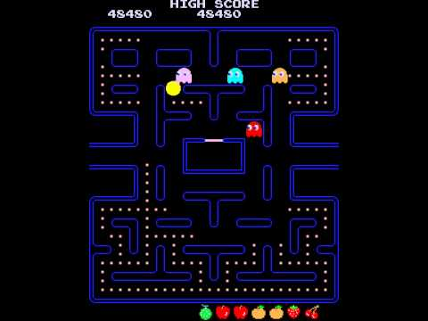

The original Pac-man in 1980

The gameplay of Pac-man is simple, yet amazingly fun. The game consists of one player (Pac-man) and a Maze with dots in each free space, and four flashing energizers in each corner. There are also fruits which appear twice every level. The dots are each worth 10 points, and the flashing energizers are worth 50 points, and depending on what level fruits can give you between 100 and 5,000 points. A level is complete once all dots on the screen (including the flashing energizers) have been eaten. The game consists of 256 levels, the last one being endless as the developers found a bug if it wasn’t to be.

Furthermore, the game consists of four enemies, which are called Ghosts, each having their own personality. The objectives for the ghost are to find Pac-man using an algorithm and eventually eat him which would cost the player a life. The player begins with three lives. However, Pac-man can possess the ability to eat the Ghosts once he eats a flashing energizer. The player will know this as the ghosts turn blue. A score of 200 points is given for eating the first ghost, 400 points for the second, 800 points for the third and 1600 points for the fourth. The time at which the ghosts are able to be eaten are limited, with the time decreasing every level. If a ghost is eaten, it will respawn in its original form.

To summarise, the overall objective of the original Pac-man game is to avoid the ghosts and obtain all the dots to gain access to the next level.

## Project Scope

My main focus will be to investigate how to create a working multiplayer game, first on a local network and then if possible, on a worldwide scale. In addition, I will need to investigate how to sync player movement and the game state between clients with little latency.

The single player aspect of my game will only involve one game mode, which will also be included in the multiplayer part of the game. The game mode will be an almost identical version of the original Pac-Man, but the ghosts I will create will have different AI algorithms than the original and therefore each ghost I create will have different personalities.

The multiplayer aspect of my game will contain a different game mode. This second game mode will be a player against player game mode. This game mode will involve two players who aim to survive as long as they can and to try get to 500 points. Rather than the players killing each other, tiles such as lava will spawn randomly around the map which players have to try avoid to survive. These lava tiles will only be available for players to pass through when they turn from lava to rock tiles. Players can either win by getting to 500 points while avoiding the lava tiles, or they out survive the other player (if the other player loses all three lives).

The settings part of my game, will include various features, from checking your high-score, to changing the colour of your Pac-man, to maybe even checking where you are in the online leader board. Furthermore, the settings may include a help option and an option to change the game difficulty.

I will also be focusing on developing different algorithms for the enemy AI for the single player part of the game. I will be comparing my algorithms to various other single player Pac-man games. Alongside this I will be creating a progression system where players unlock various colours for their Pac-man and map for the single player part of the game also. I will also test it to see how my algorithm matches against other single player Pac-man games. This will check the difficulty of my game.

Below I have outlined the structure of how I will be tackling this problem to create a single-player and local multiplayer Pac-Man with not just the original Pac-Man as a game mode, but another unique second game mode and maybe more.

|  |  |
| --- | --- |
| Objectives | Duration (weeks) |
| Prototype | 4 |
| Analysis | 2 |
| Documented Design | 4 |
| Technical Solution | 12 |
| Testing | 1 |
| Evaluation | 2 |

This table of objectives and how long they will take are subject to change depending on if I think I need to remove or add extra features to my project. The duration could therefore change throughout my documentation.

## Client/Supervisor

My supervisor for this project will be my computer science teacher, Mr Abbas. Me and Mr Abbas will have meetings weekly to discuss if my project is going along the right path, or if there are any alterations I need to make.

## Target Audience

When I have finished creating my game, I will test it amongst friends and family spread around the UK (or even World) if possible and of all ages, to see how latency affects gameplay and to see which game mode is preferred and if there is a correlation with age. However, arcade games tend to appeal to teenage and kid audiences, so I will aim to cater to those first.

## Investigation

**1.Pac-Man Battle Royale**

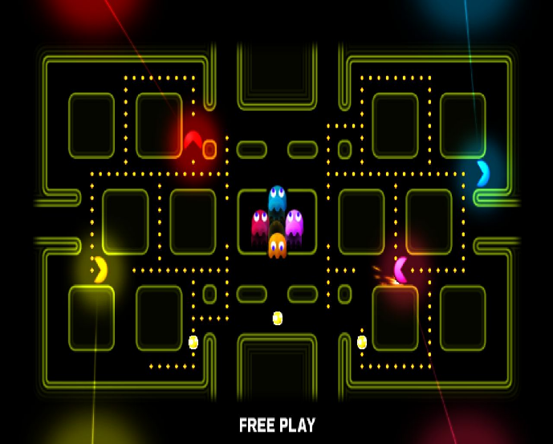Pac-Man Battle Royale is the 17th arcade game (11th official game) in the in Pac-Man’s series. It was developed and released by Namco Bandai Games in January 2011 and later ported for a digital release on console and PC in 2014. The game can be played as a single player or local Co-Op. It was never released as an online multiplayer game.

Up to four players can compete at once, choosing a game length of between three and nine rounds. Each player controls a colour Pac-Man character. The players move throughout the maze trying to avoid the four ghosts that are present, while collecting dots or powered pellets scattered around the map. If a player collects a powered pellet, their Pac-Man character grows in size for a limited time and is now able to eat ghosts and other players. If two players have powered Pac-Men and they run into each other, they will knock each other back a certain distance (but that is it). A player wins the round if all other Pac-Men have been eaten, or they have the most points once the round ends after a maximum of two minutes. Points are obtained from eating dots and powered pellets, in which they respawn whenever they have all been eaten. The player who has won the most rounds wins the game.

The game could be very inconvenient if there are four players playing locally as there may be a lack of controllers if played on the console, or lack of space on the keyboard or controller connections if played on the PC. The game could have benefited greatly by adding in an online multiplayer feature that did not require all the users to be controlling Pac-Man locally on the same device.

My solution aims to solve this problem by providing a network for players to play on wherever they are in the world, with a focus on making sure the gameplay still remains smooth and there is a reduction in latency between clients. Friends and family would be able to play wherever they want, as long as they have access to a Computer and Wi-Fi.

|  |  |
| --- | --- |
| Pros | Cons |
| * Allows players to play with each other, rather than just on their own. * There are many clear and creative animations which make the game exciting to watch. E.g. Sparkles when collecting powered pellets or a dying animation once Pac-Man has been eaten. * Music and sound effects. Lighting effects were also great. * Gameplay is smooth as the controls are not just very easy to use but have very little delay and are very responsive during the game. * The game contains different maps, which avoid repetition. Each map is created with a different colour. | * The game is not online multiplayer, and only a local Co-Op game, so players may find it very inconvenient trying to find a way to organise a game between two to four players to all play on the same device (locally). * The game does not contain many settings besides choosing the number of rounds and colour of Pac-Man. * The score for each Pac-Man is not shown on the screen during the round, so players are not aware of the score once the round ends. |

Inspired by the creative and cool animations, I will be adding some into my project. These animations will occur when Pac-Man has been eaten, obtains a power-up (powered pellet), eats a ghost or even when the Player wins the game. I will be adding a live scoring system that will show when a player(s) is playing, and it will be updating during the game. This will let the player know how they are doing. I will also be adding a more in-depth settings menu. Other than the colour of Pac-Man, I will be adding a difficulty setting to the single-player part of my project and a speed setting to the multi-player part of my project. The difficulty setting will range from easy, to medium, too hard. The speed setting will be determined by the host and will decide how fast the Ghost’s and the Pac-Men are.

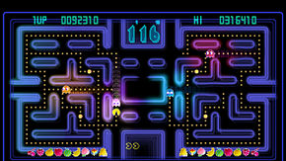**2.Pac-Man Championship Edition**

Pac-Man Championship Edition was developed and released by Namco Bandai Games in 2007 for consoles. The game was designed by the creator of the original Pac-man arcade game in 1980, and it was also the final game that he designed. The game is now ported to many devices such as android and iOS.

Like the original Pac-Man arcade game he designed, Pac-Man Championship Edition consisted of the same basic gameplay. The player navigates Pac-Man throughout a Maze, collecting dots, power pellets and fruits, all while avoiding the four ghosts. Pac-Man still dies if the ghost catches him, and the ghosts still turn blue once Pac-Man collects a powered pellet which allows him to then eat the ghosts for points.

Pac-Man Championship Edition was designed to make it a much faster paced game, decreasing the users time to decide and react as the game goes on. The game offers some major differences from the original Pac-Man. Each maze (map) is divided into two halves. Eating all dots on one side of the maze, causes a fruit to appear on the other side. Once Pac-Man eats the fruit, it causes a new maze to appear on the other side. The longer the player stays alive, the faster the game gets, increasing the speed of Pac-Man and the ghosts. If a player dies and loses a life, the game slows down. In addition, if Pac-Man eats a powered pellet, not only do the ghosts turn blue like the original Pac-Man but they go back to their original speed, until they return back to their original form.

The game features six different modes. It features a Championship mode which is the basic five-minute mode. It also features two Challenge modes which affect the stage, such as by increasing the number of powered pellets or putting the maze into darkness which lets the player only see Pac-Man (themselves), the ghosts and a smaller area around them. This limits the players ability to see how the maze has changed and increases difficulty. One of the Challenge modes is ten-minutes while the other is five-minutes. There are also three Extra modes featuring different Mazes. Furthermore, the game has some great features such as an online leader board so you can see how your high score compares to theirs. The game features new sound effects while still retaining the original Pac-Man music and provides very modern graphics and smooth animations, with even particle effects. The game also provides an achievement section, where a player can track their progress and unlock various achievements. The menu of the game contains a leader board and achievement menu. The leader board menu is something which is a priority of mine to incorporate in my game.

|  |  |
| --- | --- |
| Pros | Cons |
| * Provides more than one gamemode which increases or decreases difficulty allowing the user to customise their experience. Such as the fog of war (darkness) feature. * The game provides very modern graphics which make the feel aesthetically pleasing. * Contains an online leader board. * Contains an achievement menu. * The game is available on many devices. * The game provides a help page to allow players to get familiar with the game before playing. | * The game has no Co-Op or online features beside the leader board. * You can’t customize Pac-Man in many ways. Such as the colour of Pac-Man. * Although the game provides many modes, the concept of each mode and how to play each mode is the same. * Controls are not responsive enough. This may be due to how fast-paced the game gets. |

I aim to provide my game with an online leader board system so players can compare how they are doing against their friends and other. In addition, I will be providing a help page to allow all players to get an understanding of each game mode I will be providing. My game will also feature changes to the colour of Pac-Man. Furthermore, I aim to make my controls as responsive as possible, especially with the network part of my game. This will involve me having to reduce latency between client and server and having to make sure to sync the game-state and player movement between clients. The game has also inspired me to include some interesting features such as an increase in speed as the game goes on. I will be including this in my second game mode in the multiplayer section of my game, hoping that it will add some extra intensity to the game.

I also aim to add a menu, similar to ‘Pac-Man Championship Edition’s’ menu. I will have a single-player, multiplayer, leader board and settings options in the menu and possible an achievement option.

**3.Pac-Man 256**

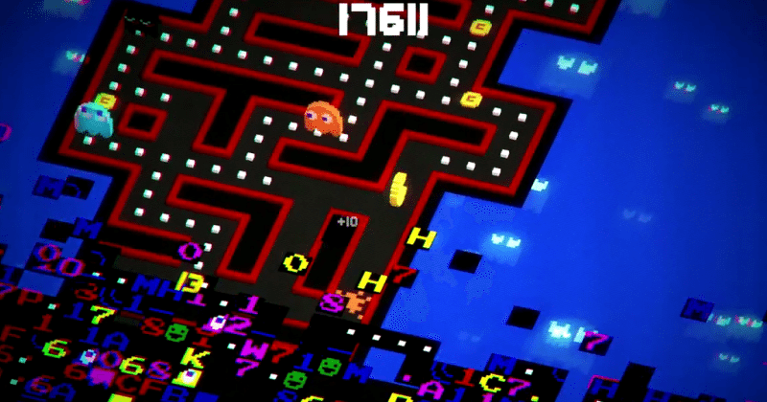Pac-Man 256 is an endless running video game developed by Hipster Whale and 3 Sprockets and published by Bandai Namco Entertainment for iOS and android in 2015, then later ported to console and PC in 2016. The game was inspired by the original Pac-Man game’s level 256 glitch. Pac-Man 256 puts a player in control of Pac-man as he moves through an endless trying to avoid both the ghosts and the glitches trying to catch up to him, so the player must act quick. While trying to survive the player tries to obtain powered dots, like from the original Pac-Man games, or power-ups which are a new feature introduced in Pac-Man 256. There are over 20 power ups ranging from tornadoes to laser-beams. Another new feature specifically designed for this game is whenever Pac-man collects 256 dots, all ghosts in the vicinity are wiped out and the player gets a mega bonus score. Furthermore, on console and PC a new local Co-Op game mode was introduced, which allows up to 4 players to play simultaneously trying to gain as many points together as a team. If a player dies a power-up will spawn and one player will return if it is collected. In conclusion Pac-Man 256 is an exciting endless runner game rather than a level-based Pac-man game we are used to seeing.

|  |  |
| --- | --- |
| Pros | Cons |
| * Provides a local Co-Op mode, for up to 4 players. Rather than players against each other, players team up together. * Contains new features, such as powerups and an endless maze which adds a fresh new look to the Pac-Man Series. * Translates Pac-Man’s art style into 3D. * Several visual themes for the maze and player character, making the game more interactive. * The game provides amazing particle effects, especially when using one of the many power-ups. * Available on many devices, including console, mobile and PC. This allows for a variety of target audiences. * The game gives the player a feel of progression by allowing the player to obtain coins to upgrade power-ups. | * No music apart from the title screen, which feel boring for the user. * No global leader board only a friend’s leader board. * Not many games modes, so could lead to repetitiveness. * Quests are very minimal, so game may tend to become quite tedious (especially single player) rather than fun. * Although it is a local Co-Op game, the game is not an online multiplayer game, meaning the multiplayer aspect does have its limitations. |

In my game I will also be including a Co-Op, with the aim to make it local first, and hopefully to a point where anyone around the world can play, making it an online multiplayer game. In addition, I will be adding a sense of progression in my game, by being able to unlock different colour characters and possibly even a levelling system. However, unlike Pac-Man 256 I will be adding music throughout my game, and more than one game mode to make the game feel more interesting as it will minimise repetitiveness.

I will not be making my game 3D (so no 3D-art), as I want as many users to be able to access the game as possible without being limited by hardware or operating system.

**4.Rally-X**

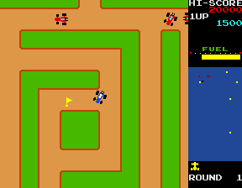Rally-X is a maze arcade game developed and published by Namco in 1980. The player takes control of a blue race car, where the objective is to collect all ten yellow flags around the map, while avoiding the red cars. Once all flags have been obtained, the player progresses to the next round, which is of greater difficulty and the map also changes. On the right of the screen, the score, high-score, round number and the amount of fuel the car has is shown. The fuel depletes every round, and if it reaches zero before all flags are collected the players car goes extremely slow, often resulting in the player losing a life. The flags increase in value by 100 as they are collected. If the flag with the letter ‘S’ (meaning special) is next to a flag being collected, all other flags after this one earns the player double the value of what they would usually get. The player is also given a smoke screen to try stun any red enemy cars following. There also obstacles place randomly throughout the game to make the player lose a life, as the player must avoid them also. Rally-X provides exciting single player gameplay for various reasons. One of which being the idea that you never know exactly where the enemy is, although the map does give you a rough idea. Another reason being that you have to race time, as you have to try get the flags before fuel runs out, otherwise you are in a lot of trouble. However, the game can get repetitive after you have played it many times due to the fact that the map for that certain round never changes. animations and particle affects are very minimal, even the smoke screen animation is very limited. This is most likely due to the hardware limitations in 1980. Music however is played throughout the game.

|  |  |
| --- | --- |
| Pros | Cons |
| * Variety of maps * Scoring system allows the user to feel a sense of progress. * The game can provide slow or fast paced moments, making it exciting. * Music throughout game. Specific music when collecting flags or losing a life. * The game adds colour to try limit how quickly a player may decide to exit the game, by making it look more aesthetically pleasing. * Features like the fuel system adds an extra challenge as it makes the user race against time. | * Animations and particles are very limited, most likely due to hardware limitations. Although music is played throughout the game, it doesn’t seem to bring much life to the game. * Only single player and the maps for the specific round never change, so game may get boring quickly. * There are no game settings, so very little customisation by the user. * The difficulty of the game is quite hard and can’t be change. This is not a good idea as it does not attract a large children audience. |

While looking at Rally-X, the two main things that I will be adding to my game is a feeling of progression and a difficulty setting. By adding a difficulty setting I will be able to appeal to a variety of people, from children who prefer easier games and those who aren’t experienced with games to those who want a very hard challenge. In addition, a difficulty setting on the Singleplayer game mode will make the game more fast-paced, so the player never gets bored and the game always feels intense. Moreover, the progression system will involve unlocking different colour schemes for Pac-Man, and for the map. A progression system will also give the user a sense of satisfaction once that unlocked something. Furthermore, particle effects and music will be added when the player collects power-ups or power ups, and also when the player eats another player or a ghost, depending on the game mode.

## Questionnaire

This questionnaire provides me with the suitable information, so I can provide the best user experience.

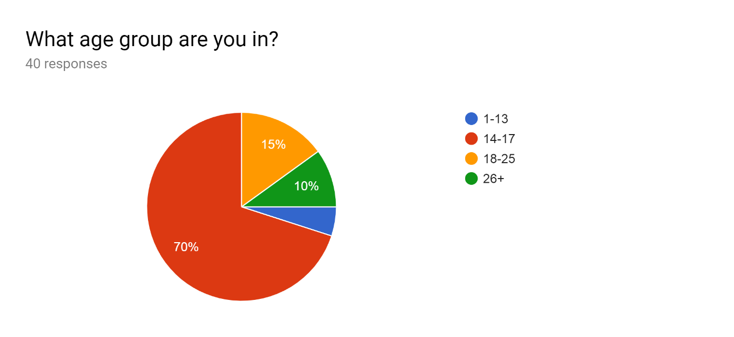

The majority group in this chart, are people aged between 14-17, and the second most are aged between 18-25. The rest of the groups only take up a small part of the chart. Therefore, the majority of my users will be teenagers, so I need to cater the game to that audience mainly. In addition, this confirms I do not need to make the game simple, as teenagers will most likely be able to pick up and understand any complex ideas the game may have.

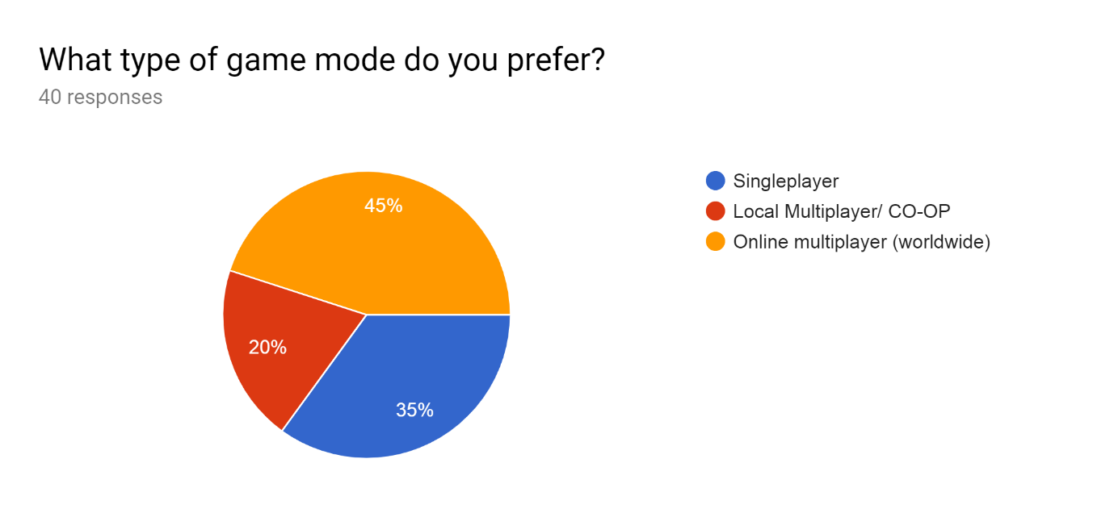

The majority of the people that responded, chose online multiplayer, however there were still a large amount of response for both single player and local multiplayer. Therefore, the single player part of my game should still be popular amongst users. However, I will be concentrating on implementing more multiplayer features, and making the gameplay more complex than the single player part of the game. I will be implementing features such as an increase in speed for the ghosts and/or Pac-man as time goes on, in the multiplayer part of the game. First, I will be creating a local multiplayer game, where players can play along the same network, this will allow me to implement the most popular multiplayer features below (in the questionnaire). With a local multiplayer game, players will still be able to enjoy a lot of the things they enjoy with an online multiplayer game.

On the other hand, a majority of users would prefer an online multiplayer game instead, which I will be attempting once I have completed the local multiplayer and if there is enough time. When being attempted, I will have to focus on reducing latency between clients so user inputs are not delayed wherever they are in the world.

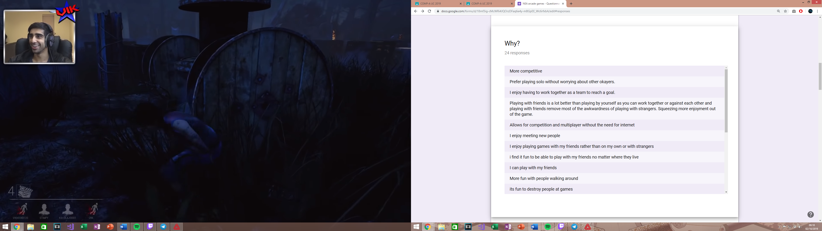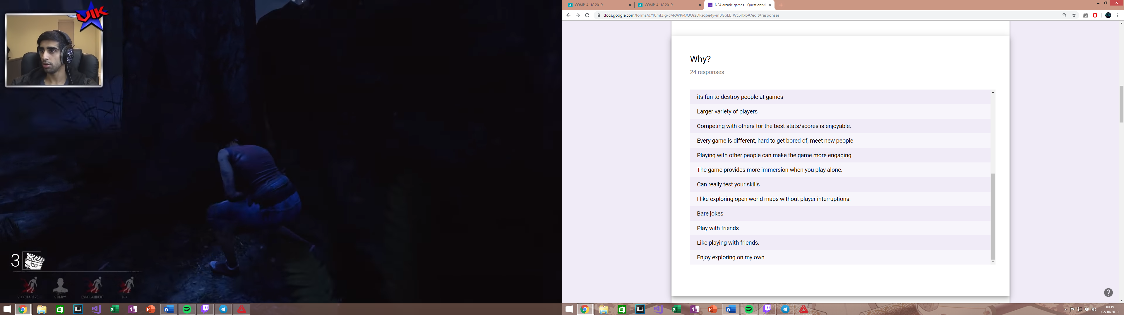

These responses are to why the user has preferred a certain game mode, from the above. This allows me to identify specifics aspects to each game mode where the user has enjoyed their experienced.

For the single player aspect of the game, users said how the game was more immerse when playing solo. With this information I will be adding specific single player features for the user, such as a customizable Pac-man, where the user can change Pac-man’s colour, and even change the colour of the map and the background. In addition, users said how they prefer playing without the interruptions of other players. With this I am to make the AI clever enough so the user gets a good and challenging experience while not having the interruptions of other users. Moreover, a user specified a reason by saying, “I like exploring open world maps without player interruptions”, which I can’t relate to my arcade game as it does not have anything to do with playing an open world game, so I will not be including aspects from an open-world game in my game.

For the local multiplayer aspect of the game, users said that playing with or against friends is much more fun, as it squeezes more enjoyment out of the game, while removing the awkwardness from meeting strangers. I will therefore aim to create an option where players can select who they want to join their game, via a lobby option or a friends list where they can invite specific users (friends). Another user responded, that they want to test their skills. This can be applied to all game modes, but especially for the Singleplayer part of my game as the difficulty setting can be adjusted. By increasing or decreasing the difficulty of my game, users will experience a different pace in the Singleplayer game mode, due to the cost function, which means the user can adjust it to cater to their skillset of arcade games.

For the online multiplayer part of the game, users responded by saying, “I find it fun to be able to play with my friends no matter where they live”. If I attempt to create an online multiplayer part to the game, I will focus on reducing latency between players, to keep the game fun and fair no matter where you are in the world. Another user said they want to compete for the best states/score. I will aim to create an online leader board here, for all modes (single player, local multiplayer and possibly online multiplayer), where players can see their high score. Users also stated how they enjoy playing with a large variety of players, who each have different play styles. This is one of the main reasons I will be focusing on creating an online multiplayer version after I have finished my main focus, which is the single player and local multiplayer parts of the game.

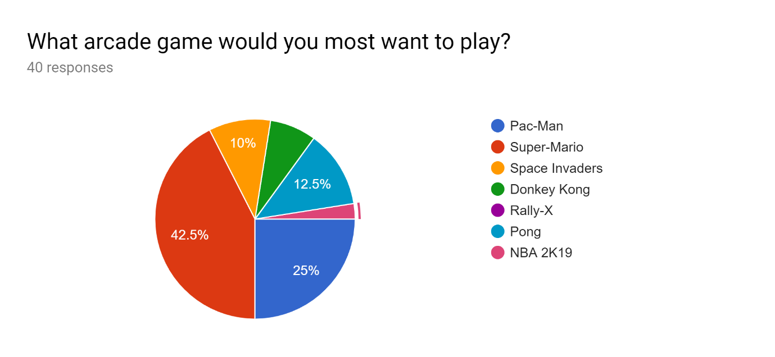

Here users decided on which arcade game that would most want to play. I found out that the majority of users selected Super-Mario. This shows me, that I will need to aim to include various features from Super-Mario that are not included in the conventional Pac-man games. A feature that I may use are the powerups, one of which being the character enlargement one, this being the mushroom that Mario collects to grow bigger and stronger. I will use this, so whenever Pac-man obtains this power-up scattered randomly around the maze, the user increases in size and the ghosts will start avoiding him. This is actually a similar concept Pac-Man Battle Royale has, in which I have discussed above. In addition, another power-up I may use is the flower power-up which allows the user to spray fire in front of them. I might adapt this however, so Pac-man shoots a laser directly in front of killing either a ghost or an enemy Pac-man. A main part of super Mario was trying to collect three coins in three different locations during the level. I may incorporate this in my game while still maintain the authenticity of Pac-man, by spawning fruits at random locations, and giving the user only a small amount of time to collect them, and if the user collects all three, they may gain an extra life plus extra points to their score.

Furthermore, another thing I take from this chart is very few would want to play Donkey-Kong, so I may not include some features that Donkey-Kong may have. Donkey-Kong was a one of the most difficult games in its times (1980), as you had to concentrate hard to time the players jumps. This may be a reason my users would not enjoy the game, so therefore I will aim to not make my game hard but still add an option to increase difficulty if the user wants to, by adding a settings option for this.

Twenty-five percent of users said they would play Pac-man which is the second most on my chart. This lets me know that although 25% of my users would rather play Pac-man as an arcade game rather than any other, which is still a substantial amount to maintain an audience interested in a Pac-man based game, but I would want to try increase this number so I can get a larger player base. This means I have to include various of other features to try get players interested that my game (project) is unlike any Pac-Man game they have seen before. Therefore, while implementing my game, I will be taking constant feedback from various users of all ages, including my client/supervisor.

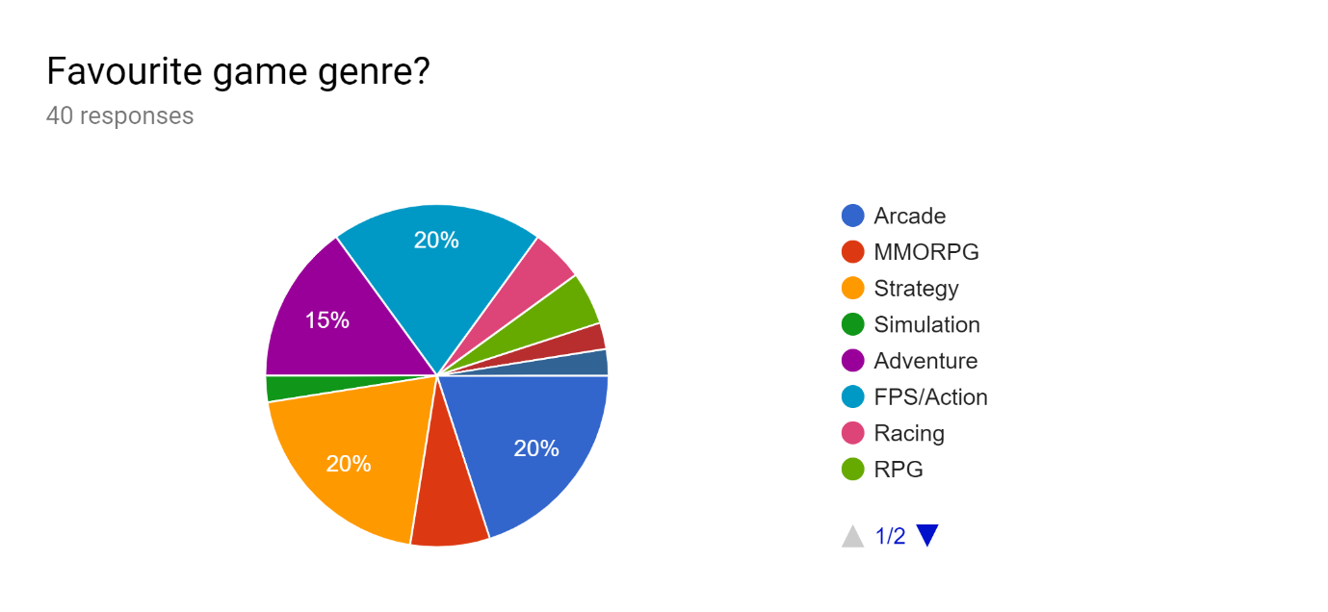

This chart showed me a variety of things, as there was no majority response. The leading responses though, were Adventure, FPS/Action, Arcade and Strategy.

From the strategy genre, I aim to include tactical features to my project, by adding risks and rewards for actions a player may choose. For example, I may spawn fruits that give you an extra life and/or points, but I will spawn them near the locations of ghosts, so the player will have to make decision by safely staying away and having a higher chance of staying alive, trying to risk it for extra points, or even figuring out a way to draw out the ghosts quickly and go back to collect the fruits before they disappear. Really it is up to the user to creatively figure out ways to get the fruits if they choose to do so.

From the adventure genre, essentials include story-telling and exploration, which I can’t relate to my project. I will not be able to including exploration as my game is not open-world nor will it have many levels, if I do include levels. However, adventure games are usually known for having exciting music and themes, which I will be including in my Pac-man game. My themes will include different colour schemes for the maze and background, and even Pac-man. In addition, I will be including music throughout the whole game, which will allow the user to immerse themselves even more into the game.

From the FPS/Action genre, multiplayer is usually an integral part to FPS games, so in the multiplayer part of my game I may include in game statistics, such as how many kills a player ghost has, and if there are multiple Pac-men I will include how many dots each Pac-man has collected and how many ghosts they have killed. This could help users who are controlling ghosts see which players are performing the best and they may decide to focus on taking down that player first. This also makes the game more strategic also.

Twenty percent chose the arcade genre, which show me that players may enjoy using simple controls, such as ‘WASD’ or arrow keys. This is because most arcade games are made with simple controls. Furthermore, by having simple controls I will be able to cater to a larger audience, because children may find it difficult to remember complicated controls.

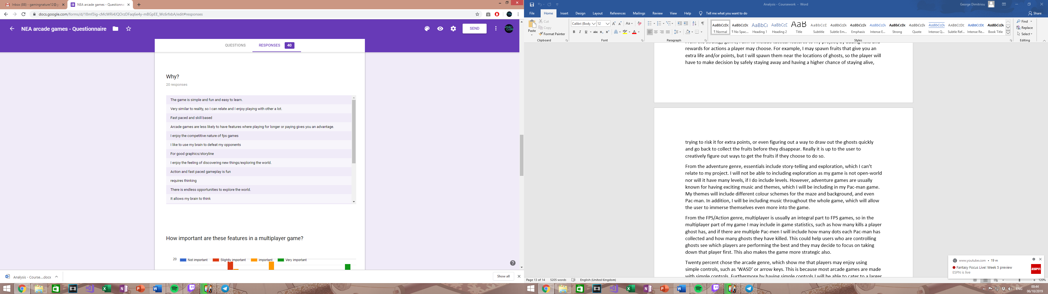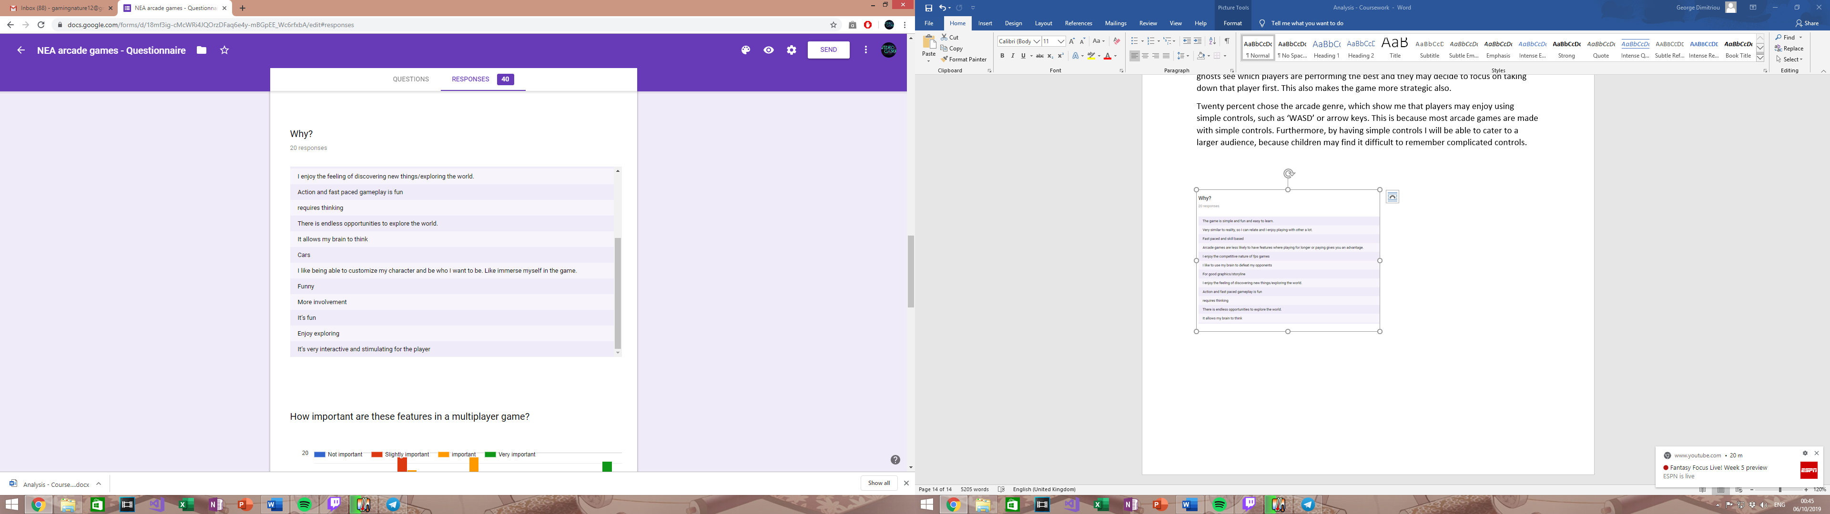

A response I received stated, ‘The game is simple and fun and easy to learn’. From this I will strive to create my games with simple controls and possibly give the user a choice between using arrow or ‘WASD’ keys.

A couple responses that users sent were, ‘fast paced and skill based’, and ‘action and fast paced gameplay is fun’. From these responses, I aim to add an element of fast gameplay to my project. In my first game mode, which is meant for Singleplayer, I will add a feature, where as time goes on and score increases, Pacman and the ghosts will increase in speed, requiring faster reactions and quicker thinking from the user. Furthermore, many responses from my users also said, ‘I like to use my brain to defeat opponents’, ‘requires thinking’ and ‘it allows my brain to think’. I believe by adding a fast gameplay feature as previously mentioned, already adds a challenging feature. In addition, the power-ups I will be adding will need to user to think how they will approach the game. The power-ups range from Pac-man being able to go invisible, to shooting lasers that kill ghosts, to even items that will give the player a disadvantage, such as slowness.

Many users seemed to enjoy game genres, where the main focus was role-play or adventure. The only feature that I will be adding that may relate to an adventure style game, is a progression system. However, anything else from those responses I can’t relate to the type of project(game) I am creating.

A response I got was ‘good graphics/storyline’. My game will not feature a storyline nor 3D graphics but I will aim to create unique animations that engage the play more. This is not a priority of mine, but it is still something I would like to achieve. Also, I believe 3D graphics in a Pac-Man game will lose its authenticity.

One user responded, ‘I like being able to customize my character and be who I want to be. Like immerse myself in the game’. Features in my game that will allow to customize Pac-man will be integrated into my progression system. For example, when a player reaches 100,00 points achieved all-time or a certain level (if I have a levelling system), they may unlock a new Pac-man colour or even a new animation. In additions, players may even receive an option to upgrade power-ups.

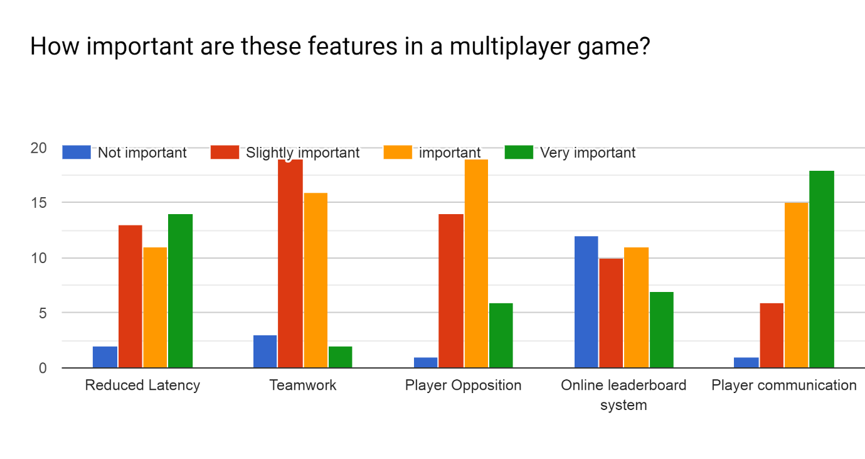

In the first section ‘Reduced Latency’, the responses were very spread out. However, almost all users saw it as somewhat important, which means when creating my multiplayer section, if and where I manage to create an online multiplayer rather than just local, I need to focus on reduced latency between clients. To reduce latency, I will have to make the client to most of the work rather than the server. In addition, I need to reduce the server sharing very big chunks of information often to all clients, as this can cause high cases of latency, which can create a bad user experience. This will be high on my priority list once if I enter the stage of creating an online multiplayer mode for my project, as all users found it somewhat important.

From this information, more users preferred having player opposition, than working with other players towards a specific goal, therefore I will be creating game modes that focus on player vs player rather than teamwork, due to majority of users prefer so. The second game mode where users have to avoid lava tiles, is focused on player vs player, and will have features that support it. These features will include the various powerups and a score counter to see who has collected the most pellets/dots which will make the game more intense and competitive. Players having to avoid lava tiles will also make it more intense. A power-up inspired by Pac-Man Battle Royale, will allow Pac-man to increase in size and eat the other Pac-men that are in the game. Moreover, a possible third game mode will actually include a mix of both teamwork and player opposition. This is so my game can accommodate to all users, so I must take into account those that prefer a multiplayer teamwork mode.

The online leader board system had a majority of users seeing it as not important. This means that I will not be placing it as a high priority, but I would love to implement it at some point, so users can see how they are doing against friends and others around the world, which I believe will add longevity to the game, as players will constantly want to climb the leader board. I will be able to have my users more immersed into the game and more likely to play for longer. The online leader board system will be able to be accessed via the menu.

Player communication is something that users found very important in a multiplayer game. As my game will be mainly focusing on player opposition, communication will not be necessary, however when I create my third game mode, I will need to consider some form of communication as the game mode will consist of players working together. A form of communication that I believe will effective yet not too difficult, is a ping system. This is where users can ping their teammates at a point in the maze, and the ping will appear in the maze, depending on where the user pointed at.

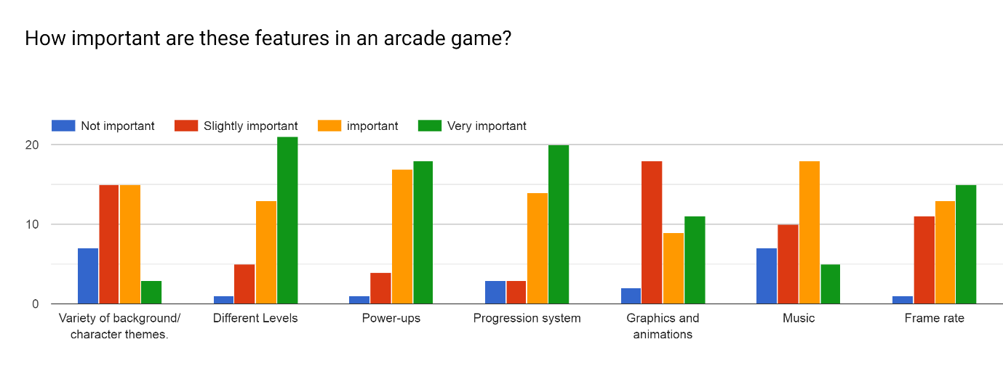

* Variety of background/character themes:
  + Majority of user found that having a variety of background and character themes was either important or slightly important, however, many found it not important. I will aim to add this into my progression system and allow players to unlock different backgrounds and themes, however it will not be a key component to my game.
  + I will hope to add a variety of colour schemes to Pac-man, as well as different styles of tiles to backgrounds, giving my game creative and new looks. Themes may include, lava(fire) themes, galaxy themes etc.
* Different Levels:
  + Most users thought that different levels are very important to an arcade game, so I have decided to make it an integral part of my project. The levels will each include different power-ups and also the pace of the game will change as gameplay will get faster through levels. In addition, my game may include a few mazes which may change throughout the levels, so players have to adjust accordingly.
  + Levels will definitely be included in the single-player part of my game. I will give the player the option to either play an endless Pac-Man game or a Pac-Man game with levels, on single-player.
  + Levels in multiplayer are not a part of my project plans, but if free time is available after I have finished my project, I will definitely take it into consideration.
* Power-ups:
  + Once again, the majority of users found it very important to have power-ups in an arcade game, which was already going to be a main focus for my project, as power ups will be included especially in the first game mode, and I will aim to include it in the second gamemode too. I aim to include somewhere between 3 to 5 power-ups.
* Progression System:
  + This is another response, where users also seemed to think it was very important to have a progression system in an arcade game. This is also an integral part of my game, as I want players to feel immersed into my game. In addition, I want my game to experience longevity, as players will continuously come back to try unlock new things and ‘progress’ through the game.
  + By having a progression system, my game will become more competitive as users will naturally want to try progress further than others (including friends).
  + Players will be able to unlock power-up upgrades and even different background/character themes for single-player.
  + A levelling system will also possibly be put in place so players have an extra go to try and reach (levelling up). This will also allow players to see each other’s experience when in a lobby.
* Graphics and Animations:
  + Most users only seemed to think graphics were slightly important for an arcade game. This could be because arcade games are not usually known for having good graphics as that is not the reason people mainly enjoy them. In addition, most arcade games also have basic animations, however some fairly new arcade games provide very unique graphics that engage the user more. For example, super smash bros and even street fighter. New Pac-Man games, especially ‘Pac-Man Championship Edition 2’ is very well-known for having amazing 3D graphics and animations, but it has received many complaints for losing Pac-Mans authenticity. This a reason to why I do not want to create 3D graphics. Another is because it is very time consuming and my main focus is making sure all aspects of the main game are functioning correctly before I introduce better graphics and animations.
  + I aim to have a tile-based graphics games. The tiles may even include depth which will make the gameplay look more impressive.
* Music:
  + Users categorized music as an important feature to add to an arcade game. I aim to add music throughout the game, from the main menu to when the user is actually in-game.
  + The music will be inspired by the original Pac-Man game, and will most likely feature the same or similar music.
* Frame-rate/FPS:
  + Majority of users categorized this feature as very important. I believe this to be very important, as I do not want users to have a bad experience while playing my game.
  + To increase FPS and allow all users with hardware and software limitations play my game, I need to focus on optimising the client side of my code. I do not want my game to contain unnecessary chunks of code that are not needed. In addition, by keeping my graphics 2D and tile based, I am not putting pressure on the user’s hardware, to keep their frame-rate as high as possible.
  + This should not be a problem to maintain high FPS for the user because arcade games are not very hardware dependent and do not require expensive machines.

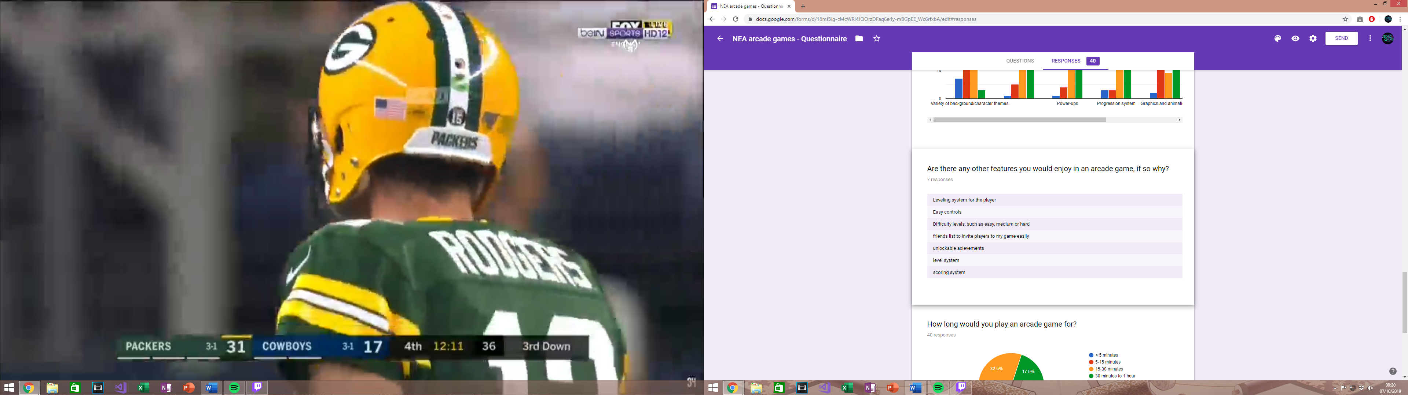

* Multiple users stated that they wanted a levelling system. Since many players have wanted this feature, I am very much considering to add a levelling system. This levelling feature, will be a part of my progression system. As players level up, they may unlock various things which I have discussed above.
* A scoring system I have already considered, and will be applying it to my project, because an essential part of Pac-Man and my project is a scoring system. With a scoring system, players will be able to see how good or bad they are doing, with the addition of seeing how good or bad other users are doing (in the multiplayer section).
* Easy controls, is something I have already implemented into my prototype from my previous analysis, as I want to cater to a large audience, so children may find it difficult to play with complicated controls. Therefore, simple controls were the best solution.
* Difficulty levels, is also something I have considered as I want to cater to players with different abilities to play arcade games. Some players also prefer challenge, and some prefer to play the game chilled and easy. My difficulty levels will involve how fast paced the game is by using an inverse-logarithmic cost function, making ‘hard’ the fastest paced the game can get. It will also feature how often power-ups spawn, and how also how often bad items spawn.
* A user responded by saying that another feature they would like is a friends list so they can easily invite friends to a game. Players join multiplayer games, by browsing lobbies that players have hosted and joining the available ones. However, to make things easier I might add an invite option, where the host will have to type in the name of the user to invite them rather than a friends list. Once they invite the player, it will check for the name in the database and locate the user, the user will then be notified to join the hosts lobby and can decide if they want to or not. This will be an extra feature.

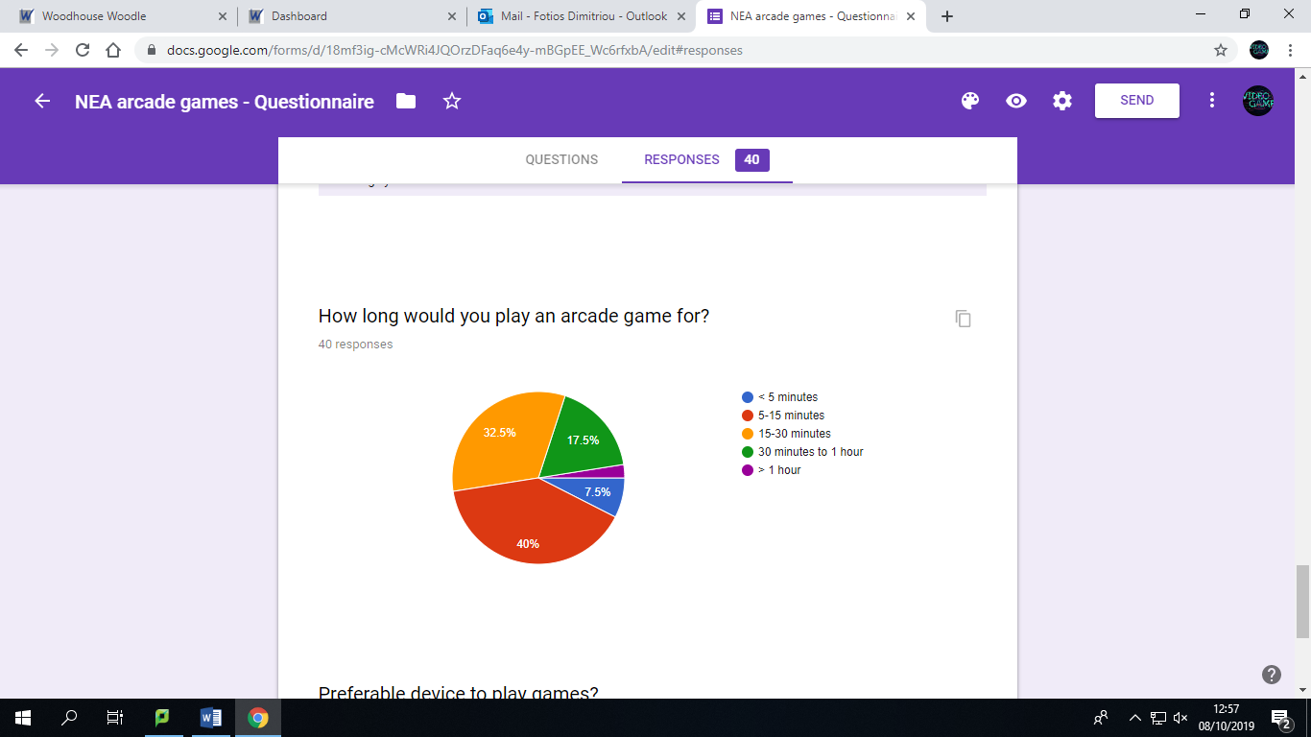

Majority of users would play an arcade between 5 to 15 minutes or 15 to 30 minutes. This shows that my gameplay should not be too long or too short. Having a difficulty level which adjusts how fast-paced the game is allows me to provide all users the opportunity to play the game for however long they want (playing on easy of course will allow you to play for a much longer time than hard difficulty).

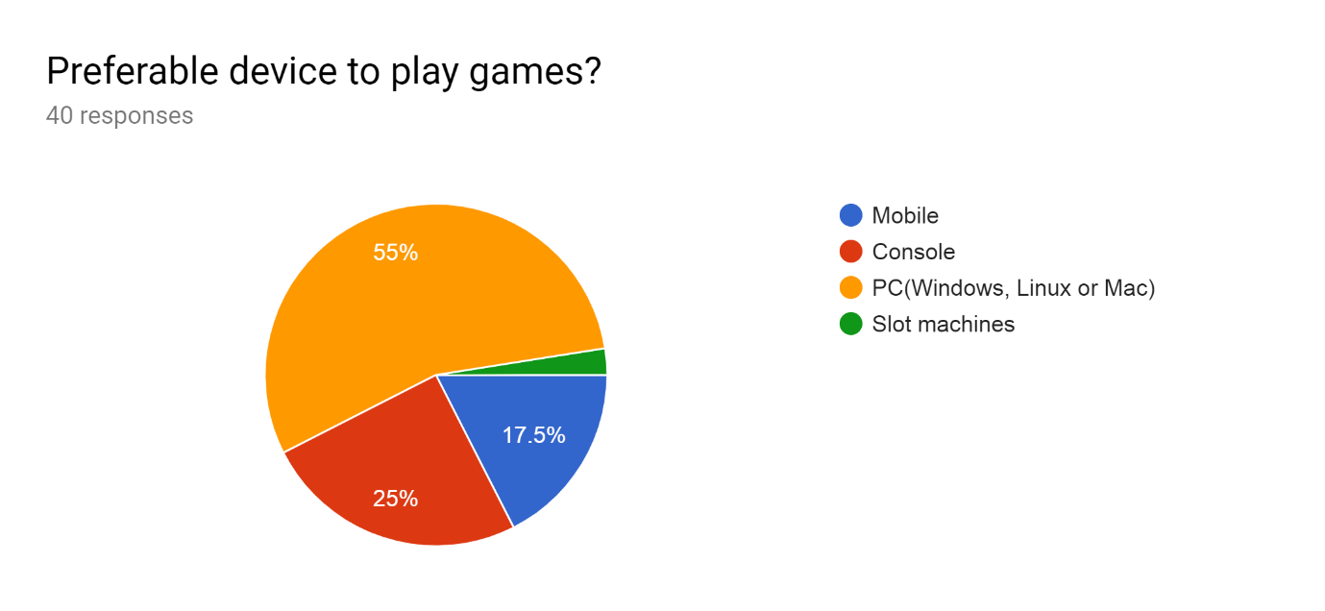

Majority of users prefer to play games on PC, so I will focus on making my game playable on PC first, which is what I intended to do. I also considered mobile devices, but not many of my users preferred to play games on mobile, so by porting my game to mobile, it would most likely be a waste of time, which could be better spent on improving other aspects of my game.

## Prototype

Over a 4 to 6 week span, I created a prototype of my game, to get an understanding of what may work, or what may need changing. The features I mainly added were, Pac-man’s basic movement using arrow keys, random enemy movement (but I have explored various algorithms that I will implement), a scoring system which gets updated when Pac-man eats the dots and collision detection for both the enemies and Pac-man. Video that explains my prototype <https://www.youtube.com/watch?v=1LXjLjGR8UE&feature=youtu.be>. GitHub for my project (only includes prototype at the moment). <https://github.com/FotiosGeorge/Pacman>

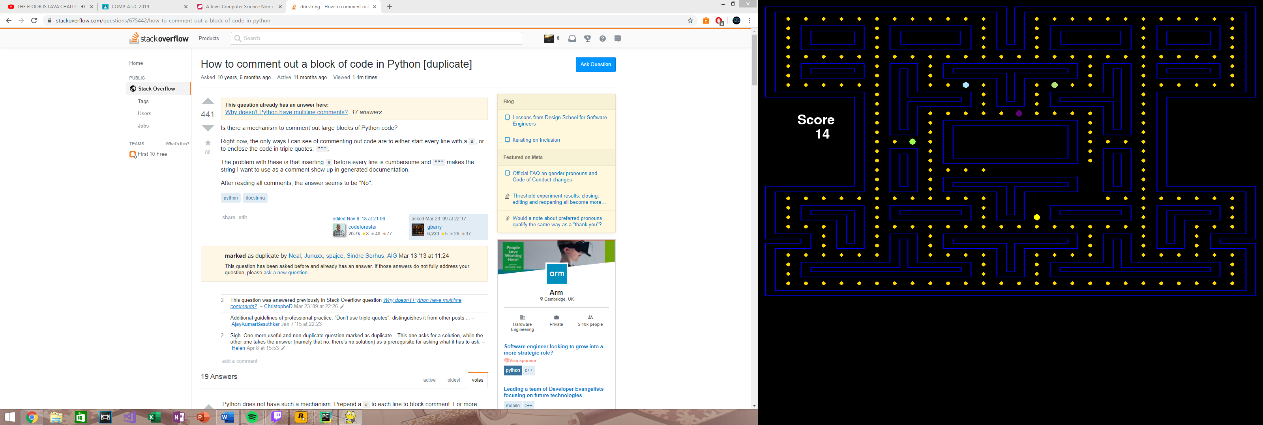

Screenshot of prototype.

Furthermore, I looked into various additional things, that I will be most likely implementing in the next step. By creating a Pac-man maze based off an image png and a grid array, I was able to understand that a better, more optimal way than what I have done so far, is by tile rendering. Tile rendering will allow me to create various levels much easier. Due to my research I also found out that a lot of arcade games are made using tiles.

I have researched the personalities of the four ghosts, “inky”, “blinky” “pinky”, “clyde”. They all have three modes in common: Chase, Scatter, or Frightened. Moreover, each ghost decides on their next move at every intersection, and each ghost has a personality which makes them slightly different to the other ghosts (therefore each one has a different algorithm). One of the ghosts will find the quickest route to Pac-man, meanwhile the other ghost tries to go to the nearest intersection where Pac-man is to try ambush him. The third ghost will move around the centre of the Maze, waiting for Pac-man to cross to the other side of the maze. Once Pac-man crosses to the other side, the ghost will gain extra speed every time, and if Pac-man is within a four-tile radius, the ghost will lock onto him. The fourth ghost will be a random ghost which only locks onto Pac-man when Pac-man has one life left.

* A new skill which I have learnt developing this prototype is how to use classes in python. I will now explain how the classes of my prototype works so far.
  + Class Board:
    - A function called “load” is called first which renders everything onto the screen. Then function “cells” is called which assigns the pixel position of the free cells, walls and dots to three different lists, so I can compare each one to the position of ghost and Pac-man.
    - A player object, and four ghost objects are created
    - A main loop is then called, which has three functions, “event”, “draw” and “update”. An event occurs, such as a user moving Pac-man, then using the other classes, Pac-man gets redrawn and so do the dots and the ghosts. This is done via the draw function, then are updated per frame via the update function.
    - This has made me realise, that as my project progresses, I will need states, otherwise all my event, draw and update functions will get kluged.
      * To solve this, I will need to create states. For example, when the game starts, the user will enter a menu, so the state has to equal ‘menu’, and when the user selects single player, the state would change to ‘playing’, and when the user selects multi player, the state would change to ‘multi_playing’.
  + Class Player:
    - Includes position attribute.
    - Changes position of Pac-man and draws him in the new position
    - Removes dots from screen if Pac-man is in the same location
    - Manages scoring system using the scoring function, and displays it to a screen.
  + Class Enemy:
    - It includes the attributes, colour, direction, and the x and y value.
    - Changes direction and moves the ghosts’ pixels using the functions “changeLocation” and “moves”.

These are what my classes should look like when I have finished. I have mapped out class diagrams for the single-player and local multiplayer aspect of my game to give me guidance of how I will be laying out my code. It will also give me an idea on how my classes will be interacting. The relationship between my classes such as association, and inheritance.

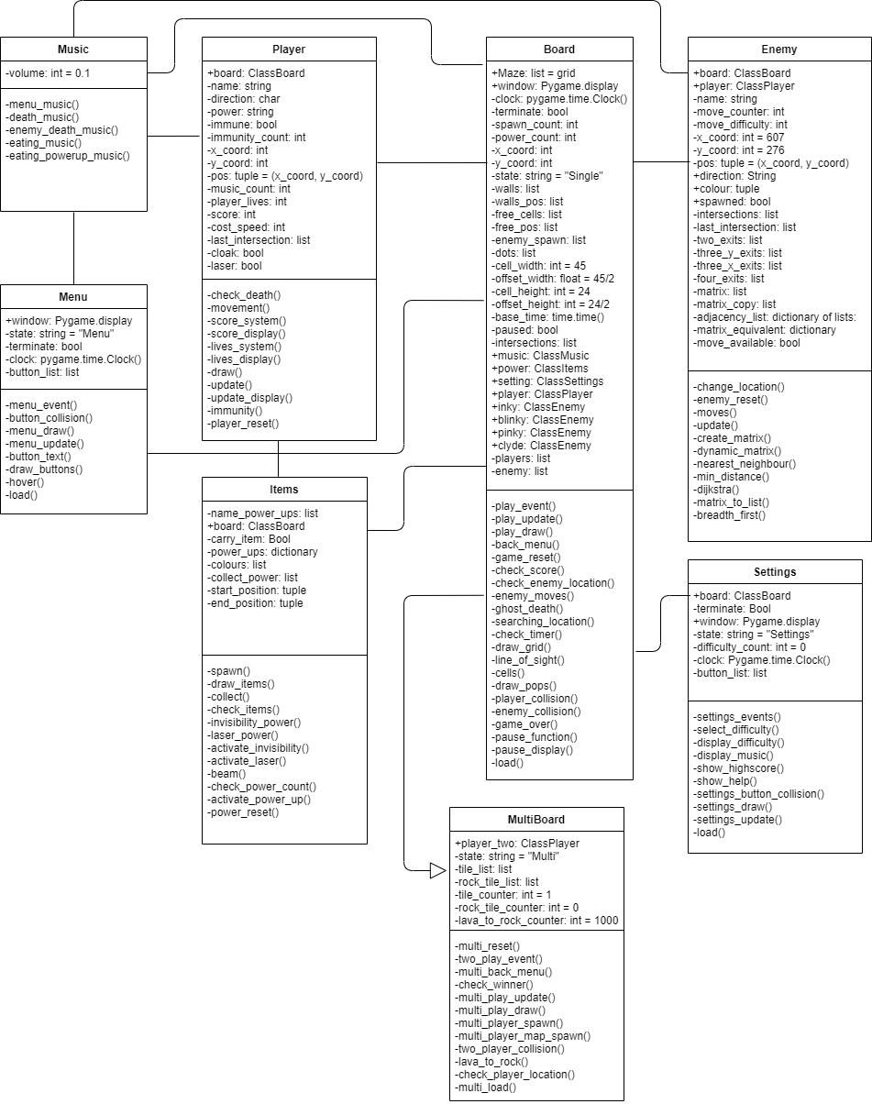

I will be explaining the new classes I will be creating, which are shown in the class diagram above, but not yet implemented (they are not in my current prototype). All current methods and attributes are explained and shown in the YouTube video above.

* Items:
  + This class will be used for the power ups in my game.
  + The Class Items, contains various functions. These functions are used to spawn in the power ups onto the board/maze.
  + This class also contains each power up’s functionality. For example, it contains how the beam of the laser power up kills enemies. In addition, the class contains the functionality of checking if the player has collected the power up, by being in the same location as it on the board.
* Music
  + This class contains all the music for ever aspect of the game. There is main menu and settings music, music for when Pacman eats a dot and music for when either Pacman or a ghost dies. Furthermore, there is music played whenever a power up is collected, when the function eating_powerup_music() is called.
* Menu:
  + This class is used whenever the game is in state “Menu”.
  + This class contains all the buttons that when pressed change the game state, depending on the button. The functions draw the buttons to the screen alongside handling the events when the button(s) are clicked.
  + Also, should include the animation for hovering over a button.
* Settings:
  + In this class, the many functions (methods) will draw different settings options and handle each setting option event differently.
  + The settings options will include:
    - Changing the difficulty
    - Adjusting the music/volume
    - Observing the players current high score.
    - Observing the help section in the settings.
    - Possibly, being able to adjust the players Pacman skin/colour.
* MultiBoard:
  + This class stores the state “Multi”, when the game loop for the second game mode runs.
  + This class is used for the local multiplayer aspect of my game. It inherits all the attributes and methods from the class Board.
  + This class stores all the tiles (lava tiles, water tiles, rock tiles etc…) functionality. This includes, what events occur when the player interacts with these tiles, and when these tiles will spawn and how often they will spawn.
  + In addition, a new object, Player_Two, is created to store everything the second player does.

**What each of the functions and attributes exactly do in detail in every class are all explained in the technical solution as part of the large amount of comments in my code.**

## AI Algorithms

Adjacency Matrix Vs Adjacency List:

Adjacency Matrices and Adjacency lists are used to represents graphs. All searching algorithms I will be analysing for my AI involve traversing through a graph or tree.

An adjacency list is better used for a sparse graph and an adjacency matrix is better used for a dense graph. If a graph is sparse and I use an adjacency matrix, many matrix cells will remain unused and it will lead to a waste of memory.

An adjacency list is an array/list of nodes, and each node points to only the neighbouring nodes. The space complexity of an adjacency list is O(2n) -> O(n). However, time complexity is O(n).

An adjacency matrix is a “n * n” matrix to store weights of vertices between nodes. The space complexity of an adjacency matrix is O(). However, time complexity is O(1).

I will be using an adjacency matrix as my graph will be dense. The nodes in my graph will represent the intersections on the Pac-Man maze and the weights of the vertices will be distances between adjacent nodes. Furthermore, I am not worried about space complexity as my game will take up minimal space no matter what I choose, but I do care about time complexity as I want my game to run at peak performance, therefore choosing an adjacency matrix would be a better option.

I will also be using a **dynamic matrix algorithm** which adjusts the matrix (representation of the algorithms) depending on the position of other ghosts and Pacman.

* **Dijkstra:**
  + Finds the shortest paths between nodes in a graph.
  + Dijkstra traverses every single node in the graph and try finds the shortest path from source to destination. In Pac-Man, this algorithm will be used so the ghost(s) find the shortest/quickest path to Pacman.
  + Dijkstra initially sets every weight (distance) to other nodes as infinity (in the adjacency matrix). This is to imply that the nodes have no been visited. Weights are constantly being updated as adjacent nodes are being visited. Once destination node is found, the algorithm will trace backwards to store the order of nodes of the shortest path, from source to destination.
* **A* Search:**
  + It is in an informed variation of Dijkstra
  + It is considered a “best first search” because it greedily chooses which vertex to explore next according to the value of f(v) [f(v) = h(v) + g(v)] – where h is the heuristic approach/function and g is the cost function.
  + A* search achieves better performances by using heuristics to guide its search.
  + A heuristic approach is problem specific. For Pac-Man, my heuristic approach would be if another ghost is following close behind Pacman using the shortest path, the ghost that uses A* search should not follow the same path behind the other ghost. Instead the ghost that uses A* search should re-route using another open path to possibly try trap Pacman, otherwise that ghost would possibly be useless.
  + The time complexity is O. This is worse than the time complexity for Dijkstra, however the heuristic approach eliminates traversing many nodes.
* **Breath-First Search:**
  + BFS searches through a graph to find the destination node by exploring all of the neighbour nodes at the present depth before moving on to the nodes at the next depth level.
  + BFS uses a queue (First In First Out) instead of a stack to do the searching.
* **Depth-First Search:**
  + DFS searches through a graph to the find the destination node by exploring as far as possible down one branch, before back-tracking and exploring the next branch
  + DFS uses a stack for searching (First In Last Out).

For the multiplayer part of my game, I will be using “Twisted” (which is a framework and library) <https://github.com/twisted/twisted> . This is an event-driven networking engine written in Python. If I do not use “Twisted”, I will just be using pythons basic networking modules. I have not developed a prototype for the multiplayer part of my game, but I have drawn out a data flow diagram to get an idea of where the multiplayer section is heading.

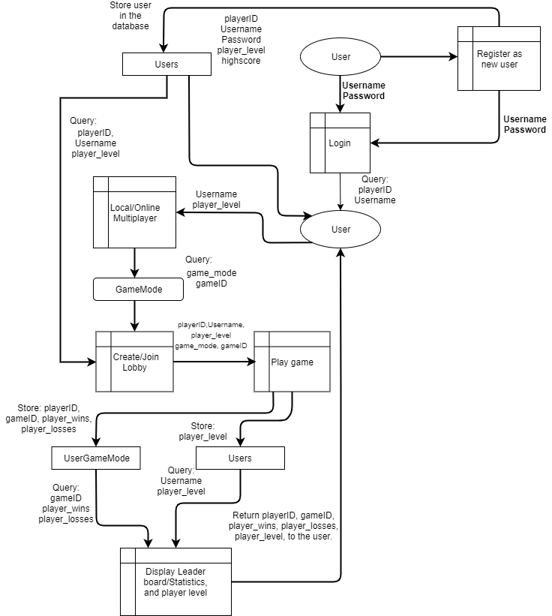

* My database contains three tables:
  + Users:
    - Contains the players’ level, the playerID, username and password
    - It also contains the high score for single player.
  + GameMode:
    - Contains the different game modes and the gameID
  + UserGameMode:
    - Contains the players wins and losses per game mode and the gameID and playerID

This is the EDR:

UserGameMode

Users

GameMode

|  |
| --- |
| Users |
| playerID: int, Primary Key  Username: String  Password: String  player_level: float  highscore: int |

|  |
| --- |
| UserGameMode |
| playerID: int, Primary Key, Foreign Key  gameID: int, Primary Key, Foreign Key  player_wins: int  player_losses: int |

|  |
| --- |
| GameMode |
| gameID: int, Primary Key  gamemode: String |

My database represents a many-many relationship. Therefore, I normalized my database and create a table in the middle that holds the primary key of both the Users and the GameMode, making it a composite key.

I will be running my database via MySQL database which will be running on a server that will hold all the user’s information in tables. The different entity attributes are still subject to change, but my data flow diagram has given me a rough idea of what attributes I need and when I need to store and query.

Having a GameMode table and the database in a normalized form, allows me to add in extra game modes without interrupting how the database works.

* User:
  + Contains the information of the user, such as username and player level.
* Creating/joining Lobby:
  + A player creates a room by selecting the game mode. This player is now the host and decides when to start the game and the host may decide to invite specific players. If the host does this, the database will look for a username that the host typed in to invite.
* Display leader board/statistics and player level:
  + At the end of every game the winner will be displayed on the screen, alongside the players level and the number of wins and losses they have on this game mode.

## Hardware Constraints

* I want my game to be played smoothly by as many users as possible, so I will need to aim for low PC specifications.
  + CPU:
    - Low clock speed, around 1.6 GHz
    - Dual core processor
  + Graphics Card:
    - Integrated graphics card, managed by the CPU, for example Intel HD Graphics.
  + RAM:
    - I aim to make my game only require 200MB
    - PC’s with 4GB should therefore manage is, as some RAM would also be needed for the operating system, and system software.

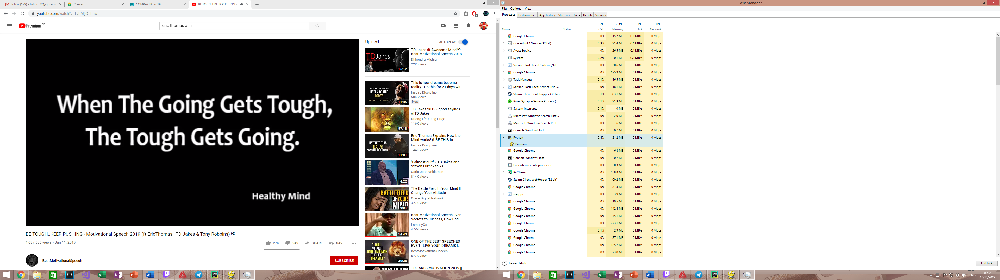

My prototype only uses 31.2MB of RAM here.

## Software Constraints

As I am only creating my project for PC, I need to make sure I satisfy all users who may have different operating systems. I will be focusing on making my game available for Windows, MacOS and Linux. This will not create complexity when programming, however I will need to compile it each time for every operating system. To do so I will need access to multiple devices with the various operating systems.

Furthermore, to test that each game is working on the different operating systems, I will ask friends and family to test the single player and the multiplayer, to see if users with different operating systems can still play with each other. In addition, I will be creating YouTube videos to show myself testing the game on each device.

* PC minimum specifications:
  + Windows:
    - Windows 7 +
  + MacOS:
    - OSX 10.6 +
  + Linux:
    - Ubuntu

## Limitations

This section, I will be pointing out the features that are not essential or will not be possible.

Firstly, my project will be created using 2D graphics as pygame does not support 3D graphics. This means my animations will be in 2D as well, however if I create my game using tiles and tile rendering, I will be able to add depth in my tiles, but this will only be for visual effects. My game is therefore limited to 2D graphics as pygame does not support otherwise.

Secondly, due to time restrictions my project may only feature a local multilayer mode, but if it contains an online multiplayer mode it will have some limitations. For the online multiplayer mode, having more than four players would cause lag as the server would have to update too many clients and more players’ states at once. For a game developing company this would not be an issue, but for me, I do not obtain a larger server to support many players. I will therefore have to put a restriction on every lobby to four players. For local multiplayer, I would most likely not have this limitation.

Thirdly, a main feature of my first game mode, is that the speed of the game increases as the players score increases (every multiple of 100 the speed of the game increases using a cost function). If the online multiplayer game goes on for a long period of time, clients may experience some latency as the server will be trying to updating the clients much faster. This may cause difficulty for the user to play, but I will not be able to avoid this. If I make the second game mode local multiplayer instead of online latency will not be issue.

Lastly, creating more complex algorithms for the ghosts in my Pac-man game will be of high priority and will be my main focus for my project. If I have time, I will make my second game mode online rather than just local multiplayer. This is mainly because I am already learning many new things for this project, so by adding networking not enough time would be available.

## Data Volume

I will be using a MySQL database running on a server to store data long-term. The tables will hold a record of all the matches, which will specify the what game mode it was using an ID (gameID), the users ID (userID), and if they won or not (player_wins/player_losses). If the user has chosen to play single-player it will update the users high-score in the database rather than players wins or players losses, as those are only for multiplayer. The high-score will be 2 bytes. So, if the user plays multiplayer (LAN) or single-player, one entry will be the same amount (specified below).

* Users table:
  + Username = 12 bytes
  + player_level = 1 byte
* UserGameMode:
  + playerID = 4 bytes
  + gameID = 1 byte
  + players_wins = 1 byte
  + players_losses = 1 byte

In total, 20 bytes are store in the database per game (for one player). If 1,000 games were played, that is 20,000 bytes (0.020 MB) stored per player. I also expect my game to need a maximum of 100 MB to 200 MB of RAM to run. I am therefore not concerned about data storage requirements.

## General/Specific Objectives

* General Objectives:
  + Create a menu with a single player, local multiplayer, leader board and settings options.
    - When a player clicks on one of the buttons, the games state will change from ‘menu’ to ‘playing’
  + Create two game modes:
    - First game mode will be similar to the original Pac-man. The algorithms for the ghost AI will be created by me, and I will then compare them in many ways to the original Pac-man algorithms. I will be comparing how complicated they are, how smart the AI is and if my game becomes easier or more difficult with the AI I used. If this gamemode is play in local multiplayer there can be two Pac-men.
    - The second game mode will be a player vs player game mode. It will be an only local multiplayer game mode, where the player who wins has to survive the longest (the other player loses all three lives) or get to a specific score (500 points). Lava tiles will spawn temporarily to kill the players, and then eventually the lava tiles will turn into rock tiles. Players can only move over a rock tile, not lava tile.
    - Single-player will contain only the first game mode, meanwhile local multiplayer will contain the second game mode.
  + Progression System:
    - I will be creating a levelling system, where players will be able to progress through the game and unlock new things. For example, power up upgrades or new character colours.
    - Online leader board which shows high scores.
    - Users will be able to obtain high scores only through Singleplayer (so the first game mode).
  + Power-ups:
    - I will be creating between 3 to 5 power-ups.
    - These will include ones that affect the player badly or in a good way. For example, some may allow ghosts to travel through walls and some will allow Pac-man to teleport around the map or add immunity from other players.
    - An interesting power-up will be included in the multi-player part of the game that allows you to switch position with another random Pac-man user in the game.
  + Controls:
    - The game is played with the arrow keys.
    - I may give the player an option to use ‘WASD’ instead
  + Difficulty:
    - If a user clicks on single-player they will then be asked to choose a difficulty, which will not only decrease Pac-man’s lives from 3 all the way to 1, but the harder the difficulty the faster the pace of the game gets.
    - I will develop a cost function to increase the pace for Pac-man and the ghosts as time goes on. Cost function will change depending on difficulty. The cost function will be an inverse
* Specific Objectives:
  + Gameplay:
    - Assign each tile type a value, such as ‘1’, ‘0’ and ‘2’. ‘1’ being the walls, ‘0’ being the free cells and ‘2’ being the enemy spawn point.
    - Creating Pac-man and allowing him to move UP, DOWN, LEFT OR RIGHT.
    - Create a collision detection function so Pac-man can only interact with the free spaces and the enemy ghosts can only interact with free spaces once they exit out of the spawn points.
    - If both the ghosts and player are in the same location depending on what state the ghost is, the player will eat the ghost or be eaten.
    - A scoring system will also be put in place, every game each player will have their individual score being displayed on the screen.
    - Creating an algorithm/search method for each individual ghost. This will be complex as the main focus is creating the searching/pathfinding algorithms, and then the secondary focus is the local network game mode. These complex algorithms will be Dijkstra, Breadth-First Search, and my own algorithms, being, line of sight algorithm and dynamic adjacency matrix algorithm. The dynamic adjacency matrix algorithm adds complexity to my game and stops ghosts from directly following each other and taking other directions to try trap Pacman.
    - Music and animations will also occur throughout the game.
  + (LAN) Network System:
    - If the user is new, they will create a username and password which will get stored in the database. They will then be able to login with this username and password. They have to login to play single player also, as their player level carries on to multiplayer.
    - A user may decide to host a game by choosing the second game mode to play. Players will then be able to see this lobby and click on it to join.
    - A possible case may be, where I include both game modes as local multiplayer game modes, not just the second game mode.
    - The game will now start and users will play the game. Once the game is finished the players wins/losses will be updated in the database and the winner will be shown on the screen.
  + Settings:
    - Most importantly, users will be able to change the game difficulty (‘easy’, ‘medium’, or ‘hard’) in the settings.
    - Ability for users to change their Pac-man colour. Users will be able to unlock colours by levelling up.
    - Users will be able to increase/decrease the sound level (volume). Music will be played throughout the game.
    - Users will be able to unlock power upgrades for single player (possibly multiplayer).
    - Users will be able to seek help on how to the game works in the settings.
    - Users will be bale to view their Singleplayer high score also.
* Extras (if I have extra time):
  + If I have extra time, the first thing I will be considering and the most important feature I will be considering, is making my game online multiplayer not just local. The only guaranteed feature that is online is the leader board.
  + Allow the user to change controls to “WASD”.
  + Create particle affects when Pac-man eats dots.
  + I will aim to provide a third game mode where there are two teams, each consisting of a Pac-man and a ghost. The aim would be for the Pac-men to avoid the other teams’ ghost, and for the ghosts to try consume the other teams Pac-man.
  + Allow the user to invite people by username.
  + Different levels, which will mean different maps will have to be created. This would include map generation using a map/level generation algorithm. This is of low priority but it will be considered.
  + Allow a difficulty level to be chosen in multiplayer by the host.

## Proposed Solution

As I will be programming in python 3.7, I will be using the Anaconda Navigator(<https://docs.anaconda.com/anaconda/navigator/>). The Anaconda Navigator provides a web-based application called Jupyter Notebook. Jupyter Notebook is interactive as it allows me to test code blocks and evaluate them. In addition, it allows me to see the input code, output code and any kind of visualization in the same document. Anaconda Navigator also me to customized my environment easily and add libraries easily.



I chose python because it provides large standard libraries which make writing code a lot simpler and easier for the user (very user friendly). This means less time is needed to code, which allows me to add in as many features as possible into my project within my given time frame. Furthermore, if I only create a local multiplayer mode, I will be using pythons basic networking modules (such as with sockets and threading), but if I decide to add on an online multiplayer mode, python will be able to provide amazing libraries and frameworks for networking, such as “Twisted” or “Asyncio”. Most other programming languages either do not have a network library or their network library is worse than Pythons.

I will be using Pygame (<https://github.com/pygame/>), which is a cross-platform library (allowing it to work on Windows, MacOS and Linux) containing modules designed for creating games. For example, it includes sound libraries which is helpful as I will be adding music throughout my game. The library handles other things for me too, such as keyboard input, game windows, rendering onto screens, drawing objects, and also calculating pixel positions. Moreover, it also allows me to update the game every frame easily. Pygame providing these features allows me to learn how to create more complicated path finding algorithms for the ghosts on the single-player part of my game (and multiplayer if there is not enough players). It also gives me more time to learn about networks locally and worldwide as I have no previous knowledge of programming networks.

If the multiplayer aspect of my game is only local, the user will be hosting the server on a LAN network using their computer. If my game expands to being online, I will be hosting an AWS server, which would cost $70.81 per month for a 15 GB RAM and 2 core CPU server. This may be too expensive so I might have to find another server provider that is cheaper.

# Design

## High level Overview

These flowcharts describe the overview of how my project will work. The flowcharts show the process in how users access different parts of the game and what happens when users click on certain buttons.

**Main Menu**

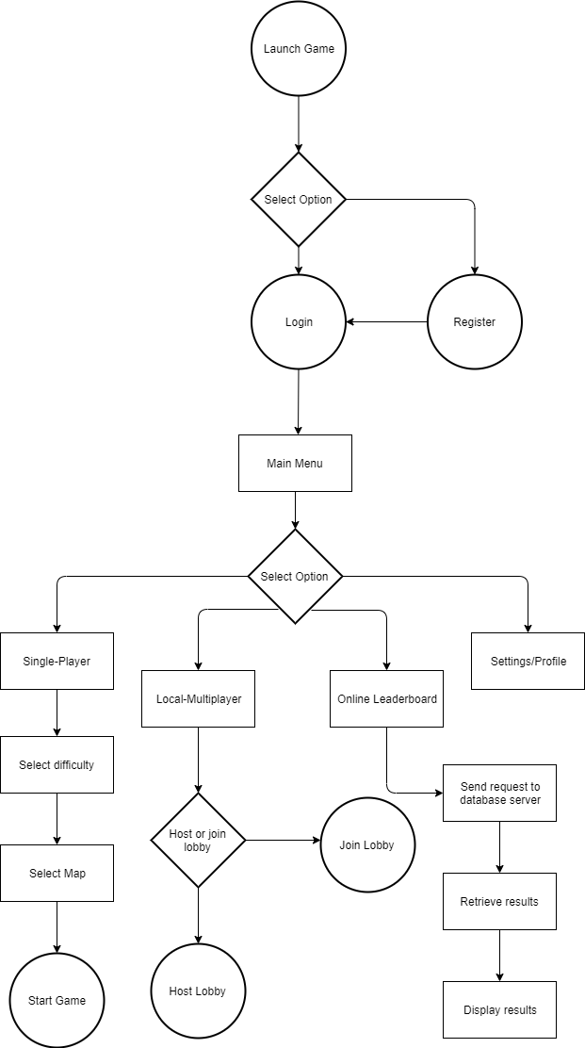

**Register**

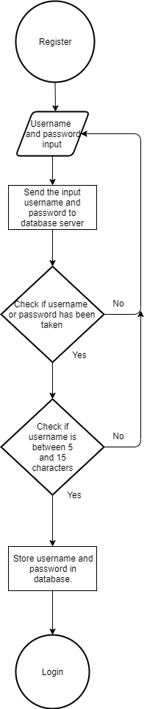

**Login**

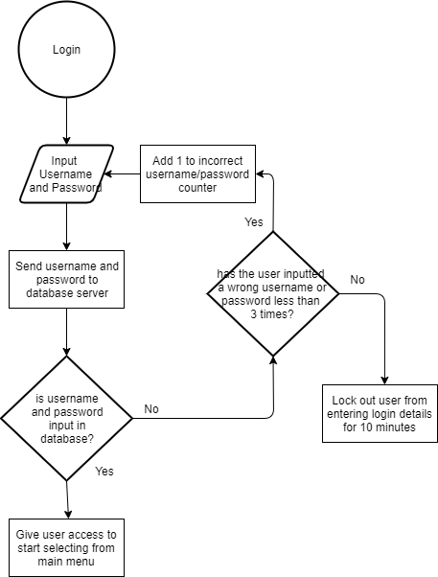

**Join Lobby**

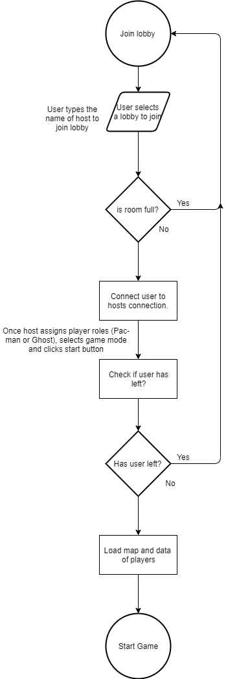

**Host Lobby**

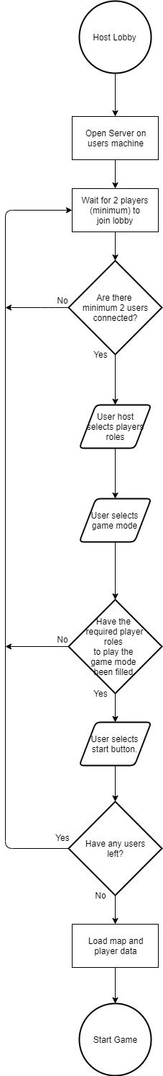

## Description of modular systems

When the game is launched, the user is shown a login/register screen. This is a diagram of the different screens that will be included:

Lobbies

Selected Lobby screen

Settings

Local-Multiplayer

Single-Player

Leaderboard

Register

Main Menu

Username, High scores and game mode displayed.

Login

The leaderboard will only show the local multiplayer high scores for each game mode individually. However, in the settings users will be able to see their single-player high score, and also in game.

When the user launches the game, the attribute “state”, of Class Board is initialised as “loginOrRegister”. Once the user registers then clicks login to enter the main menu, the state changes to “menu”. The user is then able to see, Single-Player, Local-Multiplayer, Leaderboard and Settings options on their screen. Once the user enters a game and it has started, the user state changes to “play”, and once the game ends the user is returned to the main menu and the state changes back to “menu”.

* This is an IPSO table for my project.

|  |  |  |  |
| --- | --- | --- | --- |
| **Inputs** | **Processes** | **Storage** | **Outputs** |
| -player input (keyboard presses and mouse clicks)  -user details, such as username, password | -increasing player level after every game by using calculations.  -collision detection between players and walls. This is done by distinguishing 1’s and 0’s. If the tile represents 0 it is a wall, if it represents 1, it is a free cell.  -calculate players new position in map using pixel position, based on the user’s keyboard input.  -calculate score and decide if it is higher than the current high score.  -calculate if user is in current position to pick up dots or power-ups.  -calculate if a player won or lost. | Database tables:  Users  GameMode  UserGameMode  Local storage:  Preferred Controls  Maps (if I create more than 1 map) | -Sorted list of users, high scores and game mode. (Displayed in Leaderboard section).  -Output game map to the screen.  -Output Pacman and ghost sprites to screen.  -Output power-up sprites to screen. |

## Data Dictionary

I will be storing data long term and retrieving data from a MySQL database when queried. Here are the tables in my database in which I will be storing and retrieving data:

**Users table:**

|  |  |  |  |  |  |
| --- | --- | --- | --- | --- | --- |
| **Field name** | **Field type** | **Field size** | **Purpose** | **Example data** | **Validation** |
| playerID | INT | 5 | Assigning a unique identifier to each player which acts as a Primary Key. Allows me to normalise database | 00001 | Is numeric |
| Username | VARCHAR | 20 | Stores username of each player | FotiosD | Must be between 5 and 15 characters. |
| Password | VARCHAR |  | Stores player’s password | fotios_dimi1 | Must contain an integer and letters. Must have a minimum length of 5 and maximum length of 15 |
| player_level | FLOAT |  | Stores player’s level. |  | Is numeric |
| highscore | INT |  | Stores the player’s highest score on single player. |  | Is numeric |

**GameMode table:**

|  |  |  |  |  |  |
| --- | --- | --- | --- | --- | --- |
| **Field name** | **Field type** | **Field size** | **Purpose** | **Example data** | **Validation** |
| gameID | INT | 3 | Assigns a unique identifier to each game mode created by the project developer (myself). This acts as a Primary Key. | 001 | Is numerical |
| game_mode | VARCHAR | 20 | Stores the name of each game mode created. | Regular pacman | n/a |

**UserGameMode:**

|  |  |  |  |  |  |
| --- | --- | --- | --- | --- | --- |
| **Field name** | **Field type** | **Field size** | **Purpose** | **Example data** | **Validation** |
| playerID | INT | 5 | Stores the ID of a player related to a specific game mode. Foreign Key | 00001 | Is numeric |
| gameID | INT | 3 | Stores the ID of the specific game mode. Foreign Key | 001 | Is numeric |
| player_wins | INT |  | Stores the totals wins of a player in a specific game mode | 10 | Is numeric |
| player_losses | INT |  | Stores the totals losses of a player in a specific game mode | 5 | Is numeric |

The table UserGameMode allows the user to see their totals wins and losses per game mode.

## Data structures

* Variables most often used in my game:
  + pos: tuple list which includes x and y position
  + ghost_players: All players which are ghosts (only for multiplayer).
  + pacman_players: All players which are Pacman.
  + time: This will only be used for the second game mode.
  + Grid: The array that represents my map.
* I will be using a queue for respawning power-ups onto the map. Initially when the game starts various random power-ups will be spawned. In addition, there will be a full queue of power-ups when the game starts. As players pick up the power-ups they are added onto the queue and the first power-up is popped off and spawned onto the map. Therefore, a queue is perfect for designing this. Furthermore, once the power-up is popped off there is a time delay before it spawns.
* Data structures used in Python:
  + SQL
  + Timer
  + Queues
  + Tuple lists
* Data structures in Pygame:
  + Surfarray (Allows efficient per pixel effects)
  + display (Controls display window and screen)
  + draw (Draws simple shapes)
  + mixer (Loads and plays sounds)
  + time (manages time and framerate)
  + image (Loads, saves and transfers surfaces)
  + key (manages the keyboard device and controls inputs)
  + event (Manages the incoming events from input devices and the windowing platform)

## Validation

I will be validating various user inputs to ensure guidelines are met so that the game will not crash or break.

|  |  |  |  |
| --- | --- | --- | --- |
| **Field name** | **Validation checks** | **Description** | **Error message** |
| Username | Min length is 5 characters.  Max length is 15 characters. | Make sure that the username length meets the requirement. | “Username must be a length between 5 and 15 characters” |
| Password | Min length is 5 characters.  Max length is 15 characters.  Must contain numerical and alphabetical characters. | Make sure that the password length meets the requirement.  Make sure that the password contains numerical and alphabetical characters. | “Password must bet within 5 and 15 characters”  “Make sure your password contains numerical and alphabetical characters” |

## Database design

“Users” table stores information on the player, such as Username, Password, player level and high score. This is very useful as it allows me to develop a leaderboard system so players can compete with each other, by uniquely identifying each user. It also allows more than one user to access their profile on the same PC, and it allows users to access their profile on multiple devices.

“GameMode” table stores the information on each game mode. If future game modes are created for my game, they can be easily added to the database. This is also useful for displaying which game mode users got a high score in. It allows me to store each user wins and losses for each individual game mode.

Entity relationship diagram:

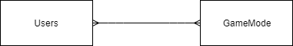

Each user can play many gamemodes, and a gamemode can have (contains) many users/many players can play one game mode.

To normalise this a join table called “UserGameMode” is introduced between the two tables. This table contains a composite key (from two foreign keys), consisting of playerID and gameID.

The new diagram is represented like this:

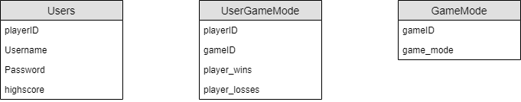

**Normalisation**

**1st Normal Form**

If I did not include the join table (“UserGameMode”), I would have to expand the ”Users” table, so it looks like this: Users (playerID, Username, Password, gamemode1_wins, gamemode1_losses, gamemode2_wins, gamemode2_losses, highscore)

The issue with this, is that some users may not want to play local multiplayer, so there will be a lot of wasted space and memory in the database. In addition, if my game obtains additional game modes, I will have to add more columns to the Users table. To fix this issue, we need to get rid of the repeating attributes gamemode_wins and gamemode_losses. Moreover, querying a specific players wins and losses in a certain game mode will be more difficult.

**2nd/3rd Normal Form**

A table is in second normal form if it is in first normal form and also contains no partial dependencies. A table is in third normal form if it is in second normal form and all of the attributes depend only on the whole primary key and nothing but the whole primary key.

My table meets these requirements as player_wins and player_wins, both depend on nothing but the whole primary key. In addition, there are no partial dependencies because only the join table “UserGameMode” contains a composite primary key and no other table does.

There are many players on 1 board and many enemies on 1 board

## Problem statement

* My game is based around Pac-man. Pac-man is a game where a single user tries to obtain as many pellets/dots around a maze as possible while avoiding the enemy ghosts who try to hunt Pac-man down.
* My implementation can be played via single-player or multi-player (locally)
* My implementation involves implementing, not only my own version of Pacman with different algorithms, but also a game mode where players have to avoid lava tiles (dying) and try obtain a certain amount of points to win. This game mode has not been seen before.
* My project introduces a never before seen game mode in Pac-Man. Local multiplayer contains the second game mode and single-player covers the first game mode.

## Use Case diagrams

**Single-player gameplay**

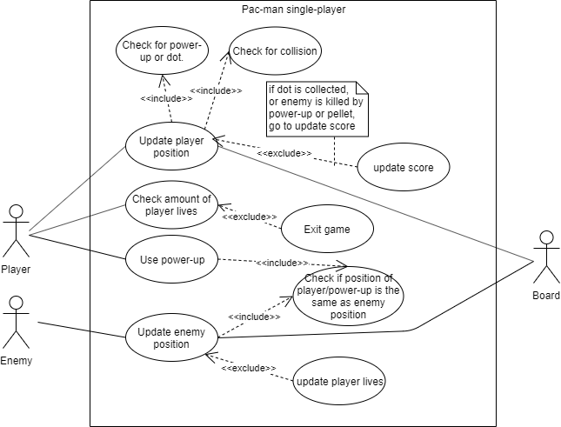

* This diagram shows:
  + Enemy and player movement
  + Runs all checks for player to see if new position is valid and if there are any items or enemies in that new position.
  + Game values update accordingly (e.g. score or player lives)
  + Shows implementation of power-up usage

**Leaderboard**

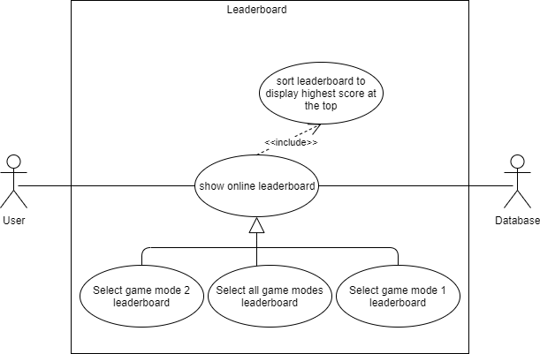

* This diagram shows:
  + User access to online leaderboard
  + Leaderboard options/selection
  + Database query and leaderboard sorting.

## Sequence diagrams

**Player movement**

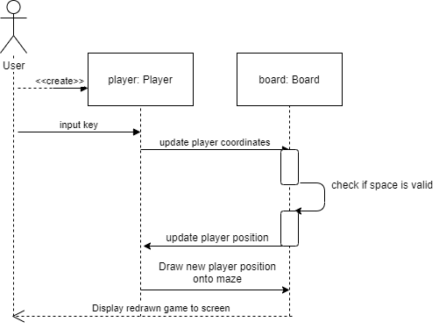

* This diagram shows what happens when a user presses a movement key to move their character. Once the user presses the key, the object
* Player retrieves those coordinates and updates them.
* The object board then checks if that position is valid and the player is allowed to move into that space, if not then the player stays in the same position.
* However, if the new position is valid the board will place the new position as the current position now.
* The object player, then retrieves the position and draws the new player position onto the screen. The board now updates the screen

**Checking items (power-ups or dots) or enemy in same position as player**

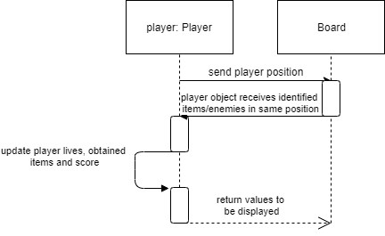

* This diagram shows how my program checks if an item or enemy is in the same location as a player.
* Class Board retrieves player position from the object player.
* It then checks that position for enemies (from an enemy position list) and checks if any power-ups or dots are currently in that location.
* If an enemy is in that position, object player updates the player lives. If a power-up is in that position, the power-up gets added to the players inventory. If a dot is in that position the score gets updates.
* Class Board then retrieves these values and displays to screen.

**Shows how power-up is used**

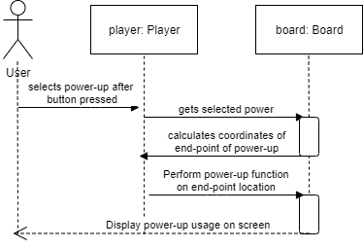

* This diagram shows how my program determines and uses the players obtained power-up
* The user first presses the key to user a power-up.
* The object player then determines what power-up is in the players inventory and passes it on to the object board.
* Object board then calculates at which coordinates (in the map) the power-up will act upon (this can vary between power-ups)
* The object player then performs the function of that power-up on that location. The board then retrieves that location and updates the display onto the screen.

**Gameplay pace (speed gameplay increase)**

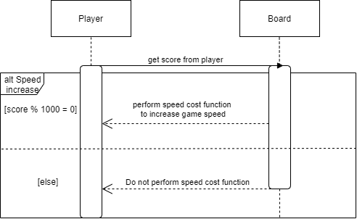

* This diagram shows how the speed of the game increases over time by using a cost function
* The Class Board retrieves the score from the Class Player.
* If the score hits a multiple of 1000, the cost function is performed to increase the speed of all characters in the game. If the score has not hit a multiple of 1000, score function is not performed.

## Class diagrams

**System overview**



## AI algorithms

* Here I will be giving an insight into the algorithms I am using for each of the four enemies. Each enemy will have a calculated distance from their position to the players position. The distance will be calculated using Pythagoras. It will take the x and y distance (in pixels) from the enemy position to the users’ position and find the hypotenuse from those values.
* The four enemies are called, Pinky, Blinky, Inky and Clyde.
* The algorithms I will be implementing include:
  + Dijkstra
  + Breadth-First Search
  + Line of sight/ray casting
  + Dynamic Matrix
  + Enemy Detection
  + Also other small algorithms will be included that are talked about in the Analysis, Design, and Technical Solution.

**Inky Algorithm**

The ghost Inky will use a Dijkstra algorithm to find Pacman (the player). Dijkstra works by finding the optimal shortest-path algorithm by calculating the total weights (distances) between each node. The image below shows where each node would be (the white dots). The nodes are placed at intersections to allow the enemy to change direction at these points. Between the nodes, there are vertices which are weighted based on the distance (using coordinates)

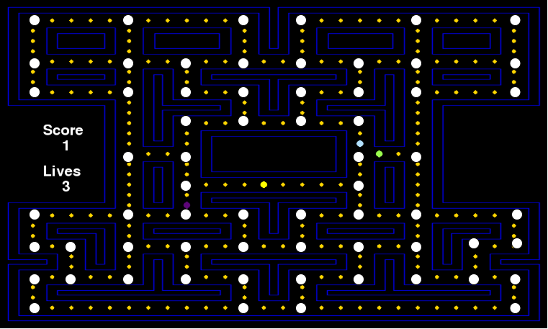

An adjacency matrix is used to store all vertices between two nodes. An adjacency matrix is a list of lists, in which every list initially stores values of infinity before weights are calculated. Each index also has a unique set of coordinates, which are stored as a key-value pair in an intersection dictionary. The dictionary is used to manoeuvre Pinky on the maze once Dijkstra calculates the shortest path.

All the ghosts besides Inky will have their last intersection stored. For all the adjacent intersections to the ghosts last intersection, the vertices’ weights will be changed to a very high number or infinity. By doing this, the ghosts will not follow each other when path finding for Pacman, instead they will try reroute and trap Pacman. Furthermore, it stops the ghost Inky from following other ghosts and Inky will try trap Pacman as he won’t take the same route as the other ghosts. To do this, I need to create a dynamic matrix algorithm.

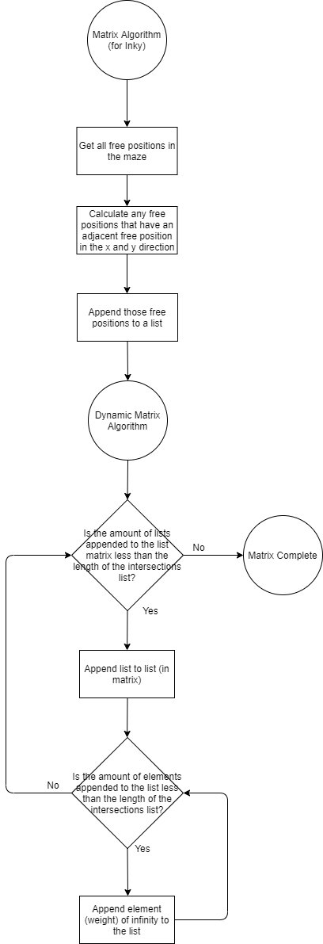

The values on the first row and column (0, 1, 2…)

Here is where the weights of the vertices will be stored. If there is a weight other than infinity there is an adjacent node. If weight is inf (infinity), the two nodes are not adjacent.

|  |  |  |  |
| --- | --- | --- | --- |
|  | 0 | 1 | 2 |
| 0 |  |  |  |
| 1 |  |  |  |
| 2 |  |  |  |

**Dynamic Matrix Algorithm**

This algorithm is used to constantly change the matrix depending on the other ghosts’ positions, besides Inky. The matrix is only change for Inky as Pinky does not use weights when calculating the path to Pacman using Breadth-First Search. It will only work for Dijkstra.

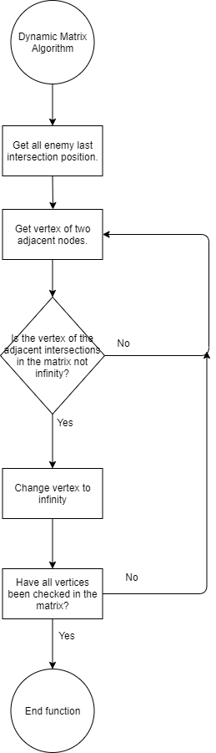

**Pinky Algorithm**

The ghost Pinky will use breadth first search to find Pacman. It will start at the tree root (starting node) and explores all of the neighbour nodes at the present depth before moving on to the nodes at the next depth level. Like the nodes I used for Dijkstra, I will be using the same nodes for Breadth-First search. Those nodes will be the intersections which I displayed previously. I will be representing the tree-graph by converting the adjacency matrix I created for the previous algorithms into an adjacency list. The adjacency list created stores each node and what nodes are adjacent to it; however, the adjacency list does not hold the weights of the vertices, unlike the adjacency matrix. This means that the path is not weighted, so Breadth-First Search won’t necessarily find the shortest path, but instead Pinky will use the first possible path found my Breadth-First Search.

**Blinky Algorithm**

The ghost Blinky will move randomly throughout the whole game until he sees Pacman in his line of sight. Once he sees Pacman, Blinky will move straight towards Pacman (using ray casting/line of sight), until Pacman leaves his line of sight.

**Clyde Algorithm**

The ghost Clyde, will move intersection to intersection without try to search for Pacman (like Blinky). Clyde also acts as a blind ghost, therefore, even if Pacman is in Clyde’s line of sight, Clyde will not spot Pacman.

**Line of Sight Algorithm (Used for Inky, Pinky and Blinky):**

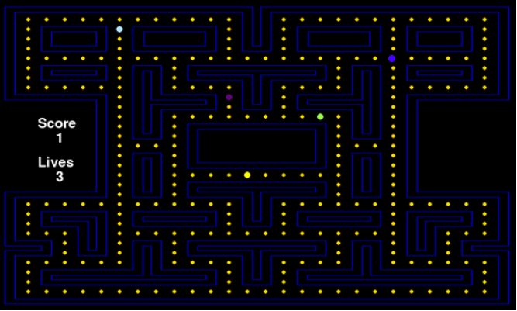

This algorithm is a form of ray casting. The destination for every searching algorithm (Dijkstra and Breadth-First Search) is the last intersection (node) Pacman was located at. If either Inky or Pinky reach this last intersection, they will stop or an error would occur, therefore a line of sight algorithm would be needed. Whenever Inky or Pinky reach the last intersection, they will then move towards Pacman, who will always be in their line of sight if they have reached the last intersection. Blinky on the other hand does not use a searching algorithm, and just uses line of sight. If a user just stumbles into the line of sight of Blinky, Blinky will move straight towards Pacman until Pacman moves away from its line of sight.

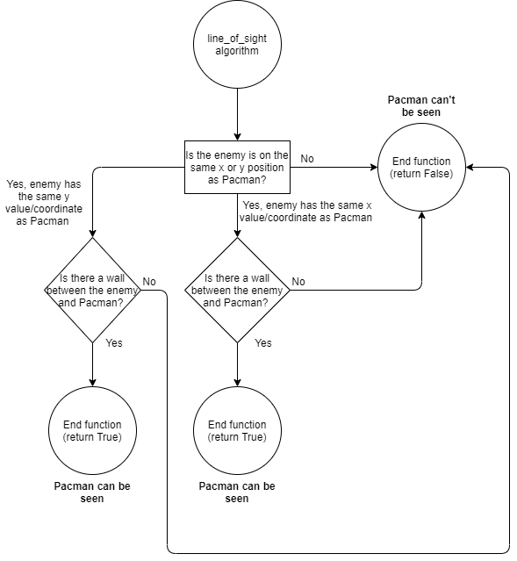

**Enemy Detection Algorithm**

This algorithm is used so enemies can detect each other and avoid moving over each other (overlapping). This algorithm checks other enemies’ locations and if the ghosts are next to each other, they will move one tile away from each other in opposite directions.

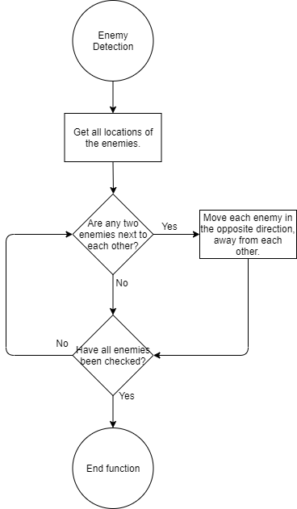

## Local-Multiplayer/Networking

Users will have an option to join or host a lobby. If a user hosts a lobby, they will open a server and port on their computer, and all other users that join will send and receive messages through the port on that server. The server will send messages to all users connected, and the users will receive and send messages back.

* Messages being sent to server:
  + X and Y coordinates of player
  + When a user collects a power-up
  + When player uses a power-up
* Messages being sent back to all clients:
  + Co-ordinates of all players gets sent to all clients so the maze (board) can be updated on the client side, as the maze will be stored individually for every client. The maze will not be server side.
  + Server will randomize where power-ups will spawn, and sends the locations to all clients.
  + When a player collects a power-up, so it is updated on everyone’s board
  + Location of where power-ups are used.

## UI Design/HCI rationale

My project aims to cater to all target audiences, younger and older audiences. To make it accessible to all users I need create a UI that is easy to read and understand. To create a very accessible UI, I need to create a clear layout of the buttons and make sure they are organised on the screen in a simple, clear way.

The background of the screen (before user enters a game) will be colourful and have a strong contrast to colour of the buttons, so the buttons stand out visibly to all users. The background will have dark colours, while the buttons will project bright visible colours.

According to this website “<https://www.vistaprint.com/hub/design-decoded-top-12-easy-read-fonts?couponAutoload=1&GP=11%2f09%2f2019+13%3a07%3a16&GPS=5527287966&GNF=0>”, Open Sans is one of the most readable fonts for user interfaces, so I will be using it when creating text for the screen.

**Start Menu**

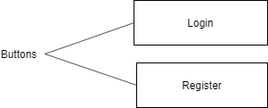This is the first screen that will appear when users enter the game. Both buttons Login and Register only send users to different screens.

The login button sends the user to the login screen and the register button sends the user to the register screen.

**Register Menu**

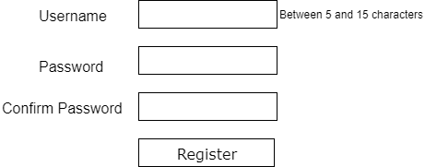If users click “Register” from the Start Menu, this screen will appear. Here users type in a Username, Password and a confirmation of that same Password.

When the button Register is clicked, the program determines if “Password” and “Confirm Password”. If they are not an error message is sent, saying “Passwords do not match”. If the passwords match, the program will then check if the Username is between 5 and 15 characters. If everything is successful up to now, the program will send a query to the database to check if both the username and password have not been taken.

If everything is successful, the User will be taken to the Login Menu.

**Login Menu**

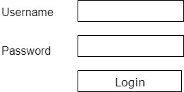If users click “Login” from the Start Menu, this screen will appear. Here users type in their Username and Password to access the Main Menu.

When the button Login is clicked, a query is sent to the database to check if the Username and Password are correct. If they are not, the user will receive an error message saying “type login details again”. If login details have been typed in wrong 3 times, the user will receive a ten-minute time out.

If login is successful, the User will be shown the Main Menu screen.

**Main Menu**

Once the User Logs in successfully, this screen will appear. There will be an arcade-style background. I will aim to create an animated background. Furthermore, four buttons will appear o Once the User Logs in successfully, this screen will appear. There will be an arcade-style background. I will aim to create an animated background. Furthermore, five buttons will appear o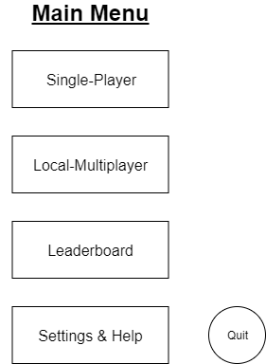n the screen.

The Single-Player button sends the User to the Start-Game Menu, where the user can select the settings (such as difficulty) for the game about to be played by the user.

The Local-Multiplayer button sends the User to the Lobby menu where users can select to either Join or Host a lobby. After this, the users will enter the gamemode chosen and the game will end with a decided winner.

The Leaderboard button sends the User to the Leaderboard Menu where the User can see the online rankings of all Users displayed (from the database).

The Settings & Help button sends the User to the settings where they can adjust the volume for the game, see their high score for single-player and their player-level, and more. Players unfamiliar with the game can also receive help, which will instruct the player how to play the game.

The quit button has the most basic function, where the user exits the program once it has been pressed.

**Start-Game Menu**

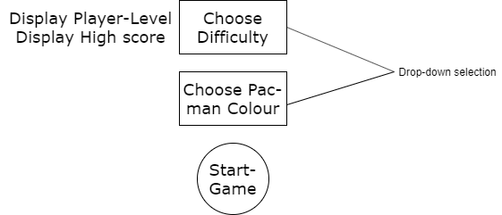

Once the User selects “Single-Player” they will be directed to this screen/menu. Both “Choose Difficulty” and “Choose Pac-man Colour” are drop-down selections.

The difficulty changes the cost function which affects how much the speed of the Ghosts/enemies and Pac-man increase throughout the game. The User may also change the colour of their Pac-man. Users can unlock cool colours and colour schemes by levelling-up.

The Start-Game Menu also displays the Users current high score and player level.

Once the User wants to start the game, they can select the button “Start-Game”. It will then take the user to the actual game where the gameplay starts.

**Lobby Menu**

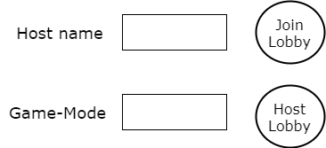

To join a lobby, the user must type in the hosts username then select the button “Join Lobby”. A request will be sent to join that lobby. If a lobby is not found with the username typed in, the game will send a message back saying “Lobby not found”. If lobby is found, user will be sent to the Multiplayer-Game Lobby.

To Host a Lobby, the user needs to select the game-mode, which will be a drop-down selection, and then select “Host Lobby”. The lobby name will be the user’s username. The user will now be sent to the Multiplayer-Game Lobby. Other users can now join this lobby.

**Multiplayer-Game Lobby**

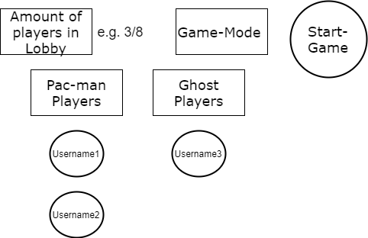

Whenever Users enter the lobby, the Host selects what role they play. When there are a sufficient number of players in a role, the Host may start the game.

Depending on what game-mode, there is a minimum number of players in each role. For game-mode 3, there is a minimum of 1 Pac-man and 1 Ghost. For game-mode 2, there is a minimum of 2 Pac-man players and 0 ghost players. Gamemode 3 however, will most likely not be implemented.

The UI also shows the number of players in the lobby, and displays each player underneath the title of their role.

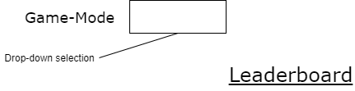**Leaderboard**

Below the leaderboard title will be displayed all players high scores and what game-mode they achieved it in. The user can sort by game-mode using the drop down above. My program also sorts the players to displayed on the leaderboard from highest score to lowest score.

I will be using a Merge Sort, to sort the leaderboard from highest to lowest high scores because the amount of data may be massive if many players play the game. Bubble sort would be much slower, especially when data grows.

**Settings & Help**

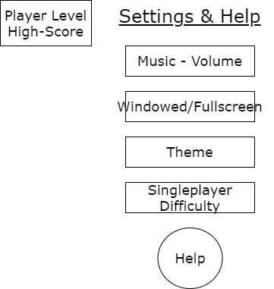

The settings provide you with information on your Single-Player high score and your player-level.

Furthermore, the “Music – Volume” option is an input box, where the user types the volume (between 0 and 100). The “Windowed/Fullscreen” option allows the user to choose between having their game Fullscreen (max screen size according to resolution), or Windowed, which makes the program appear in a smaller window and not cover the whole screen. The theme option allows the user to choose the background of their game during gameplay and out of gameplay (in the menu screen). When the user selects the “Help” option a text box appears on the screen with instructions on how to play the game. The user can close it by clicking the close button at the bottom of the text box.

*Rather than choosing the “Singleplayer difficulty” after the user has selected the Singleplayer gamemode, the user may decide to select the difficulty in the settings*

# Technical Solution

## Game File

**import** pygame  
**import** sys  
**from** pygame.locals **import** *  
**from** Grid **import** *  
**from** Player **import** *  
**from** Enemy **import** *  
**from** Powerup **import** *  
**from** Music **import** *  
**import** time  
**import** random  
**from** random **import** shuffle  
  
**"""Pygame.mixer is used to initialise the audio for my game. 44100 is the frequency, the size is 16, 2 is amount of   
channels (multiple channels allow different sounds to be paused at once, rather than having to pause all at once), and  
4096 is the buffer size"""  
  
"""Pygame.init is used to initialize pygame and the pygame window. The caption is also set here, alongside the  
resolution (1260 x 744). The window is then initialized, which automatically puts the game in Fullscreen. Users will be  
able to exit out of Fullscreen"""**pygame.mixer.pre_init(44100, 16, 2, 4096)  
pygame.init()  
pygame.display.set_caption(**"Pacman"**)  
screen_width = 1260  
screen_height = 744  
window = pygame.display.set_mode((screen_width, screen_height), FULLSCREEN)  
  
  
*#-----------------------------------------------Menu_State-----------------------------------------------#***""" This class is the Menu Class. This class is for players to navigate to different parts of the game (classes).  
The Menu Class detects mouse clicking and positioning, then depending on which button is clicked, the game will change  
state and run the game loop for that state."""  
  
"""The attributes for class Menu indicate the game state, window display for the background image, clock tick which  
calculates the frames per second, a self.terminate attribute which is set to false unless the user exits the main menu,  
and a button list which holds the top left corner of each button so pygame can draw the rectangle shape"""  
  
  
class** Menu(object):  
 **def** __init__(self, terminate):  
 self.window = window  
 self.state = **"Menu"** self.terminate = terminate  
 self.clock = pygame.time.Clock()  
 self.button_list = [(155, 152), (155, 272), (155, 392), (155, 512), (155, 632)]  
  
 **"""The function menu_event is the first part of the game loop when the game state is in Menu. The function handles  
 all events on the menu"""  
  
 def** menu_event(self):  
 *"""self.clock.tick represents the frames per second the game is ticking at"""* self.clock.tick(120)  
 **"""This is the event loop"""  
 for** event **in** pygame.event.get():  
 **"""mouse_pos gets the exact position coordinates of the mouse and represents the coordinates as a tuple."""** mouse_pos = pygame.mouse.get_pos()  
 **"""This event type checks for the motion of the mouse and if it is hovering over a button. The first if  
 statement will always be executed as long as the mouse is moving. If the mouse is not within the  
 boundaries of a button, the buttons will just be redrawn with the normal colour. However, if the  
 mouse position is within the boundaries of a button, the buttons will be redrawn but shaded."""  
 if** event.type == pygame.MOUSEMOTION:  
 **if** self.button_collisions(mouse_pos):  
 **"""If the mouse is hovering over a button, that button will be shaded."""** self.hover()  
 self.button_text()  
 pygame.display.update()  
 **else**:  
 self.draw_buttons()  
  
 **"""Depend on which button the user clicks, it will change the state of the game, and therefore change the  
 game loop. The last if statement in the nested-if statement will terminate the game if the user clicks (with  
 the left mouse button) the quit button."""  
  
 if** event.type == pygame.MOUSEBUTTONDOWN:  
 **if** self.button_collisions(mouse_pos) **and** self.button_count == 0:  
 self.state = **"Play"  
 return** self.state  
 **if** self.button_collisions(mouse_pos) **and** self.button_count == 1:  
 self.state = **"Two_Play"  
 return** self.state  
 **if** self.button_collisions(mouse_pos) **and** self.button_count == 3:  
 self.state = **"Settings"  
 return** self.state  
 **if** self.button_collisions(mouse_pos) **and** self.button_count == 4:  
 self.terminate = **True  
 break  
  
 """If the user is not in fullscreen and clicks the x button on the window, the code will terminate"""  
  
 if** event.type == pygame.QUIT **or** (self.terminate **is True**):  
 self.terminate = **True  
 break  
  
 """if the user presses the Escape button in the main menu, the game will terminate"""  
  
 if** event.type == pygame.KEYDOWN:  
 **if** event.key == K_ESCAPE:  
 self.terminate = **True  
  
 """This function is checks if the position of the mouse is within the boundaries of a button. If the mouse is within  
 the boundaries and the user clicks their mouse, it will exit out of the main menu.If so, it will return true to the   
 main event loop where more functions are further called."""  
  
 def** button_collisions(self, mouse_pos):  
 self.button_count = -1  
 **for** pos **in** self.button_list:  
 self.button_count += 1  
 **if** (mouse_pos[0] > pos[0]) **and** (mouse_pos[0] < (pos[0] + 200)):  
 **if** (mouse_pos[1] > pos[1]) **and** (mouse_pos[1] < (pos[1] + 100)):  
 **return True  
  
 """Function is here just in case other objects/things need to be drawn to the menu (for future development)"""  
  
 def** menu_draw(self):  
 **None  
  
 """menu_update, updates the screen display for the user (120 frames per second)"""  
  
 def** menu_update(self):  
 pygame.display.update()  
  
 **"""This function is always called on the menu. It draws the text onto the buttons."""  
  
 def** button_text(self):  
 display_list = [**"Single-player"**, **"Local-Multiplayer"**, **"Leaderboard"**, **"Settings"**, **"Quit"**]  
 height = 8  
 **for** x **in** display_list:  
 button_font = pygame.font.Font(**None**, 33)  
 button_surf = button_font.render(x, 1, (255, 255, 255))  
 button_pos = [3.7 * 45, height * 24]  
 height += 5  
 self.window.blit(button_surf, button_pos)  
  
 **"""This function is only called if the mouse position is not on the button. This means the button colour will be  
 its normal colour (gold/yellow) """  
  
 def** draw_buttons(self):  
 y = 154  
 **for** x **in** range(0, 5):  
 pygame.draw.rect(self.window, (0, 0, 0), (157, y, 204, 104), 0)  
 pygame.draw.rect(self.window, (255, 205, 0), (155, y-2, 200, 100), 0)  
 y += 120  
 self.button_text()  
  
 **"""This function is only called if the mouse position is on the button. This means the button colour will be  
 turned to a darker gold/yellow. This is to indicate to the user that they are hovering over the button"""  
  
 def** hover(self):  
 **for** index, pos **in** enumerate(self.button_list):  
 **if** self.button_count == index:  
 pygame.draw.rect(self.window, (178, 143, 0), (pos[0], pos[1], 200, 100), 0)  
  
 **"""This function is called only once, before the game-loop. The function loads the background, scales it to the  
 users screen and blits it to the screen so it does not change unless the game state changes. The buttons are also  
 drawn and the screen is updated using pygame.display.update()"""  
  
 def** load(self):  
 self.background = pygame.image.load(**"menuscreen.jpg"**)  
 self.background = pygame.transform.smoothscale(self.background, (screen_width, screen_height))  
 self.window.blit(self.background, (0, 0))  
 self.draw_buttons()  
 pygame.display.update()  
  
*#-----------------------------------------------Playing_State-----------------------------------------------#***"""This is the Board class for single-player. The attributes in this class all contribute to how the board and   
functionality of the game work. This class is where we get and set attributes from other classes. All board events,   
drawings to the screen, and updates occur"""  
  
"""This board consists of some key attributes.   
Self.Maze stores the 'list of lists' which is a 2D matrix of my pacman maze.   
Self.window stores the display criteria.   
Self.terminate is a bool, which when turned to True, exits out of the game.   
The attributes, spawn_count, power_count, x_coord and y_coord are just used as counters for certain board functions.   
They store int values.  
Self.clock also stores the frames/ticks per second.  
The list walls, stores the coordinates of the walls in terms of pixels, as tuples in a list(x, y). The list   
walls_pos stores the coordinates of the walls in terms of vectors, as tuples in a list. The list free_cells and  
free_pos follow the same pattern as wall lists, but instead store the free cells/spaces rather than the walls.  
The attributes self.cell_width and self.cell_height, store the width and height of a cell respectively.  
The attributes self.offset_width and self.offset_height, store the width and height to get to the centre of a free cell.  
Attribute self.base_time stores the spawn timer for the enemies (ghosts) to come out.  
Attribute self.pause stores a bool, which allows the user to pause the single-player game using the key 'p'/'P'.  
Attribute self.intersections, stores all the intersection points on the maze."""  
  
"""We initialized several objects from other classes.   
I initialized the player object which holds the attributes of the user such as score and lives, etc...  
I initialized the music object which stores all the sounds of the game as separate methods.  
I initialized the power object which stores the attributes and methods for all the power-ups in the game.  
I initialized the setting object which stores all the methods and attribute for when the game state is at settings and  
the settings game loop is running.  
I initialized all four ghosts as enemy objects (inky, pinky, blinky, clyde). Besides the board and player object being  
passed as an argument, the colour, initial direction, 'if spawned', and name are all passed as arguments.  
All objects have the board object passed to them to allow them to be manipulate the board from their class.  
The list players and enemy, store all the player and enemy objects in a list respectively."""  
  
  
class** Board(object):  
 **def** __init__(self, terminate):  
 self.Maze = grid  
 self.window = window  
 self.clock = pygame.time.Clock()  
 self.terminate = terminate  
 self.spawn_count = 0  
 self.power_count = 0  
 self.x_coord = 0  
 self.y_coord = 0  
 self.state = **"Single"** self.walls = []  
 self.walls_pos = []  
 self.free_cells = []  
 self.free_pos = []  
 self.enemy_spawn = []  
 self.dots = []  
 self.cell_width = 45  
 self.offset_width = self.cell_width // 2  
 self.cell_height = 24  
 self.offset_height = self.cell_height // 2  
 self.base_time = time.time()  
 self.paused = **False** *########Initialization###########* self.music = Music()  
 self.power = Items(self)  
 self.setting = Settings(terminate, self)  
 self.player = Player(self, **"Player1"**)  
 self.intersections = []  
 self.inky = Enemy(self, self.player, (178, 225, 255), **'L'**, **False**, **"inky"**)  
 self.blinky = Enemy(self, self.player, (178, 225, 120), **'R'**, **False**, **"blinky"**)  
 self.pinky = Enemy(self, self.player, (93, 5, 120), **'L'**, **False**, **"pinky"**)  
 self.clyde = Enemy(self, self.player, (154, 253, 78), **'R'**, **False**, **"clyde"**)  
 self.players = [self.player]  
 self.enemy = [self.inky, self.pinky, self.blinky, self.clyde]  
  
 **"""This function handles all the boards events. Some events are just single-player and some are both single-player  
 and multi-player"""  
  
 def** play_event(self):  
 *"""self.clock.tick represents the frames per second the game is ticking at"""* self.clock.tick(120)  
 **"""The variable keys is used to store any buttons pressed on the keyboard (pygame.key.get_pressed is an in-built  
 pygame function"""** keys = pygame.key.get_pressed()  
 **"""This for loop is used to detect any keyboard events other than movement. This could be quitting the game,  
 using a power up or even pausing the game"""  
 for** event **in** pygame.event.get():  
 **if** event.type == pygame.QUIT **or** (self.terminate **is True**):  
 self.terminate = **True  
 break  
 """pygame.KEYDOWN is an in-built function used to detect key presses."""  
 """If the user presses 'f' or 'F' on their keyboard the power-up of the user will activate, if the user is  
 carrying one. If the user presses 'p' or 'P' on their keyboard, the game will be paused."""  
 if** event.type == pygame.KEYDOWN:  
 **if** event.key == pygame.K_f:  
 self.power.activate_power_up()  
 **if** event.key == pygame.K_p:  
 self.paused = **not** self.paused  
 **break  
  
 """Depending on the difficulty selection in the settings, the game will change difficulty. The difficulty change  
 changes the logarithmic function I have implemented, which is the cost function."""  
  
 """self.difficulty = 0, is easy. self.difficulty = 1, is medium. self.difficulty = 2, is hard."""  
  
 for** enemy **in** self.enemy:  
 **if** self.difficulty == 0:  
 enemy.move_difficulty = 5  
 **elif** self.difficulty == 1:  
 enemy.move_difficulty = 3  
 **elif** self.difficulty == 2:  
 enemy.move_difficulty = 2  
  
 **"""self.player_collision() is an event that detects enemy movement and checks if the movement being made will  
 collide with any walls/non-free-cells"""** self.player_collision()  
  
 **"""This function updates the board every game loop by calling other functions. It updates player and enemy   
 locations. It checks the spawn timer for the enemies and if the player has died, which then makes the player immune   
 for a specific amount of time. In addition, it checks for power-ups and items on the board"""  
  
 def** play_update(self):  
 self.player.update()  
 self.check_timer()  
 self.power.check_items()  
 self.power.check_power_count()  
 self.player.immunity()  
 self.inky.update()  
 self.blinky.update()  
 self.pinky.update()  
 self.clyde.update()  
 pygame.display.update()  
  
 **"""This function draws onto the board every game loop by calling other functions. It draws the dots, power_ups,  
 player(s) amd enemies. In addition it checks for death, which re-draws the user onto the spawn location. There is  
 also a timer implemented for when enemies are in the spawn location."""  
  
 def** play_draw(self):  
 *"""self.window.fill and self.window.blit, re draws the background to the screen, so it clears all  
 previous drawings"""* self.window.fill((0, 0, 0))  
 self.window.blit(self.background, (0, 0))  
 *#self.draw_grid()* self.draw_pops()  
 self.power.draw_items()  
 self.player.draw()  
 self.player.check_death()  
 **if** self.check_timer():  
 **for** enemy **in** self.enemy:  
 **if** enemy.spawned **is False**:  
 enemy.spawned = **True** enemy.y = 276  
 **break  
 """These three functions check for enemy location to make sure they do not overlap. Also they check for enemy  
 collision and then move the enemies bases on certain/specific criteria, depending what enemy is being moved."""** self.check_enemy_location()  
 self.enemy_moves()  
 self.check_enemy_location()  
  
 **"""This function is used for when a player loses all their lives, or presses the escape button. They will then  
 return to the game menu. This is why the state changes back to menu. The function self.check_score() is also called.  
 This function checks if the current score is greater than the current high score, if so, the current score becomes  
 the new high score."""  
  
 """self.game_over is called when a player loses all three lives"""  
  
 def** back_menu(self):  
 keys = pygame.key.get_pressed()  
 **if** self.player.player_lives == 0:  
 self.check_score()  
 self.game_over(**"GAME OVER"**)  
 self.state = **"Menu"  
 return** self.state  
 *#self.terminate = True* **if** keys[K_ESCAPE]:  
 self.check_score()  
 self.state = **"Menu"  
 return** self.state  
 *#self.terminate = True* **"""When the player chooses to start a new game, all board attributes will be reset to their initial values"""  
  
 def** game_reset(self):  
 self.spawn_count = 0  
 self.power_count = 0  
 self.x_coord = 0  
 self.y_coord = 0  
 self.player.direction = **" "** self.state = **"Single"** self.walls = []  
 self.walls_pos = []  
 self.free_cells = []  
 self.free_pos = []  
 self.enemy_spawn = []  
 self.dots = []  
  
 **"""In this function i demonstrate opening, reading and overwriting/writing a file. The file 'highscore.txt' stores  
 a numerical value as a string in the file. This function checks if the current in-game score is higher than the  
 score stored in the file. If so, the score will replace the score in the file. This function is only called when the  
 user exits the single-player game to the main menu."""  
  
 def** check_score(self):  
 *"""current score stores the string value of the current game score, when the game has ended"""* current_score = str(self.player.score)  
 **"""This opens the file in read only and stores the file as the variable high_score. text_high_score then  
 interprets the first line of the text, which is the numerical string, and stores it."""  
 with** open(**'highscore.txt'**, **'r'**) **as** high_score:  
 text_high_score = high_score.readline()  
 **"""converts numerical string to an integer and stores it"""** int_high_score = int(text_high_score)  
 **"""replaces current high score with a new high score, if the players last game exceeded it."""  
 if** self.player.score > int_high_score:  
 text_high_score = text_high_score.replace(text_high_score, current_score)  
 **"""Here i demonstrate closing a file"""** high_score.close()  
 **"""Writes the new high score in the file, after replacing it"""  
 with** open(**'highscore.txt'**, **'w'**) **as** high_score:  
 high_score.write(text_high_score)  
 high_score.close()  
  
 **"""This function checks if there are other enemies in a connected free cell next to the current enemy. If there is  
 an enemy in the adjacent free cell, the current enemy will move in the opposite direction. This prevents enemies  
 overlapping in the same cell."""  
 """This is the enemy detection algorithm."""  
  
 def** check_enemy_location(self):  
 *"""nested for loop is used to test every enemy's position against all other enemies position"""* **for** enemy **in** self.enemy:  
 **for** other_enemy **in** self.enemy:  
 **"""if enemy is to the right, move left"""  
 if** (enemy.pos[0] + 45 == other_enemy.pos[0]) **and** (enemy.pos[1] == other_enemy.pos[1]):  
 enemy.direction = **"L"  
 """checks for enemy collision with walls"""** self.enemy_collision(enemy.direction, enemy)  
 **"""if enemy is to the left, move right"""  
 if** (enemy.pos[0] - 45 == other_enemy.pos[0]) **and** (enemy.pos[1] == other_enemy.pos[1]):  
 enemy.direction = **"R"  
 """checks for enemy collision with walls"""** self.enemy_collision(enemy.direction, enemy)  
 **"""if enemy is below, move up"""  
 if** (enemy.pos[1] + 24 == other_enemy.pos[1]) **and** (enemy.pos[0] == other_enemy.pos[0]):  
 enemy.direction = **"U"  
 """checks for enemy collision with walls"""** self.enemy_collision(enemy.direction, enemy)  
 **"""if enemy is above, move down"""  
 if** (enemy.pos[1] - 24 == other_enemy.pos[1]) **and** (enemy.pos[0] == other_enemy.pos[0]):  
 enemy.direction = **"D"  
 """checks for enemy collision with walls"""** self.enemy_collision(enemy.direction, enemy)  
  
 **"""This function contains all the different types of movements each ghost will make. Inky will use Dijkstra with a,  
 dynamic matrix that changes every game loop to try trap the player. Pinky will use breadth-first search. Blinky  
 will use random movement but Blinky can track Pacman if he sees him in his line of sight, by using the line of   
 sight algorithm. Clyde will just move intersection to intersection, but will not be able to track Pacman."""  
  
 def** enemy_moves(self):  
 *"""I put a time delay, otherwise the game speed would be too quick, an in face unplayable. The value 120 is the  
 time in milliseconds. So there is a delay of 120 milliseconds per game loop."""* pygame.time.delay(120)  
  
 **for** enemy **in** self.enemy:  
 **"""for each enemy, the function change_matrix() is called. This function gets the previous intersection of  
 every enemy, and adjusts Inky's adjacency matrix accordingly"""** enemy.change_matrix()  
 **"""This if statement check if the enemy position has reached an intersection. If so, a tuple is appended to   
 a list. The reason we need the enemy's last intersection, is to see where the path for the searching  
 algorithms will start for Inky and Pinky, and where the next possible intersection can be for Clyde. Also  
 the line of sight algorithm for Blinky, Inky and Pinky. In addition, we need the last intersection of each   
 enemy to be able to change the adjacency matrix for Inky."""  
  
 if** enemy.pos **in** self.intersections:  
 enemy.last_intersection.append(enemy.pos)  
 **"""When the enemies spawn and the player spawns, they have not yet touched an intersection, so all four   
 algorithm's will not be able to work. Therefore the enemies will move randomly until they   
 touch one and the player touches one."""  
 """If the player uses the invisibility potion, all the ghosts will have to move randomly"""  
  
 if** ((len(enemy.last_intersection) **and** len(self.player.last_intersection)) != 0) **and** (self.player.cloak **is False**):  
  
 **"""If the enemy in the for loop is inky, the dijkstra algorithm will take place"""  
 if** enemy.name == **"inky"**:  
 cords, cords_next = enemy.dijkstra()  
 self.searching_location(enemy, cords, cords_next)  
  
 **"""If the enemy in the for loop is blinky, blinky will move randomly but the line of sight algorithm   
 will take place"""  
 if** enemy.name == **"blinky"**:  
 bool_value = self.in_line(enemy)  
 **if** bool_value **is True**:  
 enemy.changeLocation(random.choice([**'L'**, **'U'**, **'D'**, **'R'**]))  
 self.enemy_collision(enemy.direction, enemy)  
 **else**:  
 **if** enemy.pos[0] > self.player.pos[0] **and** enemy.pos[1] == self.player.pos[1]:  
 enemy.changeLocation(**'L'**)  
 self.enemy_collision(enemy.direction, enemy)  
 **if** enemy.pos[0] < self.player.pos[0] **and** enemy.pos[1] == self.player.pos[1]:  
 enemy.changeLocation(**'R'**)  
 self.enemy_collision(enemy.direction, enemy)  
 **if** enemy.pos[1] < self.player.pos[1] **and** enemy.pos[0] == self.player.pos[0]:  
 enemy.changeLocation(**'D'**)  
 self.enemy_collision(enemy.direction, enemy)  
 **if** enemy.pos[1] > self.player.pos[1] **and** enemy.pos[0] == self.player.pos[0]:  
 enemy.changeLocation(**'U'**)  
 self.enemy_collision(enemy.direction, enemy)  
  
 **"""If the enemy in the for loop is pinky, the breadth-first search algorithm will take place"""  
 if** enemy.name == **"pinky"**:  
 cords, cords_next = enemy.breadth_first()  
 self.searching_location(enemy, cords, cords_next)  
  
 **"""If the enemy in the for loop is clyde, the intersection to intersection algorithm will take place."""  
 if** enemy.name == **"clyde"**:  
 **if** enemy.pos **in** self.intersections:  
 enemy.changeLocation(random.choice([**'L'**, **'U'**, **'D'**, **'R'**]))  
 self.enemy_collision(enemy.direction, enemy)  
 **else**:  
 self.enemy_collision(enemy.direction, enemy)  
  
 **else**:  
 enemy.changeLocation(random.choice([**'L'**, **'U'**, **'D'**, **'R'**]))  
 self.enemy_collision(enemy.direction, enemy)  
  
 **"""This try and except is used to detect whether an enemy is within the boundary of the laser, if the user  
 has activated it. The laser has a start position and an end position. If the enemy is between those two  
 coordinate positions or directly on top of the position, the enemy will die"""  
 """We have to put an except for IndexError because if the player has activated the laser and has run into  
 a wall, the starting and ending position will have an empty tuple."""  
  
 """self.player.power stores the users power up. self.player.laser stores a boolean to check if the player  
 has activated the power_up. enemy.spawned also stores a boolean operation, and is used as condition to  
 prevent a possibility of players killing ghosts before they have even spawned"""  
 try**:  
 **if** (self.player.power == **"laser"**) **and** (self.player.laser **is True**) **and** (enemy.spawned **is True**):  
 **if** (self.player.direction == **"L"**) **or** (self.player.direction == **"R"**):  
 **if** (self.power.start_position[0] >= enemy.x >= self.power.end_position[0]) **or** (self.power.start_position[0] <= enemy.x <= self.power.end_position[0]):  
 **if** enemy.y == self.player.y:  
 **"""calls the ghost_death function to reset some of the ghosts attributes"""** self.ghost_death(enemy)  
 **if** (self.player.direction == **"D"**) **or** (self.player.direction == **"U"**):  
 **if** (self.power.start_position[1] >= enemy.y >= self.power.end_position[1]) **or** (self.power.start_position[1] <= enemy.y <= self.power.end_position[1]):  
 **if** enemy.x == self.player.x:  
 **"""calls the ghost_death function to reset some of the ghosts attributes"""** self.ghost_death(enemy)  
 **except** IndexError:  
 **return None  
  
 """This function is called when a ghost dies by a user. It resets attributes and plays the 'ghost death' music"""  
  
 def** ghost_death(self, enemy):  
 *"""Calls ghost death music"""* self.music.enemy_death_music()  
 **"""Reset ghost spawn point. Spawn point is stored as a tuple which contains x and y integers (x, y)"""** enemy.x = 607  
 enemy.y = 324  
 **"""Sets the spawned attribute to false. This stops players killing enemies before spawning. In addition by  
 setting the boolean value to false, the if condition of the function self.check_timer() will pass, which starts a  
 timer for the enemy to spawn again. Once the timer is done, enemy.spawned turns to True."""** enemy.spawned = **False** enemy.last_intersection.clear()  
  
 **"""This function is called when the path from Dijkstra and Breadth-First Search is found, for Inky and Pinky  
 respectively. Once the path is found, the current intersection cords of the ghost and the next intersection cords,  
 alongside what ghost it is, are passed as arguments into the function.."""  
 """This function is how Inky and Blinky move, after using Dijkstra or Breadth-First Search."""  
 def** searching_location(self, enemy, cords, cords_next):  
 *"""If the cords or cords_next are none, the else condition will be executed. The reason these may be none, is  
 because the enemy is very close to Pacman meaning that there are no further intersections to go to, which means  
 the line of sight algorithm will be used instead. So in that case the ghost goes straight towards Pacman, as  
 there is no intersection between the enemy and Pacman."""* **if** (cords **or** cords_next) **is not None**:  
 **if** enemy.pos[0] > cords_next[0]:  
 enemy.changeLocation(**'L'**)  
 self.enemy_collision(enemy.direction, enemy)  
 **if** enemy.pos[0] < cords_next[0]:  
 enemy.changeLocation(**'R'**)  
 self.enemy_collision(enemy.direction, enemy)  
 **if** enemy.pos[1] < cords_next[1]:  
 enemy.changeLocation(**'D'**)  
 self.enemy_collision(enemy.direction, enemy)  
 **if** enemy.pos[1] > cords_next[1]:  
 enemy.changeLocation(**'U'**)  
 self.enemy_collision(enemy.direction, enemy)  
 **else**:  
 **if** enemy.pos[0] > self.player.pos[0]:  
 enemy.changeLocation(**'L'**)  
 self.enemy_collision(enemy.direction, enemy)  
 **if** enemy.pos[0] < self.player.pos[0]:  
 enemy.changeLocation(**'R'**)  
 self.enemy_collision(enemy.direction, enemy)  
 **if** enemy.pos[1] < self.player.pos[1]:  
 enemy.changeLocation(**'D'**)  
 self.enemy_collision(enemy.direction, enemy)  
 **if** enemy.pos[1] > self.player.pos[1]:  
 enemy.changeLocation(**'U'**)  
 self.enemy_collision(enemy.direction, enemy)  
  
 **"""This is the spawn timer for the ghosts. Self.base_time is the initial time. Spawn time is current time.  
 Final time is the current time subtract the base time. We return a bool. True if final_time == 0, and false if it  
 does not. If true is returned, the enemy spawns in during the game loop. Self.spawn_count is used to delay the  
 spawn time (this may not be necessary to have the spawn timer working)."""  
  
 def** check_timer(self):  
 spawn_time = time.time()  
 final_time = int(spawn_time - self.base_time) % 20  
 self.spawn_count += 1  
 **if** self.spawn_count % 5 == 0:  
 **return** final_time == 0  
  
 **"""The function draw_grid was created to help me calculate the exact amount of free cells and specific locations   
 I needed for my game (e.g. enemy spawn location). The function draws lines horizontally and vertically to created  
 boxes around the free cells. This function does not run in the game loop, only when I am changing some functionality  
 to the game using location coordinates."""  
  
 def** draw_grid(self):  
 *"""Draws horizontal lines"""* **for** line **in** range(screen_width // 45):  
 pygame.draw.line(self.window, (107, 107, 107), (line * self.cell_width, 0),  
 (line * self.cell_width, screen_height))  
 **"""Draws vertical lines"""  
 for** line **in** range(screen_height // 24):  
 pygame.draw.line(self.window, (107, 107, 107), (0, line * self.cell_height),  
 (screen_width, line * self.cell_height))  
  
 **"""This is my line of sight algorithm. If the function returns True, the player is not in the line of sight of the  
 enemy. If the function returns False, the enemy can see the player in their line of sight"""  
  
 def** in_line(self, enemy):  
 *"""This if statement checks if the enemy is on the same x or y coordinate as the player."""* **if** (enemy.pos[0] == self.player.pos[0]) **or** (enemy.pos[1] == self.player.pos[1]):  
 **"""This for loop checks if there is a wall between the enemy and player because even though they may be on   
 the same x or y coordinate, a wall will stop the enemy from seeing the player"""  
 for** value **in** self.walls:  
 **if** (value[0] == enemy.pos[0]) **or** (value[1] == enemy.pos[1]):  
 **if** (enemy.pos[1] < value[1] < self.player.pos[1]) **or** (enemy.pos[1] > value[1] > self.player.pos[1]):  
 **return True  
 if** (enemy.pos[0] < value[0] < self.player.pos[0]) **or** (enemy.pos[0] > value[0] > self.player.pos[0]):  
 **return True  
 return False  
 return True  
  
 """The cells function calculates the free cells in coordinates and in vectors form and stores them in lists   
 free_cells and free_pos respectively. In addition it stores all the free cell positions into a dots list. Dots are  
 what Pacman collects as he moves along (dots accumulate the points). As Pacman collects the dots, they get removed  
 from the dots list. Furthermore, the function calculates the wall cells in coordinates and in vectors form and  
 stores them in lists walls_pos and walls respectively. The enemy spawn location is also calculated."""  
  
 """The reason I need to calculate the free cells as vectors is for the Dijkstra, Breadth-First Search and Line of  
 Sight algorithm."""  
  
 """The function also calculates each intersection on the maze in coordinate form."""  
  
 def** cells(self):  
 *"""self.Maze stores the grid, which is a list of lists. row takes one of the lists, from the lists of lists.  
 cell takes each element from row."""* **for** y, row **in** enumerate(self.Maze):  
 **for** x, cell **in** enumerate(row):  
 **"""0 on the grid represents a free cell"""  
 if** cell == 0:  
 self.free_pos.append((x, y))  
 self.free_cells.append((self.x_coord + self.offset_width, self.y_coord + self.offset_height))  
 self.dots.append((self.x_coord + self.offset_width, self.y_coord + self.offset_height))  
 **"""1 on the grid represents a wall"""  
 elif** cell == 1:  
 self.walls_pos.append((x, y))  
 self.walls.append((self.x_coord + self.offset_width, self.y_coord + self.offset_height))  
 **"""Any other value on the grid represents the enemy spawn"""  
 else**:  
 self.enemy_spawn.append((self.x_coord + self.offset_width, self.y_coord + self.offset_height))  
 **"""As the cell goes through every element per list (row), we must add 45 to the x coordinate because  
 every cell is 45 pixels in width."""** self.x_coord += 45  
 **"""As the list (row) ends and it goes to the next row, we need to reset the x coordinate"""  
 if** self.x_coord == 1260:  
 self.x_coord = 0  
 **"""Every row down, the y coordinate increase by 24 because every cell has a height of 24"""** self.y_coord += 24  
  
 **"""Here is where we append each intersection on the maze to a list, self.intersections"""  
  
 for** value **in** self.free_cells:  
 **"""If there is minimum an empty cell horizontally and vertically next to the free cell, it must be an  
 intersection."""  
 """free cell to the right"""** x1 = (value[0] + 45, value[1])  
 **"""free cell to the left"""** x2 = (value[0] - 45, value[1])  
 **"""free cell down"""** y1 = (value[0], value[1] + 24)  
 **"""free cell up"""** y2 = (value[0], value[1] - 24)  
 **if** x1 **in** self.free_cells **or** x2 **in** self.free_cells:  
 **if** y1 **in** self.free_cells **or** y2 **in** self.free_cells:  
 **if** value **not in** self.intersections:  
 self.intersections.append((value[0], value[1]))  
  
 **"""This function draws the dots to the screen"""  
  
 def** draw_pops(self):  
 *"""Value takes the coordinates as a tuple and draws the dots onto the screen"""* **for** value **in** self.dots:  
 pygame.draw.circle(self.window, (255, 215, 0), (value[0], value[1]), 5)  
 **"""If all the dots have been collected on the maze, all possible dot positions get appended back to the list and  
 all dots will be redrawn on the board."""  
 if** len(self.dots) == 0:  
 **for** value **in** self.free_cells:  
 self.dots.append((value[0], value[1]))  
 **"""There are two power ups, and they spawn alongside the dots, in place of two of them."""** self.power.spawn()  
 **"""Value takes the coordinates as a tuple and draws the dots onto the screen"""  
 for** value **in** self.dots:  
 pygame.draw.circle(self.window, (255, 215, 0), (value[0], value[1]), 5)  
  
 **"""This function is how a player moves during the game. This function covers player collision, to make sure  
 that players can only move within free cells"""  
  
 def** player_collision(self):  
 keys = pygame.key.get_pressed()  
 **"""tup[0] stores the x coordinate and tup[1] stores the y coordinate"""  
 """self.player.direction stores the direction the player is moving in the player class."""  
 """self.player.movement calls the movement function in the player class which actually changes the coordinates  
 of the player depending on the arguments given."""  
  
 """If the player presses the left arrow key, it will check if there is a free cell to the left of the player"""  
 if** keys[pygame.K_LEFT]:  
 **for** tup **in** self.free_cells:  
 **if** (tup[0] == self.player.x - self.cell_width) **and** (tup[1] == self.player.y):  
 self.player.direction = **"L"** self.player.movement(-self.cell_width, 0)  
 **return None  
 """If the player presses the right arrow key, it will check if there is a free cell to the right of the   
 player"""  
 if** keys[pygame.K_RIGHT]:  
 **for** tup **in** self.free_cells:  
 **if** (tup[0] == self.player.x + self.cell_width) **and** (tup[1] == self.player.y):  
 self.player.direction = **"R"** self.player.movement(self.cell_width, 0)  
 **return None  
 """If the player presses the up arrow key, it will check if there is a free cell above the player"""  
 if** keys[pygame.K_UP]:  
 **for** tup **in** self.free_cells:  
 **if** (tup[0] == self.player.x) **and** (tup[1] == self.player.y - self.cell_height):  
 self.player.direction = **"U"** self.player.movement(0, -self.cell_height)  
 **return None  
 """If the player presses the down arrow key, it will check if there is a free cell below the player"""  
 if** keys[pygame.K_DOWN]:  
 **for** tup **in** self.free_cells:  
 **if** (tup[0] == self.player.x) **and** (tup[1] == self.player.y + self.cell_height):  
 self.player.direction = **"D"** self.player.movement(0, self.cell_height)  
 **return None  
 """Nothing occurs from this function if the player tries to move into a non free cell"""  
  
 """This is how all enemies move. This function checks for collision. It makes sure when all enemies move in a  
 certain direction that it is a free cell and not any other cells. The enemy will not be able to move if it is not  
 a free cell. This function takes the direction and what enemy is moving as the arguments."""  
  
 def** enemy_collision(self, direction, enemy):  
 *"""If the direction the enemy wants to move is left, it will check if there is a free cell to the left of the  
 enemy. If so the function enemy.moves() is called, which is a function in the Enemy class."""* **if** direction == **"L"**:  
 **for** tup **in** self.free_cells:  
 **if** (tup[0] == enemy.x - self.cell_width) **and** (tup[1] == enemy.y):  
 enemy.moves()  
 **break  
 """If the direction the enemy wants to move is right, it will check if there is a free cell to the right of the  
 enemy. If so the function enemy.moves() is called, which is a function in the Enemy class."""  
 if** direction == **"R"**:  
 **for** tup **in** self.free_cells:  
 **if** (tup[0] == enemy.x + self.cell_width) **and** (tup[1] == enemy.y):  
 enemy.moves()  
 **break  
 """If the direction the enemy wants to move is up, it will check if there is a free cell above the  
 enemy. If so the function enemy.moves() is called, which is a function in the Enemy class."""  
 if** direction == **"U"**:  
 **for** tup **in** self.free_cells:  
 **if** (tup[0] == enemy.x) **and** (tup[1] == enemy.y - self.cell_height):  
 enemy.moves()  
 **break  
 """If the direction the enemy wants to move is down, it will check if there is a free cell below the  
 enemy. If so the function enemy.moves() is called, which is a function in the Enemy class."""  
 if** direction == **"D"**:  
 **for** tup **in** self.free_cells:  
 **if** (tup[0] == enemy.x) **and** (tup[1] == enemy.y + self.cell_height):  
 enemy.moves()  
 **break  
  
 """If the game state stored is single, the game is running the single player mode. If so, when the player loses all  
 three lives, the game will be over and this function will be called."""  
  
 """If the game state stored is multi, the game is running the co-op multiplayer mode. If so, when a player loses all  
 three lives, the other player wins and this function is called, or if a player reaches a score of 500, this function  
 is also called and the player that reached score 500 wins."""  
  
 """This function has a parameter text. Depending on what state the game is in, a different argument for text will be  
 passed."""  
  
 """The function creates an animation for the text"""  
  
 def** game_over(self, text):  
 *"""expansion stores an integer which is the font size of the text"""* expansion = 30  
 **"""This for loop means that the size of the text increases font size up to an extra 120 (so 150 in total).  
 This creates an animation of the text."""  
 for** value **in** range(0, 120):  
 **"""This creates a black screen before displaying the text."""** self.window.fill((0, 0, 0))  
 **"""button_font is the font for the text"""** button_font = pygame.font.Font(**None**, expansion)  
 **"""button_surf stores the text that will be rendered in and the colour it will be"""** button_surf = button_font.render(text, 1, (236, 0, 0))  
 **"""button_pos stores the position [x, y] of the text"""** button_pos = [8 * 45, 12 * 24]  
 **"""Draws and blits the text to the screen using pixels"""** self.window.blit(button_surf, button_pos)  
 **"""Increases the font size by 1 every loop"""** expansion += 1  
 **"""By putting a delay of 5 milliseconds, the expansion of the text doesn't increase as fast. Slows the  
 animation down."""** pygame.time.delay(5)  
 **"""Updates the screen every loop."""** pygame.display.update()  
 **"""Once the animation has finished, the text is displayed for another 840 milliseconds."""** pygame.time.delay(840)  
  
 **"""This function, paused_function, is only called in the game loop if the game is currently paused. The function  
 gets the event pygame.KEYDOWN, which detects if a key is pressed. I have declared that only if 'p' or 'P' is pressed  
 an event occurs. This event is unpausing the game."""  
  
 def** pause_function(self):  
 **for** event **in** pygame.event.get():  
 **if** event.type == pygame.KEYDOWN:  
 **if** event.key == pygame.K_p:  
 self.paused = **not** self.paused  
 **break  
  
 """If the game is paused, the text 'Paused' will be displayed on the screen and be blit onto the screen so it does  
 not flash off it."""  
  
 def** pause_display(self):  
 pause_font = pygame.font.Font(**None**, 150)  
 pause_surf = pause_font.render(**"Paused"**, 1, (255, 255, 255))  
 pause_pos = [10 * 45, 12 * 24]  
 self.window.blit(pause_surf, pause_pos)  
 pygame.display.update()  
  
 **"""The load function is only run once, when the state is firstly changed/initialized. Function always runs before   
 the game loop starts. It takes the argument, 'difficulty' which can range from '0', being easy, '1', being medium,   
 and '2' being Hard."""  
  
 def** load(self, difficulty):  
 *"""self.background loads in the maze image and stores it"""* self.background = pygame.image.load(**"Maze.png"**)  
 **"""This in-built function (pygame.transform.smoothscale), scales and adjusts the the image resolution and size   
 to the screen it will be displayed on."""** self.background = pygame.transform.smoothscale(self.background, (screen_width, screen_height))  
 **"""blits the image and renders it permanently onto the screen, until the state changes or the game finishes"""** self.window.blit(self.background, (0, 0))  
 **"""Calls the self.cells() and self.power.spawn() function before the game loop starts"""** self.cells()  
 self.power.spawn()  
 **"""The difficulty is set so the cost function can be adjusted for the enemy movement before the game starts."""** self.difficulty = difficulty  
 **"""Updates the screen display before the game starts, so everything gets rendered and updated onto the screen"""** pygame.display.update()  
  
  
*#-----------------------------------------------Multi_Player_State-----------------------------------------------#***"""This class (MultiBoard) inherits all the attributes and methods from the class Board.  
The class MultiBoard then has its own attributes. One of which is a player class object, which takes the parameters  
'self'(class board) and the name of the player 'Player2'."""  
  
"""The attribute self.tile_list store all the coordinates of the lava tiles as tuples in a list.  
The attribute self.rock_tile_list store all the coordinates of the rock tiles as tuples in a list.  
The attribute self.tile_counter stores an integer and is used as a timer that spawns in the lava onto the maze at a  
specific interval.  
The attribute self.rock_tile_counter stores an integer and is used as a timer that converts the lava to rock in the at a  
specific interval.  
The attribute self.lava_to_rock_counter is used to create a specific time interval in which lava turns to rock."""  
  
  
class** MultiBoard(Board):  
 **def** __init__(self, terminate):  
 super().__init__(terminate)  
 self.player_two = Player(self, **"Player2"**)  
 self.tile_list = []  
 self.rock_tile_list = []  
 self.tile_counter = 1  
 self.rock_tile_counter = 0  
 self.lava_to_rock_counter = 1000  
  
 **"""When the player chooses to start a new game, all board class and multiboard class attributes will be reset to   
 their initial values"""  
  
 def** multi_reset(self):  
 self.tile_list = []  
 self.rock_tile_list = []  
 self.tile_counter = 1  
 self.rock_tile_counter = 0  
 self.lava_to_rock_counter = 1000  
 self.spawn_count = 0  
 self.power_count = 0  
 self.x_coord = 0  
 self.y_coord = 0  
 self.state = **"Two_Play"** self.player.direction = **" "** self.walls = []  
 self.walls_pos = []  
 self.free_cells = []  
 self.free_pos = []  
 self.dots = []  
  
 **"""This is the event function in the game loop when the state stores the string 'Two_Play'.  
 This event function checks and calls for player one and player two collision detection, as well as if there is   
 a winner of the game. In addition, there is an event loop which detects if the user has terminate the game and   
 quit from it."""  
  
 def** two_play_event(self):  
 self.clock.tick(120)  
 pygame.time.delay(120)  
 **for** event **in** pygame.event.get():  
 **if** event.type == pygame.QUIT **or** (self.terminate **is True**):  
 self.terminate = **True  
 break** self.check_winner()  
 self.player_collision()  
 self.two_player_collision()  
  
 **"""If a player loses all three lives or presses escape, the game state will change to 'Menu' and the function  
 self.game_over will be called, where the Player that won will be displayed (if a player lost all three lives).   
 This function returns the game state to the main game loop."""  
  
 def** multi_back_menu(self):  
 keys = pygame.key.get_pressed()  
 **if** self.player.player_lives == 0:  
 self.game_over(**"Player2 Wins"**)  
 self.state = **"Menu"  
 return** self.state  
 **if** self.player_two.player_lives == 0:  
 self.game_over(**"Player1 Wins"**)  
 self.state = **"Menu"  
 return** self.state  
 **if** keys[K_ESCAPE]:  
 self.state = **"Menu"  
 return** self.state  
  
 **"""This function checks if a player has reached 500 points. If a player has reached 500 points, the function  
 self.game_over is called, and the winner is displayed onto the screen, before the game state 'Menu' is returned  
 to the game loop."""  
  
 def** check_winner(self):  
 **for** player **in** self.players:  
 **if** player.score >= 500:  
 winner = player.name + **" Wins"** self.game_over(winner)  
 self.state = **"Menu"  
 return** self.state  
  
 **"""This is the update function of the game loop. It calls all other functions that are related to the current game   
 state and checks and updates certain attributes related to the player or any other class in the game."""  
  
 def** multi_play_update(self):  
 self.check_player_location()  
 self.player.immunity()  
 self.player_two.immunity()  
 self.player.update()  
 self.player_two.update()  
 pygame.display.update()  
  
 **"""This is the draw function of the game loop. It draws objects and specific things to the screen."""  
  
 def** multi_play_draw(self):  
 *"""self.window.fill and self.window.blit, re draws the background to the screen, so it clears all  
 previous drawings"""* self.window.fill((0, 0, 0))  
 self.window.blit(self.background, (0, 0))  
 *#self.draw_grid()* **"""Draws the dots, player one and player two to the screen. In addition, it checks if player one or player two  
 has died by lava, so they can re draw the player to a position where there is no lava or rock."""** self.draw_pops()  
 self.player.draw()  
 self.player_two.draw()  
 self.player.check_death()  
 self.player_two.check_death()  
 **"""This function is called to draw lava or draw rocks and remove lava from the maze/board."""** self.multi_player_map_spawn()  
  
 **"""The function multi_player_spawn is called once from the load function. It changes the game state to 'Two_Play'.  
 It also appends the second player to the list of players, and then initialize each players spawn using pixel  
 coordinates."""  
  
 def** multi_player_spawn(self):  
 self.state = **"Two_Play"** self.players.append(self.player_two)  
 **for** player **in** self.players:  
 **if** player == self.player:  
 player.x = 1192  
 player.y = 36  
 **if** player == self.player_two:  
 player.x = 67  
 player.y = 708  
  
 **"""This function is the exact same as player_collision() function which I described above in the board class.  
 The only differences, is this function is only used for player two and the other is only used for player one, or  
 single player. In addition, instead of arrow keys, player two uses W A S D. """  
  
 def** two_player_collision(self):  
 keys = pygame.key.get_pressed()  
 **if** keys[K_a]:  
 **for** tup **in** self.free_cells:  
 **if** (tup[0] == self.player_two.x - self.cell_width) **and** (tup[1] == self.player_two.y):  
 self.player_two.direction = **"L"** self.player_two.movement(-self.cell_width, 0)  
 **return None  
 if** keys[K_d]:  
 **for** tup **in** self.free_cells:  
 **if** (tup[0] == self.player_two.x + self.cell_width) **and** (tup[1] == self.player_two.y):  
 self.player_two.direction = **"R"** self.player_two.movement(self.cell_width, 0)  
 **return None  
 if** keys[K_w]:  
 **for** tup **in** self.free_cells:  
 **if** (tup[0] == self.player_two.x) **and** (tup[1] == self.player_two.y - self.cell_height):  
 self.player_two.direction = **"U"** self.player_two.movement(0, -self.cell_height)  
 **return None  
 if** keys[K_s]:  
 **for** tup **in** self.free_cells:  
 **if** (tup[0] == self.player_two.x) **and** (tup[1] == self.player_two.y + self.cell_height):  
 self.player_two.direction = **"D"** self.player_two.movement(0, self.cell_height)  
 **return None  
  
 """This function is called to draw lava or replace lava for rocks, on the maze/board."""  
  
 def** multi_player_map_spawn(self):  
 *"""Every time self.tile_counter reaches a multiple of 10, this if statement will be executed. This gives a  
 slight delay for when a new lava tile/cell will be placed."""* **if** self.tile_counter % 10 == 0:  
 tile = random.choice(self.free_cells)  
 **"""If there are 30 lava tiles on the map/board, no more will be placed. Once 30 lava tiles are placed, the  
 self.lava_to_rock_counter will = 200. This means every 200 game loops a lava tile will change to a  
 rock tile, once 30 lava tiles have been placed onto the map."""  
 if** len(self.tile_list) < 30:  
 self.tile_list.append(tile)  
 shuffle(self.tile_list)  
 **else**:  
 self.lava_to_rock_counter = 200  
 **"""When the 'tile counter' is a multiple of the 'lava to rock counter' a lava tile will be changed to a  
 rock tile. It will call the function self.lava_to_rock()"""  
 if** self.tile_counter % self.lava_to_rock_counter == 0:  
 self.lava_to_rock()  
 self.tile_counter += 1  
 **"""This for loop takes the position of every tile and draws it onto maze. The if condition makes sure the tile  
 does not get drawn onto a player, and it is a free cell and not in the list of rock tiles."""  
 for** tile **in** self.tile_list:  
 **if** (self.player.pos != tile) **and** (tile **in** self.free_cells) **and** (tile **not in** self.rock_tile_list) **and** (self.player_two.pos != tile):  
 x_cord_one = tile[0] - self.offset_width  
 y_cord_one = tile[1] - self.offset_height  
 **"""Draws a rectangular lava tile"""** pygame.draw.rect(self.window, (255, 128, 0), (x_cord_one, y_cord_one, self.cell_width, self.cell_height), 0)  
 **"""Removes the dot from below the lava, otherwise it would be inaccessible by the players."""  
 if** (len(self.tile_list) != 0) **and** (tile **in** self.dots):  
 self.dots.remove(tile)  
 **"""If the lava tile has turned into a rock tile. The rock tile will be drawn in place of the lava tile."""  
 for** tile **in** self.rock_tile_list:  
 x_cord_two = tile[0] - self.offset_width  
 y_cord_two = tile[1] - self.offset_height  
 pygame.draw.rect(self.window, (128, 128, 128), (x_cord_two, y_cord_two, self.cell_width, self.cell_height), 0)  
 **if** (len(self.rock_tile_list) != 0) **and** (tile **in** self.dots):  
 self.dots.remove(tile)  
 pygame.display.update()  
  
 **"""The variable rock_tile stores the coordinates of a lava. If amount of rock tiles is equal to the amount of  
 lava tiles that there were, this if statement will no longer work.  
 self.rock_tile_counter starts at 0 and finishes at 29 (30 tiles). len(self.tile_list) would be equal 30."""  
  
 def** lava_to_rock(self):  
 rock_tile = self.tile_list[self.rock_tile_counter]  
 **if** self.rock_tile_counter < len(self.tile_list):  
 self.rock_tile_list.append(rock_tile)  
 self.rock_tile_counter += 1  
 pygame.display.update()  
  
 **"""This function checks if a player is on a lava tile or rock tile."""  
  
 def** check_player_location(self):  
 *"""This while loop finds a new spawn location where there is no lava or rocks"""* spawn_available = **False  
 while True**:  
 new_spawn = random.choice(self.free_cells)  
 **if** (new_spawn **in** self.tile_list) **or** (new_spawn **in** self.rock_tile_list):  
 **continue  
 else**:  
 spawn_available = **True  
 break  
  
 """Checks if a player is on a lava tile or rock tile and they are not immune. If so, they will be spawned in a   
 new location (new_spawn) where there is no lava or rock tile."""  
 """new_spawn holds a tuple which contains an x or y coordinate"""  
  
 if** spawn_available **is True**:  
 **for** player **in** self.players:  
 **if** (player.pos **in** self.tile_list) **and** (player.immune **is False**) **and** (player.pos **not in** self.rock_tile_list):  
 **"""If a player dies, the death_music() function will be called. This plays Pacman dying music.  
 The player will also lose a life.  
 The player will lose all their points, if they have 100 or less points. Otherwise they will just  
 lose 100 points."""** self.music.death_music()  
 player.player_lives -= 1  
 **if** player.score >= 100:  
 player.score -= 100  
 **else**:  
 player.score -= player.score  
 **"""Player is moved to the new location after they die."""** player.x = new_spawn[0]  
 player.y = new_spawn[1]  
 player.pos = new_spawn  
 **"""The player becomes immune from all harm for 60 game loops as soon as they die."""** player.immune = **True  
  
 """This function only gets called once, and before the game loop."""  
  
 def** multi_load(self):  
 *"""self.background loads in the maze image and stores it"""* self.background = pygame.image.load(**"Maze.png"**)  
 **"""This in-built function (pygame.transform.smoothscale), scales and adjusts the the image resolution and size   
 to the screen it will be displayed on."""** self.background = pygame.transform.smoothscale(self.background, (screen_width, screen_height))  
 **"""blits the image and renders it permanently onto the screen, until the state changes or the game finishes"""** self.window.blit(self.background, (0, 0))  
 **"""Calls the self.cells() and self.multi_player_spawn() function before the game loop starts"""** self.cells()  
 self.multi_player_spawn()  
 **"""Updates the screen display before the game starts, so everything gets rendered and updated onto the screen"""** pygame.display.update()  
  
  
*#-----------------------------------------------Settings_State-----------------------------------------------#***"""This class is the Settings Class. It is accessed when the user clicks on the Settings button in the menu.  
The attribute self.difficulty_count stores the difficulty of the game the user has chosen (as an integer). 0 is easy,  
1 is medium and 2 is hard.  
The attribute self.state would store the strings 'Settings', so the settings game loop can run.  
self.terminate stores a boolean, and when True will close the program.  
self.board is an attribute that can be used to access all attributes and methods from the Board class.  
self.window stores the properties of the display screen (e.g. resolution etc..).  
self.button_list stores a list of tuples, which are the positions of all the buttons which will be displayed onto the  
screen.  
self.clock tracks time and is used to set how many frames per second the program will aim to run at."""  
  
  
class** Settings:  
 **def** __init__(self, terminate, board):  
 self.terminate = terminate  
 self.window = window  
 self.board = board  
 self.state = **"Settings"** self.difficulty_count = 0  
 self.clock = pygame.time.Clock()  
 self.button_list = [(155, 152), (155, 272), (155, 392), (155, 512), (155, 632)]  
  
 **"""This is the events function of the settings game loop"""  
  
 def** settings_events(self):  
 *"""60 FPS"""* self.clock.tick(60)  
 mouse_pos = pygame.mouse.get_pos()  
  
 **"""This for loop calls and detects all the events in the game loop."""  
  
 for** event **in** pygame.event.get():  
 **"""If the user closes the window, the game will terminate"""  
 if** event.type == pygame.QUIT **or** (self.terminate **is True**):  
 self.terminate = **True  
 break  
 """If the user holds down the escape key, the setting state changes to a menu state, which is returned."""  
 if** event.type == pygame.KEYDOWN:  
 **if** event.key == K_ESCAPE:  
 self.state = **"Menu"  
 return** self.state  
 **"""This event type checks for the motion of the mouse and if it is hovering over a button. The first if  
 statement will always be executed as long as the mouse is moving. If the mouse is not within the  
 boundaries of a button, the buttons will just be redrawn with the normal colour. However, if the  
 mouse position is within the boundaries of a button, the buttons will be redrawn but shaded."""  
 if** event.type == pygame.MOUSEMOTION:  
 **"""self.settings_button_collision(mouse_pos) checks if the mouse position is within the boundaries  
 of a button(rectangle)"""  
 if** self.settings_button_collision(mouse_pos):  
 pygame.display.update()  
 **else**:  
 self.settings_draw()  
 **"""This event type checks if a player has pressed their left or right mouse button."""  
 if** event.type == pygame.MOUSEBUTTONDOWN:  
 **"""If this button is clicked on, the select_difficulty function is called"""  
 if** self.settings_button_collision(mouse_pos) **and** self.button_count == 0:  
 self.select_difficulty()  
 **elif** self.settings_button_collision(mouse_pos) **and** self.button_count == 1:  
 **"""If this button is clicked on, the show_highscore function is called"""** self.show_highscore()  
 **elif** self.settings_button_collision(mouse_pos) **and** self.button_count == 2:  
 **"""If this button is clicked on, the show_help function is called"""** self.show_help()  
 **"""If this button is clicked on, the volume of the music is turned to 0(off) or 0.1 (on). Volume is  
 an attribute of the Music class."""  
 elif** self.settings_button_collision(mouse_pos) **and** self.button_count == 3:  
 **if** self.board.music.volume != 0:  
 self.board.music.volume = 0  
 self.display_music()  
 **else**:  
 self.board.music.volume = 0.1  
 self.display_music()  
 **"""If this button is clicked, the state changes to 'Menu', and the user will be return to the Menu  
 and the Menu game loop will rune."""  
 elif** self.settings_button_collision(mouse_pos) **and** self.button_count == 4:  
 self.state = **"Menu"  
 return** self.state  
  
 **"""This function is called when the user selects the difficulty button. Depending on the count, a difficulty will be  
 selected. This difficulty will then be passed through from the settings game loop, to the single player game loop"""  
  
 def** select_difficulty(self):  
 **if** self.difficulty_count == 0:  
 self.difficulty_count += 1  
 **"""Display function is called"""** self.display_difficulty(**"Medium"**)  
 **elif** self.difficulty_count == 1:  
 self.difficulty_count += 1  
 **"""Display function is called"""** self.display_difficulty(**"Hard"**)  
 **elif** self.difficulty_count == 2:  
 self.difficulty_count = 0  
 **"""Display function is called"""** self.display_difficulty(**"Easy"**)  
  
 **"""Alongside actually selecting the difficulty, we must display onto the screen what difficulty the user has  
 selected. It takes one argument, which is the text that will be displayed."""  
  
 def** display_difficulty(self, text):  
 button_font = pygame.font.Font(**None**, 33)  
 button_surf = button_font.render(text, 1, (255, 0, 0))  
 button_pos = [13 * 45, 1 * 24]  
 self.window.blit(button_surf, button_pos)  
 pygame.display.update()  
 pygame.time.delay(210)  
  
 **"""Alongside toggling the music on and off by clicking the music button, we must display we the music onto the  
 screen the current state of the volume."""  
  
 def** display_music(self):  
 button_font = pygame.font.Font(**None**, 33)  
 **"""If the volume is not zero, the music is shown to be turned on"""  
 if** self.board.music.volume != 0:  
 button_surf = button_font.render(**"Music On"**, 1, (255, 0, 0))  
 **else**:  
 **"""If the volume is zero, the music is shown to be turned off"""** button_surf = button_font.render(**"Music Off"**, 1, (255, 0, 0))  
 button_pos = [13 * 45, 1 * 24]  
 self.window.blit(button_surf, button_pos)  
 pygame.display.update()  
 pygame.time.delay(210)  
  
 **"""In this function I open and read the 'highscore.txt' file. I store the first line of the file in the variable  
 high_score as a string. I then assign the font, how it will be rendered and the position of the text, before  
 displaying it onto the screen."""  
  
 def** show_highscore(self):  
 high_score_file = open(**'highscore.txt'**, **'r'**)  
 high_score = high_score_file.readline()  
 high_score_font = pygame.font.Font(**None**, 66)  
 high_score_surf = high_score_font.render(high_score, 1, (255, 0, 0))  
 high_score_pos = [13 * 45, 1 * 24]  
 self.window.blit(high_score_surf, high_score_pos)  
 pygame.display.update()  
 pygame.time.delay(210)  
 **"""Here I close the file once we are done displaying the high score."""** high_score_file.close()  
  
 **"""Here I open and read the 'help.txt' file. I then displaying the text line by line. """  
  
 def** show_help(self):  
 help_file = open(**'help.txt'**, **'r'**)  
 **"""Here I store each line of text as an element in a list (help_list)."""** help_list = help_file.readlines()  
 **"""First line of text is 3 vectors in height down, from the top of the screen."""** height = 3  
 **"""This for loop takes every element (line of text) from the list and displays it line by line. Text will only  
 disappear when all the text lines are finished displaying, as we blit every line to the screen."""  
 for** line **in** help_list:  
 help_font = pygame.font.Font(**None**, 66)  
 help_surf = help_font.render(line, 1, (255, 0, 0))  
 help_pos = [13 * 45, height * 24]  
 self.window.blit(help_surf, help_pos)  
 **"""I increase the height by 2 every time, so as every line is being displayed onto the screen, it is being  
 displayed to vector heights down from the previous line."""** height += 2  
 pygame.display.update()  
 **"""Each time after I display a line of text, before the function displays the next line, pygame delays the  
 program by 840 milliseconds."""** pygame.time.delay(840)  
 **"""When all the lines have been displayed, the file is then closed."""** help_file.close()  
  
 **"""This function is checks if the position of the mouse is within the boundaries of a button. If the mouse is within  
 the boundaries and the user clicks their mouse, it will change the state/value of certain setting option   
 (e.g. difficulty etc...).If so, it will return true to the main event loop where more functions are   
 further called."""  
  
 def** settings_button_collision(self, mouse_pos):  
 self.button_count = -1  
 **for** pos **in** self.button_list:  
 self.button_count += 1  
 **if** (mouse_pos[0] > pos[0]) **and** (mouse_pos[0] < (pos[0] + 200)):  
 **if** (mouse_pos[1] > pos[1]) **and** (mouse_pos[1] < (pos[1] + 100)):  
 **return True  
  
 """This is the draw function of the game loop when the state stores 'settings'."""  
  
 def** settings_draw(self):  
 self.window.fill((0, 0, 0))  
 self.window.blit(self.background, (0, 0))  
 **"""All rectangular buttons are drawn onto the screen"""  
 for** button **in** self.button_list:  
 pygame.draw.rect(self.window, (0, 0, 255), (button[0], button[1], 200, 100), 0)  
 display_list = [**"Difficulty"**, **"High Score"**, **"Help"**, **"Music"**, **"Exit To Menu"**]  
 height = 8  
 **"""All text onto the buttons are drawn"""  
 for** display **in** display_list:  
 button_font = pygame.font.Font(**None**, 33)  
 button_surf = button_font.render(display, 1, (255, 0, 0))  
 button_pos = [3.7 * 45, height * 24]  
 height += 5  
 self.window.blit(button_surf, button_pos)  
  
 **"""This is the update functions of the game loop. It updates all displays on the screen."""  
  
 def** settings_update(self):  
 pygame.display.update()  
  
 **"""This function only gets called once, and before the game loop."""  
  
 def** load(self):  
 *"""self.background loads in the settings image and stores it"""* self.background = pygame.image.load(**"Settings.jpg"**)  
 **"""This in-built function (pygame.transform.smoothscale), scales and adjusts the the image resolution and size   
 to the screen it will be displayed on."""** self.background = pygame.transform.smoothscale(self.background, (screen_width, screen_height))  
 **"""blits the image and renders it permanently onto the screen, until the state changes or the game finishes"""** self.window.blit(self.background, (0, 0))  
 **"""Updates the screen display before the game starts, so everything gets rendered and updated onto the screen"""** pygame.display.update()

## Enemy File

**import** pygame  
**import** math  
**import** time  
**from** collections **import** defaultdict  
  
**"""This is the Enemy Class. It contains all the methods and attributes related to enemies in my Pacman game.  
self.player is an argument in the constructor of this class. It stores all the attributes and methods of the  
Player Class.  
self.board is an argument in the constructor of this class. It stores all the attributes and methods of the  
Board Class.  
self.colour is an argument in the constructor of this class. It stores the colour of the enemy.  
self.direction is an argument in the constructor of this class. It stores the direction (L, R, U, D) the enemy is   
moving. It is stored as a string.  
self.spawned is an argument in the constructor of this class. It stores a boolean value which determines whether an  
enemy is in the spawning area waiting to be spawned in, or is currently out of spawn chasing Pacman.  
self.name stores the name of the Ghost as a string.  
self.move_counter is used as a time interval for enemy movement. self.move_counter is used alongside the cost function   
to create a speed increase during the game that slows down as the game goes on due to the logarithmic function.  
self.move_difficulty stores an integer value which represents the difficulty of the game. Depending on the difficulty  
a different value is passed through to the logarithmic function. 0 represents easy, 1 represents medium and 2 represents  
hard.  
self.x and self.y stores the x and y coordinates in pixels respectively. self.pos stores self.x and self.y as a tuple.  
self.intersections stores all the intersections on the board as vectors.  
self.last_intersection stores the last intersection the enemy reached, as a vector.  
self.two_exits stores the intersections where there are two possible exits/entrances.  
self.three_y_exits stores the intersections where there are two possible exits/entrances in the y direction  
(up and down) and one possible exits/entrances in the x direction (left or right).  
self.three_x_exits stores the intersections where there are two possible exits/entrances in the x direction  
(left and right) and one possible exits/entrances in the y direction (up or down).  
self.four_exits stores the intersections where there are four (all directions) possible exits/entrances.  
self.matrix is the adjacency matrix that stores all the vertices between nodes. The nodes being the intersections.  
self.matrix_copy is used to copy the original matrix every game loop. This is for dynamically changing the adjacency  
matrix to allow the ghost Inky to try trap Pacman.  
self.adjacency_list stores a dictionary and is used to convert the adjacency matrix to an adjacency list.  
self.matrix_equivalent is used to create dictionary that stores key-value pairs, where the key is the intersection and  
the value is the number each intersection is assigned.  
self.move_available is used to store whether an enemy move is available. Can be used with the move counter to allow  
the enemy to move after the time interval, but currently not needed."""  
  
  
class** Enemy:  
 **def** __init__(self, board, player, colour, direction, spawned, name):  
 self.player = player  
 self.board = board  
 self.name = name  
 self.move_counter = 2  
 self.move_difficulty = 0  
 self.x = 607  
 self.y = 324  
 self.pos = (self.x, self.y)  
 self.direction = direction  
 self.colour = colour  
 self.spawned = spawned  
 self.intersections = []  
 self.last_intersection = []  
 self.two_exits = []  
 self.three_y_exits = []  
 self.three_x_exits = []  
 self.four_exits = []  
 self.matrix = []  
 self.matrix_copy = []  
 self.adjacency_list = defaultdict(list)  
 self.matrix_equivalent = {}  
 self.move_available = **True  
  
 """function changeLocation is called whenever the enemy is moving, so it updates the enemy's direction."""  
  
 def** changeLocation(self, direction):  
 self.direction = direction  
  
 **"""When the player chooses to start a new game, all enemy attributes will be reset to their initial values"""  
  
 def** enemy_reset(self):  
 self.spawned = **False** self.x = 607  
 self.y = 324  
 self.pos = (self.x, self.y)  
 self.move_counter = 2  
 self.move_available = **True  
  
 """This moves function is used to move the enemy into a free cell. This function is called after the enemy collision  
 from the Board Class. This board uses a cost function for moving the enemy"""  
  
 def** moves(self):  
 *"""cost_function has two input values depending on the the players score and the games difficulty. Depending on  
 the difficulty, the self.move_difficulty value will be different. The harder the difficulty, the lower the  
 value of self.move_difficulty. self.player.cost_speed represents the x value of the logarithmic function. This  
 value increases by one every time the players score gets to a multiple of 100. This function makes sure the game  
 constantly increases in speed but at a lower (increase) rate over time. If the value is a float value it will  
 always round."""* cost_function = round(self.move_difficulty/math.log10(self.player.cost_speed))  
 **"""This makes sure that lowest value the cost function can be is 1"""  
 if** cost_function < 1:  
 cost_function = 1  
 **"""The cost_function is used with the move_counter to decide how often the enemy moves. For example, if  
 cost_function equals 5, the enemy will move 5 times slower than the player."""  
 if** self.move_counter % cost_function == 0:  
 **"""These if statements are executed only if the enemy is spawned, and is dependant on the direction the  
 enemy is moving."""  
 if** self.direction == **'L' and** self.spawned **is True**:  
 self.x -= self.board.cell_width  
 pygame.draw.circle(self.board.window, (self.colour), (self.x, self.y), 8)  
 **if** self.direction == **'R' and** self.spawned **is True**:  
 self.x += self.board.cell_width  
 pygame.draw.circle(self.board.window, (self.colour), (self.x, self.y), 8)  
 **if** self.direction == **'U' and** self.spawned **is True**:  
 self.y -= self.board.cell_height  
 pygame.draw.circle(self.board.window, (self.colour), (self.x, self.y), 8)  
 **if** self.direction == **'D' and** self.spawned **is True**:  
 self.y += self.board.cell_height  
 pygame.draw.circle(self.board.window, (self.colour), (self.x, self.y), 8)  
 self.pos = (self.x, self.y)  
 self.move_counter += 1  
 **else**:  
 self.move_counter += 1  
  
 **"""This function draws and updates the enemy's position onto the screen when the enemy has moved."""  
  
 def** update(self):  
 pygame.draw.circle(self.board.window, (self.colour), (self.x, self.y), 8)  
 pygame.display.update()  
  
 **"""This function is one of the most complicated functions in my program. This function is used to create a matrix  
 and parse the intersections into the adjacency matrix. By parsing the intersections rather than parsing every single  
 free cell, I am making the game easier for the user. If I did not do this it would be almost impossible for the  
 for the player to get a good score. In addition by parsing the intersections my game is very much more efficient.  
 Parsing the intersections means there are 4096 possible paths. If I just parsed every single free cell, there would  
 be 82944 possible paths which is a lot more paths to be calculated."""  
  
 def** create_matrix(self):  
 self.matrix = []  
 **"""Here I append all the intersection locations in terms of vectors into a list called self.intersections."""  
 for** value **in** self.board.free_pos:  
 x1 = (value[0] + 1, value[1])  
 x2 = (value[0] - 1, value[1])  
 y1 = (value[0], value[1] + 1)  
 y2 = (value[0], value[1] - 1)  
 **if** x1 **in** self.board.free_pos **or** x2 **in** self.board.free_pos:  
 **if** y1 **in** self.board.free_pos **or** y2 **in** self.board.free_pos:  
 **if** value **not in** self.intersections:  
 self.intersections.append((value[0], value[1]))  
  
 **"""The function self.nearest_neighbour() appends each intersection to either a list, self.two_exits,  
 self.three_y_exits, self.three_x_exits or self.four_exits."""** self.nearest_neighbour()  
  
 **"""Here I create the initial matrix where all the vertices are given initial values of infinity"""** index = 0  
 **for** value **in** self.intersections:  
 self.matrix_equivalent[value] = index  
 index += 1  
 **for** x **in** range(0, len(self.intersections)):  
 self.matrix.append([])  
 **for** y **in** range(0, len(self.intersections)):  
 self.matrix[x].append(float(**"inf"**))  
  
 **"""Here I adjust the adjacency matrix to parse the intersections. So add weights for the vertices between the  
 intersections (Which are the nodes)."""  
  
 for** index, value **in** enumerate(self.intersections):  
 x_count = 0  
 y_count = 0  
 cords_y_list = []  
 cords_x_list = []  
 weight_y_list = []  
 weight_x_list = []  
 **for** index2, value2 **in** enumerate(self.intersections):  
 **if** value != value2:  
 **"""Checks if two intersections (value and value2) have the same x coordinate."""  
 if** value[0] == value2[0]:  
 **"""Checks if there is a wall between those two intersections"""** wall_count = 0  
 **for** index3, value3 **in** enumerate(self.board.walls_pos):  
 **if** value3[0] == value[0]:  
 **if** (value2[1] >= value3[1] >= value[1]) **or** (value[1] >= value3[1] >= value2[1]):  
 wall_count += 1  
 **if** wall_count == 0:  
 **"""Calculates the weight and appends it to the list weight_y_list."""** weight = abs(value2[1] - value[1])  
 weight_y_list.append(weight)  
 **"""Appends index of the second intersection to the list cords_y_list."""** cords_y_list.append(index2)  
 **"""Checks if two intersections (value and value2) have the same y coordinate."""  
 if** value[1] == value2[1]:  
 **"""Checks if there is a wall between those two intersections"""** wall_count = 0  
 **for** index3, value3 **in** enumerate(self.board.walls_pos):  
 **if** value3[1] == value[1]:  
 **if** (value2[0] >= value3[0] >= value[0]) **or** (value[0] >= value3[0] >= value2[0]):  
 wall_count += 1  
 **if** wall_count == 0:  
 **"""Calculates the weight and appends it to the list weight_y_list."""** weight = abs(value2[0] - value[0])  
 weight_x_list.append(weight)  
 **"""Checks if two intersections (value and value2) have the same y coordinate."""** cords_x_list.append(index2)  
  
 **"""Depending on how many exits the intersection has, is how many weights will be added to the adjacency  
 matrix. In addition depending on if the exits are on the x or y axis, weights will be taken from either the  
 weight_x_list list or weight_y_list list respectively."""  
 if** value **in** self.two_exits:  
 **while** x_count < 1 **and** y_count < 1:  
 min_x_weight = min(weight_x_list)  
 min_x_index = weight_x_list.index(min_x_weight)  
 index_x_value = cords_x_list[min_x_index]  
 min_y_weight = min(weight_y_list)  
 min_y_index = weight_y_list.index(min_y_weight)  
 index_y_value = cords_y_list[min_y_index]  
 self.matrix[index][index_x_value] = min_x_weight  
 self.matrix[index][index_y_value] = min_y_weight  
 weight_x_list[min_x_index] = 100  
 weight_y_list[min_y_index] = 100  
 x_count += 1  
 y_count += 1  
 **elif** value **in** self.four_exits:  
 **while** x_count < 2 **and** y_count < 2:  
 min_x_weight = min(weight_x_list)  
 min_x_index = weight_x_list.index(min_x_weight)  
 index_x_value = cords_x_list[min_x_index]  
 min_y_weight = min(weight_y_list)  
 min_y_index = weight_y_list.index(min_y_weight)  
 index_y_value = cords_y_list[min_y_index]  
 self.matrix[index][index_x_value] = min_x_weight  
 self.matrix[index][index_y_value] = min_y_weight  
 weight_x_list[min_x_index] = 100  
 weight_y_list[min_y_index] = 100  
 x_count += 1  
 y_count += 1  
 **elif** value **in** self.three_x_exits:  
 **while** x_count < 2:  
 min_x_weight = min(weight_x_list)  
 min_x_index = weight_x_list.index(min_x_weight)  
 index_x_value = cords_x_list[min_x_index]  
 **if** y_count < 1:  
 min_y_weight = min(weight_y_list)  
 min_y_index = weight_y_list.index(min_y_weight)  
 index_y_value = cords_y_list[min_y_index]  
 self.matrix[index][index_y_value] = min_y_weight  
 weight_y_list[min_y_index] = 100  
 self.matrix[index][index_x_value] = min_x_weight  
 weight_x_list[min_x_index] = 100  
 x_count += 1  
 y_count += 1  
 **elif** value **in** self.three_y_exits:  
 **while** y_count < 2:  
 min_y_weight = min(weight_y_list)  
 min_y_index = weight_y_list.index(min_y_weight)  
 index_y_value = cords_y_list[min_y_index]  
 **if** x_count < 1:  
 min_x_weight = min(weight_x_list)  
 min_x_index = weight_x_list.index(min_x_weight)  
 index_x_value = cords_x_list[min_x_index]  
 self.matrix[index][index_x_value] = min_x_weight  
 weight_x_list[min_x_index] = 100  
 self.matrix[index][index_y_value] = min_y_weight  
 weight_y_list[min_y_index] = 100  
 x_count += 1  
 y_count += 1  
  
 **"""This function makes a copy of the original matrix every time it is called. After it makes a copy, it adjusts the  
 weights of the vertices of the matrix for the ghost/enemy Inky. This is based on the last intersection of the other   
 three ghosts. This makes the adjacency matrix dynamic."""  
  
 def** change_matrix(self):  
 self.matrix_copy = self.matrix[:]  
 **for** enemy **in** self.board.enemy:  
 row = len(self.matrix)  
 **if** (enemy.name != **"inky"**) **and** (len(enemy.last_intersection) != 0):  
 enemy_intersection = self.board.intersections.index(enemy.last_intersection[-1])  
 **for** non_inf_value **in** range(0, row):  
 matrix_value = self.board.inky.matrix_copy[enemy_intersection][non_inf_value]  
 **if** matrix_value < 1000:  
 self.board.inky.matrix_copy[enemy_intersection][non_inf_value] = 100  
  
 **"""This function calculates which intersections have two, three or four exits. It uses XOR to calculate this."""  
  
 def** nearest_neighbour(self):  
 **for** value **in** self.intersections:  
 a = (value[0] + 1, value[1]) *#right* b = (value[0] - 1, value[1]) *#left* c = (value[0], value[1] + 1) *#down* d = (value[0], value[1] - 1) *#up* **"""For example this first if statement states, (a and not b) or (b and not a)"""  
 if** (bool(a **in** self.board.free_pos)) ^ (bool(b **in** self.board.free_pos)):  
 **if** (bool(c **in** self.board.free_pos)) ^ (bool(d **in** self.board.free_pos)):  
 self.two_exits.append(value)  
 **if** bool(c **in** self.board.free_pos) == bool(d **in** self.board.free_pos):  
 self.three_y_exits.append(value)  
 **if** (bool(c **in** self.board.free_pos)) ^ (bool(d **in** self.board.free_pos)):  
 **if** bool(a **in** self.board.free_pos) == bool(b **in** self.board.free_pos):  
 self.three_x_exits.append(value)  
 **if** bool(a **in** self.board.free_pos) == bool(b **in** self.board.free_pos) **and** bool(c **in** self.board.free_pos) == bool(d **in** self.board.free_pos):  
 self.four_exits.append(value)  
  
 **"""This calculates the minimum distance from the source node to the available nodes, using Dijkstra Algorithm. This  
 is because Dijkstra is weighted."""  
  
 def** minDistance(self, dist, sptSet):  
 mini = float(**"inf"**)  
 min_index = -1  
 row = len(self.matrix)  
 **"""In this for loop the minimum distance/vertex index is searched for from the set of vertices that have not yet   
 been visited."""  
 for** v **in** range(row):  
 **if** dist[v] < mini **and** sptSet[v] **is False**:  
 mini = dist[v]  
 min_index = v  
 **return** min_index  
  
 **"""This function calculates the shortest path to Pacman using Dijkstra.   
 This is path is created for the ghost Inky."""  
  
 def** dijkstra(self):  
 **if** (len(self.last_intersection) **and** len(self.player.last_intersection)) != 0:  
 row = len(self.matrix)  
 col = len(self.matrix[0])  
  
 **"""source_cords is the ghosts last intersection."""  
 """destination_cords is the players last intersection."""** source_cords = self.last_intersection[-1]  
 destination_cords = self.player.last_intersection[-1]  
 **"""Getting the index of both gets them in terms of vectors rather than pixel coordinates."""** source = self.board.intersections.index(source_cords)  
 destination = self.board.intersections.index(destination_cords)  
  
 **"""dist stores elements of the weights from the source node to all other nodes"""** dist = [float(**"inf"**)] * row  
 dist[source] = 0  
 **"""sptSet stores boolean values to check if a node has been visited from the source node"""** sptSet = [**False**] * row  
  
 dict_nodes = {}  
  
 **for** count **in** range(row):  
  
 **"""u stores the minimum distance index."""** u = self.minDistance(dist, sptSet)  
 **"""stores that u has been visited by changing the bool value from False to True."""** sptSet[u] = **True** *# Update dist value of the adjacent vertices  
 # of the picked vertex only if the current  
 # distance is greater than new distance and  
 # the vertex in not in the shotest path tree* **"""Updates the dist value of the adjacent vertices from the current vertex, u."""  
 """self.matrix[u][v] makes sure the path being checked is not zero. Then makes sure the next node has   
 not yet been visited and then the condition, dist[v] > (dist[u] + self.matrix[u][v]) checks to see if   
 the current distance is greater than the new distance. This is to find the shortest distance."""  
 for** v **in** range(row):  
 **if** self.matrix[u][v] > 0 **and** (sptSet[v] **is False**) **and** dist[v] > (dist[u] + self.matrix[u][v]):  
 dist[v] = dist[u] + self.matrix[u][v]  
 dict_nodes[v] = u  
  
 **"""The next part of Dijkstra is where the path is formed"""** n = destination  
 path = [n]  
 **"""The while loop appends the nodes required to get to the destination nodes using the shortest path."""  
 while** n != source:  
 path.append(dict_nodes[n])  
 n = dict_nodes[n]  
 path.reverse()  
 **"""returns the current cords of the enemy and the next cords the enemy needs to go to.  
 I use a try and except method because if the enemy is close enough to the player that there are no next  
 cords, an index error will occur so the function will return None, None. In addition this is where 'line of  
 sight' algorithm is used, because if the enemy (Inky) is that close to the player, the player will always be  
 in the sight of the enemy."""  
 try**:  
 cords = self.board.intersections[path[0]]  
 cords_next = self.board.intersections[path[1]]  
 **return** cords, cords_next  
 **except** IndexError:  
 **return None**, **None  
  
 """This function converts an adjacency matrix to an adjacency list."""  
  
 def** matrix_to__list(self):  
 self.adjacency_list.clear()  
 **for** i, value **in** enumerate(self.matrix, 0):  
 **for** j, value2 **in** enumerate(value, 0):  
 **if** value2 != float(**"inf"**):  
 self.adjacency_list[i].append(j)  
  
 **"""This function calculates a path to Pacman using Breadth-First Search. This is unweighted so it may not take the  
 shortest path, just the first path found. This is path is created for the ghost Pinky."""  
  
 def** breadth_first(self):  
 **if** (len(self.last_intersection) **and** len(self.player.last_intersection)) != 0:  
  
 **"""source_cords is the ghosts last intersection."""  
 """destination_cords is the players last intersection."""** source_cords = self.last_intersection[-1]  
 destination_cords = self.player.last_intersection[-1]  
 **"""Getting the index of both gets them in terms of vectors rather than pixel coordinates."""** source = self.board.intersections.index(source_cords)  
 destination = self.board.intersections.index(destination_cords)  
  
 **"""Creates a queue for Breadth-First Search"""** queue = [[source]]  
 **"""stores all nodes that are visited"""** visited = set()  
  
 **while** queue:  
  
 path = queue.pop(0)  
 vertex = path[-1]  
  
 **if** vertex == destination:  
 **"""returns the current cords of the enemy and the next cords the enemy needs to go to.  
 I use a try and except method because if the enemy is close enough to the player that there are   
 no next cords, an index error will occur so the function will return None, None. In addition this   
 is where 'line of sight' algorithm is used, because if the enemy (Pinky) is that close to the   
 player, the player will always be in the sight of the enemy."""  
 try**:  
 cords = self.board.intersections[path[0]]  
 cords_next = self.board.intersections[path[1]]  
 **return** cords, cords_next  
 **except** IndexError:  
 **return None**, **None  
 elif** vertex **not in** visited:  
 **"""Gets all the adjacent nodes of vertex, provided that intersection (vertex) has not been   
 visited."""  
 for** current_neighbour **in** self.adjacency_list.get(vertex, []):  
 new_path = list(path)  
 new_path.append(current_neighbour)  
 queue.append(new_path)  
  
 visited.add(vertex)  
 **"""If queue is empty it will return None, None."""  
 return None**, **None**

## Player File

**import** pygame  
**from** Powerup **import** *  
  
**"""This is the Player class. It holds all the attributes and methods that represents a player and is related to   
a player"""  
  
"""self.board stores the board classes attributes and methods. This allows me to call attributes and methods from the  
board class in the player class.  
self.name stores the name of the player as a string. Either 'Player1' or 'Player2'.  
self.direction stores the last movement key the user pressed (L, R, U, D).  
self.power stores the current power up the user has collected as a string.  
self.immune stores a boolean value which checks if the user has recently died, so they can be for a short amount of time  
after death.  
self.immunity_count stores an integer value that is used to determine the time interval when the player is immune.  
self.x and self.y is the starting position of the player (only for single player).  
self.pos stores self.x and self.y as a tuple.  
self.music_count determines the time interval of when music is played when the user is eating the dots.  
self.score stores an integer value of the users score.  
self.player_lives stores the current amount of lives a player has. This value gets deducted by 1 every time they die and  
when it reaches 0, the game ends and the state changes back to menu.  
self.cost_speed represents the value inputted in the logarithmic function, which is the cost function for the speed of  
the game (as the game goes on it speeds up but at a slower rate every time).  
self.last_intersection stores a list of the last intersection a player has visited. This is needed for the Dijkstra and  
Breadth-First Search algorithm.  
self.cloak and self.laser both store bool values and are only changed to True when a user has activated that power up,  
using the key 'f' or 'F'."""  
  
  
class** Player(object):  
 **def** __init__(self, board, name):  
 self.board = board  
 self.name = name  
 self.direction = **" "** self.power = **"empty"** self.immune = **False** self.immunity_count = 1  
 self.x = 607  
 self.y = 420  
 self.pos = [(self.x, self.y)]  
 self.music_count = 0  
 self.score = 0  
 self.player_lives = 3  
 self.cost_speed = 2  
 self.last_intersection = []  
 self.cloak = **False** self.laser = **False  
  
 """This function checks if the user is in the same position as an enemy. If so, the player will die."""  
  
 def** check_death(self):  
 *"""If the player is in the same position as an enemy, death music is played, the player loses 1 life and their  
 power up if they have once. In addition they become immune for a short period after respawning at the starting  
 point (607, 420)."""* **"""self.board.enemy stores all four enemies, which are objects, in a list."""  
 for** tup2 **in** self.board.enemy:  
 **if** (tup2.x == self.x) **and** (tup2.y == self.y) **and** (self.immune **is False**):  
 self.board.music.death_music()  
 self.player_lives -= 1  
 self.board.player.x = 607  
 self.board.player.y = 420  
 self.power = **"empty"** self.immune = **True  
 """If the user has any power ups activated, they get deactivated here."""** self.cloak = **False** self.laser = **False  
 break  
 """The new amount of lives a player has (which will be 1 less than before) will get displayed."""** self.lives_system()  
  
 **"""This function updates the player position before redrawing the player to the screen.  
 It also appends the last intersection position the player has visited."""  
  
 def** movement(self, x, y):  
 **if** self.pos **in** self.board.intersections:  
 self.last_intersection.append(self.pos)  
 self.x += x  
 self.y += y  
 self.pos = (self.x, self.y)  
  
 **"""This is the draw function of the Player Class. It draws, not only the player, but the dots the screen, because  
 every time a player eats a dot the screen will need to be refreshed."""  
  
 def** draw(self):  
 *"""This if statement draws a yellow Pacman, when the game state is in single player and the user has not  
 activated any power ups"""* **if** (self.board.state == **"Single"**) **and** (self.cloak **is False**) **and** (self.laser **is False**):  
 pygame.draw.circle(self.board.window, (255, 255, 0), (self.x, self.y), 8)  
 **"""This elif statement draws a yellow Pacman, when the game state is in single player and the user has not   
 collected a power up, and they are immune to enemy death."""  
 elif** (self.board.state == **"Single"**) **and** (self.immune **is True**) **and** (self.power == **"empty"**):  
 pygame.draw.circle(self.board.window, (255, 255, 0), (self.x, self.y), 8)  
 **"""This elif statement draws a red Pacman, when the game state is in single player and the user has  
 activated any power up"""  
 elif** (self.board.state == **"Single"**) **and** ((self.cloak **is True**) **or** (self.laser **is True**)):  
 pygame.draw.circle(self.board.window, (255, 0, 0), (self.x, self.y), 8)  
  
 **"""This if statement draws red Pacman, when the game state is in multi player and it is Player One"""  
 if** (self.board.state == **"Two_Play"**) **and** (self.name == **"Player1"**):  
 pygame.draw.circle(self.board.window, (255, 0, 0), (self.x, self.y), 8)  
 **"""This if statement draws blue Pacman, when the game state is in multi player and it is Player Two"""  
 if** (self.board.state == **"Two_Play"**) **and** (self.name == **"Player2"**):  
 pygame.draw.circle(self.board.window, (0, 0, 255), (self.x, self.y), 8)  
  
 **"""This for loop checks if a user is in the same position as a dot. If so music will be played, the dot will be  
 removed from the screen and the score of the suer will be increased by 1 and displayed onto the screen using  
 the function self.score_system()."""  
  
 for** tup2 **in** self.board.dots:  
 **if** (tup2[0] == self.x) **and** (tup2[1] == self.y):  
 **"""The music only works every time music_count is a multiple of 4. The reason for this is because the  
 sound is four seconds long. So if a player was constantly collecting the dots and there was no music  
 count, only the first second of the sound would play every time."""  
 if** self.music_count % 4 == 0:  
 self.board.music.eating_music()  
 self.board.dots.remove(tup2)  
 self.score += 1  
 self.score_system()  
 self.music_count += 1  
 **break** self.score_system()  
  
 **"""Every time the user gets a score which is a multiple of 100 (e.g. 100, 200, 300 etc...) the cost function  
 increases. This means we increase the input value by 1 in the logarithmic function.   
 The input value represents the x value of the logarithmic function on a graph."""  
  
 if** self.score % 100 == 0:  
 **if** self.cost_speed <= 30:  
 self.cost_speed += 1  
  
 **"""Display the current players score to the screen by calling the score_display() function"""  
  
 def** score_system(self):  
 **if** self.name == **"Player1"**:  
 self.score_display(3)  
 **if** self.name == **"Player2"**:  
 self.score_display(24)  
  
 **"""score_display updates and blits to the screen the current score of the player.  
 It takes in the argument, value, which is the x coordinate, in vectors, of where the score will be displayed. This  
 depends on each player."""  
  
 def** score_display(self, value):  
 score_font = pygame.font.Font(**None**, 50)  
 score_surf = score_font.render(str(self.score), 1, (255, 255, 255))  
 score_pos = [value * self.board.cell_width, 13 * self.board.cell_height]  
 self.board.window.blit(score_surf, score_pos)  
  
 **"""Display the current players lives to the screen by calling the lives_display() function"""  
  
 def** lives_system(self):  
 **if** self.name == **"Player1"**:  
 self.lives_display(3)  
 **if** self.name == **"Player2"**:  
 self.lives_display(24)  
  
 **"""lives_display updates and blits to the screen the current lives of the player.  
 It takes in the argument, value, which is the x coordinate, in vectors, of where the lives will be displayed. This  
 depends on each player."""  
  
 def** lives_display(self, value):  
 lives_font = pygame.font.Font(**None**, 50)  
 lives_surf = lives_font.render(str(self.player_lives), 1, (255, 255, 255))  
 lives_pos = [value * self.board.cell_width, 17 * self.board.cell_height]  
 self.board.window.blit(lives_surf, lives_pos)  
  
 **"""This function updates the text on the screen that indicates what the attributes displayed mean (e.g. Score:)."""  
  
 def** update(self):  
 **if** self.name == **"Player1"**:  
 self.update_display(2)  
 **if** self.name == **"Player2"**:  
 self.update_display(24)  
  
 **"""update_display updates and blits to the screen the text description of the displayed attributes of the player.  
 It takes in the argument, value, which is the x coordinate, in vectors, of where the lives will be displayed. This  
 depends on each player.  
 In addition, the players power up is displayed on the right side of the screen, if the game state is in  
 singe player."""  
  
 def** update_display(self, value):  
 score_lives = [**"Score"**, **"Lives"**]  
 height = 11.5  
 **for** text **in** score_lives:  
 button_font = pygame.font.Font(**None**, 50)  
 button_surf = button_font.render(text, 1, (255, 255, 255))  
 button_pos = [value * self.board.cell_width, height * self.board.cell_height]  
 self.board.window.blit(button_surf, button_pos)  
 height += 4  
 **if** (self.name == **"Player1"**) **and** (self.board.state == **"Single"**):  
 power_font = pygame.font.Font(**None**, 50)  
 power_surf = power_font.render(self.power, 1, (255, 255, 255))  
 power_pos = [24 * self.board.cell_width, 11.5 * self.board.cell_height]  
 self.board.window.blit(power_surf, power_pos)  
  
 **"""This function is called whenever a player dies. It gives the player a short interval of being immune from dying.  
 This function starts counting (and is called) as soon as the player dies, and after 50 game loops the immunity  
 runs out."""  
  
 def** immunity(self):  
 **if** self.immunity_count % 50 == 0:  
 self.immunity_count = 1  
 self.immune = **False  
 elif** self.immune **is True**:  
 self.immunity_count += 1  
  
 **"""When the player chooses to start a new single player or co-op game, all player class attributes will be reset to   
 their initial values"""  
  
 def** player_reset(self):  
 self.power = **"empty"** self.immune = **False** self.immunity_count = 1  
 self.x = 607  
 self.y = 420  
 self.pos = [(self.x, self.y)]  
 self.music_count = 0  
 self.score = 0  
 self.player_lives = 3  
 self.cost_speed = 2  
 self.last_intersection = []  
 self.cloak = **False** self.laser = **False**

## Powerup File

**import** pygame  
**import** random  
  
**"""These are the RGB colour values for the power up when they get spawned onto the map."""**invisibility = (153, 0, 76)  
laser = (0, 208, 145)  
  
**"""This is the Items class. It stores all the attributes and methods related to the power ups in my game.  
self.name_power_ups stores the names of each power up that will spawn, as strings.  
self.board stores the attributes and methods of the board class, so they can be accessed and changes from the Items  
class.  
self.carry_item stores a bool value. If false, the user has not picked up a power up. If true, the user has picked up  
a power up.  
self.power_ups stores a key, value pair. The key being the name of the power up and the value being the location of the  
power up.  
self.colours stores the colours of the power up in a list.  
self.collect_power stores the name of the power up that is collected, in a list. The element is a string.  
self.start_position and self.end_position stores the coordinates as tuples of the starting and end position of the  
laser beam."""  
  
  
class** Items(object):  
 **def** __init__(self, board):  
 self.name_power_ups = [**"invisibility"**, **"laser"**]  
 self.board = board  
 self.carry_item = **False** self.power_ups = {}  
 self.colours = [invisibility, laser]  
 self.collect_power = []  
 self.start_position = ()  
 self.end_position = ()  
  
 **"""This function is called once at the start of the game, and every time all the dots are removed from the board  
 which means everything needs to respawn."""  
  
 def** spawn(self):  
 self.colours = [invisibility, laser]  
 **for** name **in** self.name_power_ups:  
 location = random.choice(self.board.free_cells)  
 **"""self.power_ups[name] adds the location of the power up as a value to the key (name of power up)."""** self.power_ups[name] = location  
 **"""Removes the dot in that location and replaces it with a power up."""** self.board.dots.remove(location)  
  
 **"""This function draws all the power ups with their designated colour to the screen."""  
  
 def** draw_items(self):  
 *"""colour index represents the designated colour index in the list self.colours"""* colour_index = 0  
 **for** index, name **in** enumerate(self.power_ups):  
 colour = self.colours[colour_index]  
 game_location = (self.power_ups[name])  
 **"""game_location is a ruple that holds the x and y coordinate of the power up location.  
 self.board.window represents the window we are drawing to.  
 The value 3 represents the radius of the power up."""** pygame.draw.circle(self.board.window, colour, (game_location[0], game_location[1]), 3)  
 colour_index += 1  
  
 **"""This function collects a power up by looping through the self.collect_power list."""  
  
 def** collect(self):  
 self.collect_power = []  
 **"""checks the invisibility and laser functions to see if the user has obtained either power up."""** power_up = self.invisibility_power()  
 power_up2 = self.laser_power()  
 self.collect_power.append(power_up)  
 self.collect_power.append(power_up2)  
 **for** value **in** self.collect_power:  
 power_up_value = value  
 **"""If the current power up the user has is not empty, the users power up attribute will be updated."""  
 if** value != **"empty"**:  
 self.board.player.power = power_up_value  
 **break  
  
 """This function is for removing a power up from the board if a user is in the same location as one"""  
  
 def** check_items(self):  
 self.collect()  
 self.beam()  
 **for** index, name **in** enumerate(self.power_ups):  
 game_location = (self.power_ups[name])  
 **"""User can only collect a power up if they currently are not carrying one."""  
 if** (self.board.player.pos == game_location) **and** (self.board.power_count == 0):  
 **if** name == **"invisibility"**:  
 self.colours.remove(invisibility)  
 **if** name == **"laser"**:  
 self.colours.remove(laser)  
 **"""key value pair of the power up is deleted from the dictionary, which therefore means it gets  
 deleted from the board."""  
 del** self.power_ups[name]  
 **break  
  
 """In this function I check if the user is able (is eligible) to collect the invisibility power up."""  
  
 def** invisibility_power(self):  
 *"""I have to do a try and except because if the user has already collected the invisibility power up, it will  
 have been removed from the dictionary, so as the function runs, it will give a Key Error."""* **try**:  
 **"""If the user is in the same location as the power up, is not holding the previous power up and if the user   
 did have a power up, the activation time of it has finished."""  
 if** (self.board.player.pos == self.power_ups[**"invisibility"**]) **and** (self.board.power_count == 0) **and** (self.board.player.power == **"empty"**):  
 self.carry_item = **True** power_up = **"invisibility"** self.board.music.eating_powerup_music()  
 **return** power_up  
 **elif** self.board.player.power == **"invisibility"**:  
 power_up = **"invisibility"  
 return** power_up  
 **else**:  
 power_up = **"empty"  
 return** power_up  
 **except** KeyError:  
 **return** self.board.player.power  
  
 **"""In this function I check if the user is able (is eligible) to collect the laser power up."""  
  
 def** laser_power(self):  
 *"""I have to do a try and except because if the user has already collected the laser power up, it will  
 have been removed from the dictionary, so as the function runs, it will give a Key Error."""* **try**:  
 **"""If the user is in the same location as the power up, is not holding the previous power up and if the user   
 did have a power up, the activation time of it has finished."""  
 if** (self.board.player.pos == self.power_ups[**"laser"**]) **and** (self.board.power_count == 0) **and** (self.board.player.power == **"empty"**):  
 self.carry_item = **True** power_up = **"laser"** self.board.music.eating_powerup_music()  
 **return** power_up  
 **elif** self.board.player.power == **"laser"**:  
 power_up = **"laser"  
 return** power_up  
 **else**:  
 power_up = **"empty"  
 return** power_up  
 **except** KeyError:  
 **return** self.board.player.power  
  
 **"""If the user activates the invisibility power up (by pressing 'f' or 'F') the attribute in the Player Class,  
 self.cloak will change to True."""  
  
 def** activate_invisibility(self):  
 self.board.player.cloak = **True  
  
 """If the user activates the laser power up (by pressing 'f' or 'F') the attribute in the Player Class,  
 self.laser will change to True."""  
  
 def** activate_laser(self):  
 self.board.player.laser = **True  
  
 """This function checks if the user is currently carrying the laser power up and has activated it. If so,  
 the first if statement will execute, and the beam will be drawn."""  
  
 def** beam(self):  
 **if** (self.board.player.power == **"laser"**) **and** (self.board.player.laser **is True**):  
 **"""direction stores a string of the direction the player is moving/facing"""** direction = self.board.player.direction  
 **"""initializes the current distance of the laser, as an integer"""** current_distance = 10000  
 **"""initializes the end position of the laser."""** self.end_position = self.board.player.pos  
 **"""Draws the beam when user is moving left."""  
 if** direction == **"L"**:  
 **"""initializes the start position of the laser."""** self.start_position = self.board.player.pos  
 **"""value stores each free cell coordinates form the list of free cells."""  
 for** value **in** self.board.free_cells:  
 **if** (value[1] == self.start_position[1]) **and** (value[0] <= self.start_position[0]):  
 **"""checks if the end position of the last will be reach the last point before it hits a wall."""  
 if** (value[0] - 45, value[1]) **in** self.board.walls:  
 distance = self.start_position[0] - value[0]  
 **"""By getting the smallest distance the laser can reach before hitting a wall makes sure  
 that the laser is not going through walls and hitting walls further away."""  
 if** distance < current_distance:  
 current_distance = distance  
 **"""end position of the laser stores a tuple of coordinates"""** self.end_position = value  
 pygame.draw.line(self.board.window, (255, 0, 0), self.start_position, self.end_position, 5)  
  
 **"""The variables described above are repeated for also moving Right, Up and Down, just with different  
 inequality symbols when comparing the value and start position in the for loop. Also when calculating the  
 distance."""  
  
 if** direction == **"R"**:  
 self.start_position = self.board.player.pos  
 **for** value **in** self.board.free_cells:  
 **if** (value[1] == self.start_position[1]) **and** (value[0] >= self.start_position[0]):  
 **if** (value[0] + 45, value[1]) **in** self.board.walls:  
 distance = value[0] - self.start_position[0]  
 **if** distance < current_distance:  
 current_distance = distance  
 self.end_position = value  
 pygame.draw.line(self.board.window, (255, 0, 0), self.start_position, self.end_position, 5)  
 **if** direction == **"U"**:  
 self.start_position = self.board.player.pos  
 **for** value **in** self.board.free_cells:  
 **if** (value[0] == self.start_position[0]) **and** (value[1] <= self.start_position[1]):  
 **if** (value[0], value[1] - 24) **in** self.board.walls:  
 distance = self.start_position[1] - value[1]  
 **if** distance < current_distance:  
 current_distance = distance  
 self.end_position = value  
 pygame.draw.line(self.board.window, (255, 0, 0), self.start_position, self.end_position, 5)  
 **if** direction == **"D"**:  
 self.start_position = self.board.player.pos  
 **for** value **in** self.board.free_cells:  
 **if** (value[0] == self.start_position[0]) **and** (value[1] >= self.start_position[1]):  
 **if** (value[0], value[1] + 24) **in** self.board.walls:  
 distance = value[1] - self.start_position[1]  
 **if** distance < current_distance:  
 current_distance = distance  
 self.end_position = value  
 pygame.draw.line(self.board.window, (255, 0, 0), self.start_position, self.end_position, 5)  
  
 **"""This function checks how long the user has held the power up for. If the user has collected a power up, after a  
 certain amount of time, whether the power up has been activated or not, it will be cleared from the user."""  
  
 def** check_power_count(self):  
 **if** self.board.player.power != **"empty"**:  
 self.board.power_count += 1  
 **if** self.board.power_count % 200 == 0:  
 **if** self.board.player.power == **"laser"**:  
 self.board.player.laser = **False  
 if** self.board.player.power == **"invisibility"**:  
 self.board.player.cloak = **False** self.board.player.power = **"empty"** self.board.power_count = 0  
 self.carry_item = **False  
 else**:  
 **return None  
  
 """If the user is carrying a power up and they press the key 'f' or 'F', this function will be called which calls  
 the power up to be activated."""  
  
 def** activate_power_up(self):  
 **if** self.board.player.power == **"laser"**:  
 self.activate_laser()  
 **if** self.board.player.power == **"invisibility"**:  
 self.activate_invisibility()  
  
 **"""When the player chooses to start a new single player or co-op game, all Items class attributes will be reset to   
 their initial values"""  
  
 def** power_reset(self):  
 self.name_power_ups = [**"invisibility"**, **"laser"**]  
 self.carry_item = **False** self.power_ups = {}  
 self.colours = [invisibility, laser]  
 self.collect_power = []  
 self.start_position = ()  
 self.end_position = ()

## Music File

**import** pygame  
  
**"""This is the Music Class. It only has one attribute, which is volume. All the methods call different sound effects."""  
  
  
class** Music(object):  
 **def** __init__(self):  
 self.volume = 0.1  
  
 **"""pygame.mixer.music.load loads in the music file"""  
  
 """pygame.mixer.music.set_volume takes the attribute self.volume. This in-built pygame function sets the volume  
 for the current music playing."""  
  
 """pygame.mixer.music.play sets the amount of times the sound effect should be repeated. If the value is -1, the  
 sound will be replayed indefinitely."""  
  
 def** menu_music(self):  
 pygame.mixer.music.load(**"pacman_beginning.wav"**)  
 pygame.mixer.music.set_volume(self.volume)  
 pygame.mixer.music.play(-1)  
  
 **def** death_music(self):  
 pygame.mixer.music.load(**"pacman_death.wav"**)  
 pygame.mixer.music.set_volume(self.volume)  
 pygame.mixer.music.play(1)  
  
 **def** enemy_death_music(self):  
 pygame.mixer.music.load(**"pacman_eatghost.wav"**)  
 pygame.mixer.music.set_volume(self.volume)  
 pygame.mixer.music.play(1)  
  
 **def** eating_music(self):  
 pygame.mixer.music.load(**"pacman_chomp.wav"**)  
 pygame.mixer.music.set_volume(self.volume)  
 pygame.mixer.music.play(1)  
  
 **def** eating_powerup_music(self):  
 pygame.mixer.music.load(**"pacman_eatfruit.wav"**)  
 pygame.mixer.music.set_volume(self.volume)  
 pygame.mixer.music.play(1)

## Grid File

**import** numpy **as** np  
  
**"""Stores a numpy array (which would allow me to manipulate the grid for future game updates). The '1' values represent  
a wall, the '0' values represents a free cell/tile and the '2' values represent enemy spawn."""**grid = np.array([[1, 1, 1, 1, 1, 1, 1, 1, 1, 1, 1, 1, 1, 1, 1, 1, 1, 1, 1, 1, 1, 1, 1, 1, 1, 1, 1, 1],  
 [1, 0, 0, 0, 0, 0, 0, 0, 0, 0, 0, 0, 0, 1, 1, 0, 0, 0, 0, 0, 0, 0, 0, 0, 0, 0, 0, 1],  
 [1, 0, 1, 1, 1, 1, 0, 1, 1, 1, 1, 1, 0, 1, 1, 0, 1, 1, 1, 1, 1, 0, 1, 1, 1, 1, 0, 1],  
 [1, 0, 1, 1, 1, 1, 0, 1, 1, 1, 1, 1, 0, 1, 1, 0, 1, 1, 1, 1, 1, 0, 1, 1, 1, 1, 0, 1],  
 [1, 0, 1, 1, 1, 1, 0, 1, 1, 1, 1, 1, 0, 1, 1, 0, 1, 1, 1, 1, 1, 0, 1, 1, 1, 1, 0, 1],  
 [1, 0, 0, 0, 0, 0, 0, 0, 0, 0, 0, 0, 0, 0, 0, 0, 0, 0, 0, 0, 0, 0, 0, 0, 0, 0, 0, 1],  
 [1, 0, 1, 1, 1, 1, 0, 1, 1, 0, 1, 1, 1, 1, 1, 1, 1, 1, 0, 1, 1, 0, 1, 1, 1, 1, 0, 1],  
 [1, 0, 1, 1, 1, 1, 0, 1, 1, 0, 1, 1, 1, 1, 1, 1, 1, 1, 0, 1, 1, 0, 1, 1, 1, 1, 0, 1],  
 [1, 0, 0, 0, 0, 0, 0, 1, 1, 0, 0, 0, 0, 1, 1, 0, 0, 0, 0, 1, 1, 0, 0, 0, 0, 0, 0, 1],  
 [1, 1, 1, 1, 1, 1, 0, 1, 1, 1, 1, 1, 0, 1, 1, 0, 1, 1, 1, 1, 1, 0, 1, 1, 1, 1, 1, 1],  
 [1, 1, 1, 1, 1, 1, 0, 1, 1, 1, 1, 1, 0, 1, 1, 0, 1, 1, 1, 1, 1, 0, 1, 1, 1, 1, 1, 1],  
 [1, 1, 1, 1, 1, 1, 0, 1, 1, 0, 0, 0, 0, 0, 0, 0, 0, 0, 0, 1, 1, 0, 1, 1, 1, 1, 1, 1],  
 [1, 1, 1, 1, 1, 1, 0, 1, 1, 0, 1, 1, 1, 1, 1, 1, 1, 1, 0, 1, 1, 0, 1, 1, 1, 1, 1, 1],  
 [1, 1, 1, 1, 1, 1, 0, 1, 1, 0, 1, 2, 2, 2, 2, 2, 2, 1, 0, 1, 1, 0, 1, 1, 1, 1, 1, 1],  
 [1, 1, 1, 1, 1, 1, 0, 0, 0, 0, 1, 2, 2, 2, 2, 2, 2, 1, 0, 0, 0, 0, 1, 1, 1, 1, 1, 1],  
 [1, 1, 1, 1, 1, 1, 0, 1, 1, 0, 1, 2, 2, 2, 2, 2, 2, 1, 0, 1, 1, 0, 1, 1, 1, 1, 1, 1],  
 [1, 1, 1, 1, 1, 1, 0, 1, 1, 0, 1, 1, 1, 1, 1, 1, 1, 1, 0, 1, 1, 0, 1, 1, 1, 1, 1, 1],  
 [1, 1, 1, 1, 1, 1, 0, 1, 1, 0, 0, 0, 0, 0, 0, 0, 0, 0, 0, 1, 1, 0, 1, 1, 1, 1, 1, 1],  
 [1, 1, 1, 1, 1, 1, 0, 1, 1, 0, 1, 1, 1, 1, 1, 1, 1, 1, 0, 1, 1, 0, 1, 1, 1, 1, 1, 1],  
 [1, 1, 1, 1, 1, 1, 0, 1, 1, 0, 1, 1, 1, 1, 1, 1, 1, 1, 0, 1, 1, 0, 1, 1, 1, 1, 1, 1],  
 [1, 0, 0, 0, 0, 0, 0, 0, 0, 0, 0, 0, 0, 1, 1, 0, 0, 0, 0, 0, 0, 0, 0, 0, 0, 0, 0, 1],  
 [1, 0, 1, 1, 1, 1, 0, 1, 1, 1, 1, 1, 0, 1, 1, 0, 1, 1, 1, 1, 1, 0, 1, 1, 1, 1, 0, 1],  
 [1, 0, 1, 1, 1, 1, 0, 1, 1, 1, 1, 1, 0, 1, 1, 0, 1, 1, 1, 1, 1, 0, 1, 1, 1, 1, 0, 1],  
 [1, 0, 0, 0, 1, 1, 0, 0, 0, 0, 0, 0, 0, 0, 0, 0, 0, 0, 0, 0, 0, 0, 1, 1, 0, 0, 0, 1],  
 [1, 1, 1, 0, 1, 1, 0, 1, 1, 0, 1, 1, 1, 1, 1, 1, 1, 1, 0, 1, 1, 0, 1, 1, 0, 1, 1, 1],  
 [1, 1, 1, 0, 1, 1, 0, 1, 1, 0, 1, 1, 1, 1, 1, 1, 1, 1, 0, 1, 1, 0, 1, 1, 0, 1, 1, 1],  
 [1, 0, 0, 0, 0, 0, 0, 1, 1, 0, 0, 0, 0, 1, 1, 0, 0, 0, 0, 1, 1, 0, 0, 0, 0, 0, 0, 1],  
 [1, 0, 1, 1, 1, 1, 1, 1, 1, 1, 1, 1, 0, 1, 1, 0, 1, 1, 1, 1, 1, 1, 1, 1, 1, 1, 0, 1],  
 [1, 0, 1, 1, 1, 1, 1, 1, 1, 1, 1, 1, 0, 1, 1, 0, 1, 1, 1, 1, 1, 1, 1, 1, 1, 1, 0, 1],  
 [1, 0, 0, 0, 0, 0, 0, 0, 0, 0, 0, 0, 0, 0, 0, 0, 0, 0, 0, 0, 0, 0, 0, 0, 0, 0, 0, 1],  
 [1, 1, 1, 1, 1, 1, 1, 1, 1, 1, 1, 1, 1, 1, 1, 1, 1, 1, 1, 1, 1, 1, 1, 1, 1, 1, 1, 1]])

## Run File

**from** Game **import** *  
**from** Enemy **import** *  
**from** Grid **import** *  
**from** Player **import** *  
**from** Powerup **import** *  
**from** pygame **import** *  
  
**"""This is the main file where I run all the game loops."""  
  
if** __name__ == **'__main__'**:  
  
 **"""Here I am creating 4 objects.  
 menu which passes the argument false (for self.terminate)  
 board which passes the argument false (for self.terminate)  
 multi_board which passes the argument false (for self.terminate)  
 setting which passes the argument false (for self.terminate) and board which is an object for the class Board"""** menu = Menu(**False**)  
 board = Board(**False**)  
 multi_board = MultiBoard(**False**)  
 setting = Settings(**False**, board)  
  
 **"""This is the load function. It loads in the game map and all the starting methods are called. Then the game loop  
 is initialized. It has the parameters state and difficulty. The program passes two arguments which are the state of  
 the game and the difficulty of the game."""  
  
 def** load(state, difficulty):  
 *"""If the state is Menu, the load function for the Menu class will be loaded, followed by the game loop for the  
 Menu."""* **if** state == **"Menu"**:  
 menu.load()  
 game_loop(state, **False**)  
 **"""If the state is Play, the load function for the Board class will be loaded, followed by the game loop for  
 the Single Player game."""  
 if** state == **"Play"**:  
 **"""Before loading in the game, all the attributes of the classes are reset. This is so if the user entered a  
 game and they quit, they are able to start a brand new game without having to exit the whole program."""** board.player.player_reset()  
 board.power.power_reset()  
 **for** enemy **in** board.enemy:  
 enemy.enemy_reset()  
 board.game_reset()  
 board.load(difficulty)  
 game_loop(state, **False**)  
 **"""If the state is Two_Play, the load function for the MultiBoard class will be loaded, followed by the game   
 loop for the Local MultiPlayer game."""  
 if** state == **"Two_Play"**:  
 **"""Before loading in the game, all the attributes of the classes are reset. This is so if the user entered a  
 game and they quit, they are able to start a brand new game without having to exit the whole program."""** multi_board.player.player_reset()  
 multi_board.player_two.player_reset()  
 multi_board.multi_reset()  
 multi_board.multi_load()  
 game_loop(state, **False**)  
 **"""If the state is Settings, the load function for the Setting class will be loaded, followed by the game   
 loop for the settings."""  
 if** state == **"Settings"**:  
 setting.load()  
 game_loop(state, **False**)  
  
 **"""The game_loop function takes the arguments, state and terminate. State takes the current game state being loaded  
 in, as a string. Terminate takes a boolean value that determines if the game loop should terminate or not (always  
 will start as False)."""  
  
 def** game_loop(state, terminate):  
 *"""create_count is used to make sure the adjacency matrix for the enemies is only created once."""* create_count = 0  
 **"""music_count is used to measure the time interval the music is played at while the Menu game loop   
 is running."""** music_count = 0  
 **"""Game loop (event, draw, update) is run here"""  
 while not** terminate **and** state == **"Menu"**:  
 **"""stores the game difficulty as an integer"""** difficulty = setting.difficulty_count  
 **"""Plays music indefinitely in the menu and restarts the soundtrack after 120 loops. """  
 if** music_count % 120 == 0:  
 board.music.menu_music()  
 menu.menu_event()  
 menu.menu_draw()  
 menu.menu_update()  
 music_count += 1  
 **"""If the user clicks a button within the main menu, a new state will be returned from menu.menu_event()  
 or the program will terminate"""  
 """The difficulty is also passed so the Enemy Class and the cost function can be adjusted for the   
 difficulty selected."""  
 """If the user selects Single player, Single player will be loaded in and the game loop will start."""  
 if** menu.menu_event() == **"Play"**:  
 state = **"Play"** load(**"Play"**, difficulty)  
 **"""If the user selects Local MultiPlayer, Local MultiPlayer will be loaded in and the game loop   
 will start."""  
 if** menu.menu_event() == **"Two_Play"**:  
 state = **"Two_Play"** load(**"Two_Play"**, difficulty)  
 **"""If the user selects Settings, Settings will be loaded in and the game loop will start."""  
 if** menu.menu_event() == **"Settings"**:  
 state = **"Settings"** load(**"Settings"**, difficulty)  
 **"""If the user selects Exit, the game will terminate."""  
 if** menu.terminate:  
 terminate = **True  
 """Single Player Game loop (event, draw, update) is run here"""  
 while not** terminate **and** state == **"Play"**:  
 **"""Here I create an adjacency matrix for both enemies, Inky and Pinky. In addition I convert the adjacency   
 matrix to an adjacency list for Pinky as Breadth-First Search using an adjacency list."""  
 if** create_count < 1:  
 board.inky.create_matrix()  
 board.pinky.create_matrix()  
 board.pinky.matrix_to__list()  
 **"""Here the game loop occurs as long as the game is not paused."""  
 if not** board.paused:  
 board.play_event()  
 board.play_draw()  
 board.play_update()  
 **"""If the game is paused using the key 'p' or 'P', only two functions run.  
 board.pause_display() updates the screen to show the text 'Paused' and board.pause_function detects if the  
 user presses the key 'p' or 'P' to unpause the game."""  
 if** board.paused:  
 board.pause_display()  
 board.pause_function()  
 create_count += 1  
 **"""If the user goes back to the main menu, the game state 'Menu' changes and the menu is loaded back in."""  
 if** board.back_menu() == **"Menu"**:  
 difficulty = setting.difficulty_count  
 state = **"Menu"** load(**"Menu"**, difficulty)  
 **"""If the user decides to exit from the whole game, the program will terminate"""  
 if** board.terminate:  
 terminate = **True  
 """MultiPlayer Game loop (event, draw, update) is run here"""  
 while not** terminate **and** state == **"Two_Play"**:  
 **"""If the user turns off the Music in the settings, this if statement makes sure that Music is off in all  
 game states of the program"""  
 if** board.music.volume == 0:  
 multi_board.music.volume = 0  
 **"""Here the main part of the game loop occurs."""** multi_board.two_play_event()  
 multi_board.multi_play_draw()  
 multi_board.multi_play_update()  
 **"""If the user goes back to the main menu, the game state 'Menu' changes and the menu is loaded back in."""  
 if** multi_board.multi_back_menu() == **"Menu" or** multi_board.check_winner() == **"Menu"**:  
 difficulty = setting.difficulty_count  
 state = **"Menu"** load(**"Menu"**, difficulty)  
 **"""If the user decides to exit from the whole game, the program will terminate"""  
 if** multi_board.terminate:  
 terminate = **True  
 """Settings Game loop (event, draw, update) is run here"""  
 while not** terminate **and** state == **"Settings"**:  
 setting.settings_events()  
 setting.settings_draw()  
 setting.settings_update()  
 **"""If the user goes back to the main menu, the game state 'Menu' changes and the menu is loaded back in."""  
 if** setting.settings_events() == **"Menu"**:  
 difficulty = setting.difficulty_count  
 state = **"Menu"** load(**"Menu"**, difficulty)  
 **"""If the user decides to exit from the whole game, the program will terminate"""  
 if** setting.terminate:  
 terminate = **True** pygame.quit()  
 sys.exit()  
  
 **"""This game starts by calling this function. It takes the arguments 'Menu' and '0'. 'Menu' is the game state and  
 '0' is the difficulty the game loads in (which is easy)."""** load(**"Menu"**, 0)

## Extra Files:

* Music Files:
  + I imported 5 different .wav music files
    - Pacman_beginning.wav
    - Pacman_chomp.wav
    - Pacman_death.wav
    - Pacman_eatfruit.wav
    - Pacman_eatghost.wav
* Image Files:
  + I imported 3 images, of .png and .jpg
    - Settings.jpg
    - Maze.png
    - Menuscreen.jpg
* Text Files:
  + I have two text files.
    - One text file contains the high score of the user.
    - The second text file contains the help text that the user will be able to see in the settings in the game.

# Testing

## Test Strategy

I will be using both black box testing and white box testing for my game. Black box testing will be

used to test the functionality of my application without looking at the structure of my code. White box testing will be used to not only test if each function gives the desired output, but also to test the efficiency of my code. I will also be using different data types to test it does not crash and the system handles everything correctly.

|  |  |  |  |  |  |
| --- | --- | --- | --- | --- | --- |
| **Test #** | **Description** | **How to test/test data used** | **Expected Outcome** | **Actual Outcome** | **Times tamp** |
| 1 | Test to see if “Single-Player” button loads the single-player version of the game. Should also test to see if the button turns into a darker shade of its colour if it is hovered over. This shows mouse detection. | Hover over the button, then press the “Singleplayer” button. | The button turns into a darker shade of its colour then the Single Player game loads in and is displayed onto the screen. | Success: The button turned into a darker shade of its colour then the  Single Player game loads and is displayed onto the screen. | 0:02 |
| 2 | Test to see if “Local Multiplayer” button loads the co-op multiplayer version of the game. | Hover over the button, then press the “Local Multiplayer” button. | The Local Multiplayer game loads in and is displayed onto the screen. | Success: The  Local Multiplayer game loads and is displayed onto the screen. | 7:32 |
| 3 | Test to see if “Settings” button loads the settings part of the game | Hover over the button, then press the “Settings” button. | The Settings load in and are displayed onto the screen. | Success: The Settings load in and are displayed onto the screen. | 10:47 |
| 4 | Check if music is being played in the main menu | Being in the “Menu” game state and making sure that music is turned on in the settings (Music being on is the initial setting). | Music should be playing in the main menu. | Success: Music is playing in the main menu. | 0:01 |
| 5 | Test to see if pressing the Escape button exits out of the whole program or exits out the current gamemode the user(s) is playing. | Pressing the escape key will do this. | The program/gamemode terminates. | Success: The program/gamemode terminates. | 7:29 |
| 6 | Test to see if the “Quit” button exits out of the whole program. | Hover over the button, then press the “Quit” button. | The program/game terminates. | Success: The program/game terminates. | 15:00 |
| 7 | Test to see if the game resets after the user exits the game (single player or co-op multiplayer), and enters back into the game. | The user must exit their current game by either losing all three lives, pressing the escape key, or get to a score of 500 if they are playing co-op multiplayer. Then the user must re-enter and start another game. | The game will reset back to its starting initial state. | Success: The game reset back to its starting initial state. | 5:45 |
| 8 | Test to see if the “GAME OVER” and “*player* WINS”, is animated and appears when the game ends | End the game on either the gamemode, by either dying three times, or getting to a score of 500 if the second gamemode is being played. | The program should show an animated “GAME OVER” of gamemode one, or “*player* WINS” in gamemode two. | Success: The program shows an animated “GAME OVER” of gamemode one, or “*player* WINS” in gamemode two. | 5:39  10:40 |
|  | **SINGLE-PLAYER GAME** |  |  |  |  |
| 9 | Check if music is being played in single player. | Being in the “Single” game state and making sure that music is turned on in the settings (Music being on is the initial setting). | Music should be playing in the single player gamemode. This includes eating the dots, dying to an enemy, killing an enemy and the continuous Pacman music throughout the whole game. | Success: Music is played throughout the single player game mode in all aspects of the game. | 0:04 |
| 10 | Test if movement works using arrow keys works. This checks for player collision with the board. | Press UP, DOWN, LEFT and RIGHT arrow keys | Player is able to move if there is free space. (Not able to move through walls). | Success:  Players is able to move wherever there is free space. | 0:04 |
| 11 | Check if the player obtains dots (items that increase score) | Pacman is moved to a space where there is a yellow dot, using the arrow keys | Pacman collects a dot to increase score | Success: Pacman collects a dot which increases the players score. | 0:04 |
| 12 | Check if the score is displayed and gets updated on the left side of the screen | Move Pacman over to a yellow dot. | When Pacman passes over a dot the score should update on the left side of the screen. | Success: The score was displayed and updated on the left side of the screen. | 0:05 |
| 13 | Check if Inky (ghost/enemy) is taking the shortest path to get to Pacman, by using Dijkstra’s Algorithm. | Go to multiple specific parts of the Maze where there are multiple routes to get to that point. | The ghost Inky to move towards Pacman using the shortest path possible. | Success: The ghost Inky moves towards Pacman using the shortest path possible. | 0:30 |
| 14 | Check if Pinky (ghost/enemy) is able to locate Pacman using the Breadth-First Search Algorithm. | Constantly move Pacman and check if Pinky follows Pacman. | Pinky will move towards Pacman using the BFS Algorithm. | Success: Pinky moves towards Pacman using the BFS Algorithm | 0:50 |
| 15 | Check if Clyde (ghost/enemy) moves intersection to intersection and does not follow Pacman | Once Clyde spawns, move Pacman away from Clyde and check to see if he follows Pacman. In addition, check to see if he only changes direction at intersections. | Clyde to move intersection to intersection. Also does not search for Pacman. | Success: Clyde moves intersection to intersection. Also, he does not search for Pacman. | 1:20 |
| 16 | Check to see if Blinky (ghost/enemy) moves randomly and does not search for Pacman. | Once Blinky spawns, move Pacman away from Blinky to see if he follows Pacman. Random values will be used for Blinky to move randomly. | Blinky to move in random directions and to not search for Pacman. | Success: Blinky moved in random directions and did not search for Pacman. | 1:27 |
| 17 | Check if Inky, Pinky and Blinky use the line of sight algorithm to detect Pacman is in their sights. To also make sure that those three ghosts cannot see Pacman through a wall. | Move Pacman to the same x or y axis as the three ghosts individually to whom the line of sight algorithm applies. To check this works Pacman has to be on the same x or y axis as the ghost(s). Furthermore, to make sure the ghosts cannot see Pacman through a wall, the user should also go on the same x or y axis as the ghost but have a wall between them, which will test if Pacman can be seen through a wall. | Inky, Pinky and Blinky can see Pacman in their sight using the line of sight algorithm, provided Pacman is on the same x or y axis and there is no wall between them. | Success: Inky, Pinky and Blinky can see Pacman in their sight using the line of sight algorithm. Pacman can be seen when he is on the same x or y axis as those three ghosts as long as there is no wall. Therefore, this test is successful. | 1:50  2:00  4:10 |
| 18 | Test to see if Pacman collects the laser power up. | Move Pacman to the red dot on the maze. Then move Pacman away from that cell. | The dot disappears once Pacman moves over the cell where the red (laser) power up is. | Success: Pacman collects the laser power up after moving over where it spawned. | 2:05 |
| 19 | Test to see if the screen display updates to “laser” when Pacman collects the power up. | Move Pacman over a power up if Pacman is currently not holding one. | The text on the right side of the screen that displays “empty” will change to “laser”. | Success: The text changes to “laser” | 2:05 |
| 20 | Test to see if Pacman changes to red when the power up is activated, then back to yellow after the user’s activation of the power up finishes. | Move Pacman to the location of the power up to collect it. The user should activate it using the key ‘f’ or ‘F’. | Pacman should change to the colour red, then back to yellow. | Success: Pacman changes to the colour red, then back to yellow. | 2:08 |
| 21 | Test to see if the laser power up can be activated and if it lasts for a specific period of time (200 game loops) | Get Pacman to move towards a power up location then while carrying a power up (laser power up in this case), the user can activate it using the key ‘f’ or ‘F’. In addition, the user must wait some time to see if the power up eventually runs out. | The laser beam will appear on the maze after the user presses the key ‘f’ or ‘F’ and will run out after a specific period of time. | Success: The laser beam appears on the maze after the user presses the key ‘f’ or ‘F’ and it runs out after a specific period of time. | 2:37 |
| 22 | Test to see if the power up kills the ghost(s), and the ghost is sent back to the spawn area. | The user moves Pacman to be in the line of sight of a ghost which means the laser beam will collide with the ghost. Once the ghost dies, check to see if the ghost is now in the spawn area. | The laser beam should kill the Ghost and the ghost should be sent back to spawn. | Success: The laser beam killed the ghost and changed the ghost’s location to spawn. | 2:10 |
| 23 | Test to see if the laser beam does not go through walls. This checks for the collision detection. | The user constantly moves Pacman in all directions to check if the laser beam collides with the walls. | The laser beams starting position is Pacman and the end position is wherever the first wall is. | Success: The laser beams starting position is Pacman and the end position is where the beam collides with the first wall. | 2:13 |
| 24 | Test to see if the user can pick up another power up if Pacman is carrying the laser powerup | Once the user has picked up the laser power up and activated it, they should move Pacman to the “invisibility” power up to check if the laser power up gets removed/replaced. | The user should not be able to collect the “invisibility” power up as they are carrying the “laser” power up. | Success: The user is not able to collect the “invisibility” power up as they are carrying another power up. | 6:01 |
| 25 | Once the laser power up runs out, test to see if the invisibility power up is able to be collected. | Move Pacman towards the spawn location of the invisibility power up. Make sure Pacman is not currently holding a power up. | The invisibility power up should be removed from the board. | Success: The invisibility power up gets removed from the board when Pacman moves over it while not carrying a power up. | 3:05 |
| 26 | Check if the power up display on the right of the screen is updated from “empty” to “invisibility”. | Once Pacman has collected the power up, the user must check the right of their screen. | The power up displayed on the right side of the screen should display “invisibility”. | Success: The power up display says “invisibility” once the invisibility power up is collected. | 3:05 |
| 27 | Check if the invisibility power up works by activating it using the key ‘f’ or ‘F’. By activating the power up no enemies should be searching for Pacman for a specific period of time. | The user should press the key ‘f’ or ‘F’ once they have collected the power up and then move away from all the enemies to see if they follow Pacman. | Pacman should turn red for a specific period of time, which shows the power up has activated and is only available for a period of time. In addition, the ghosts should end up moving randomly and not be following Pacman. | Success: Pacman turns red for a period of time and all the ghosts end up moving randomly and do not search for Pacman, until the power up runs out. | 3:05 |
| 28 | Check the algorithm that allows for a dynamic adjacency matrix for the ghost Inky that uses the shortest-path algorithm, Dijkstra. The algorithm changes the adjacency matrix’s weights depending on the location of the other three ghosts. Furthermore, the matrix uses intersections as nodes and stores the vertices between them. To parse these vertices a complex method had to be used, which included figuring out how to implement XOR alongside other things. | Move Pacman to a part of the map where a ghost other than Inky is following you. Once this happens, make sure Inky is behind the first ghost. As this happens Inky will end up taking another route. | Inky will take another path to the ghost in front of him, to try trap Pacman and kill him. | Success: Inky uses another path than the ghost in front of him to try to trap Pacman rather than just following another ghost (which makes Inky useless). | 5:35 |
| 29 | Check that the player collision with the ghost’s work. | Pacman must move into the same space as an enemy and die, and therefore lose a life. | Pacman is expected to die, lose a life and then respawn and the starting location. | Success: Pacman dies when colliding with an enemy. He then loses a life and respawns in the starting location | 5:25 |
| 30 | Check the player lives indicator is updated on the screen when the player dies. | Let Pacman collide with the enemy, provided he is not immune, to lose a player life. | The integer displayed on the left side of the screen that states the players lives should decrease by one when the player dies. | Success: The players lives displayed decreases by one when the player (Pacman) dies. | 5:25 |
| 31 | Test to see if the player is immune to dying for a specific period of time. Check to also see if Pacman loses his power up when he dies. | Pacman is moved to a spot where he can collect a power up, then he should be holding this power up before he dies and should immediately try colliding into an enemy after dying. Then after a specific amount of time, the user should try dying again. | Pacman should be immune to the enemy the first time he collides with the enemy. The second time (when the specific immune time period is finished), Pacman should lose another life. Pacman should lose his power up (It should say “empty”). | Success: Pacman is immune the first time he collides with the enemy, and then the second time he dies. In addition, Pacman loses his power up. | 3:20  6:28 |
| 32 | Test to see if the cost function works. The cost function is used to speed up the game every 100 points, by using an inverse logarithmic function. | Get Pacman to keep collecting dots until he reaches a multiple of 100. To show the cost function obviously works, get the player to get a score of 200 rather than 100. This will increase the cost function twice, making it obvious in the game. | The ghosts should increase in speed as Pacman reaches a score which is a multiple of 100. | Success: The ghosts are visible much faster than when they started, after reaching a score of 100 and 200, etc... | 2:43 |
| 33 | Test to see if all the dots and power ups respawn once Pacman collects all items available on the board. | Pacman must collect all items available on the board/Maze (power ups and dots). | All dots and power ups should respawn on the board/Maze. | Success: All dots and power ups respawn on the board/Maze. | 5:10 |
| 34 | Test to see if the enemy spawn timer works every time the enemy dies from a laser beam. | Get Pacman to pick up the laser power up and kill a ghost. | Each ghost has a designated time in which it takes for them to spawn in, so depending on what ghost dies (in this case it is Inky) the spawn timer would be different. In this case Inky will spawn in the same amount of time as it took him to spawn in the first time (when the game started). | Partial Success: The ghosts spawn in using a spawn timer every time after they die which is what I wanted, however after the first time they spawn in (start of the game), their spawn timers become random, which is not what I intended. | 2:08 |
| 35 | Test to see if enemies move away from each other when they collide outside of spawn. (Enemy Detection Algorithm) | To test this enemy detection algorithm, enemies need to be within one vector distance away from each other. | The enemies move in opposite directions if they are within one vector distance away from each other. This is to prevent enemies overlapping. | Success: The ghosts/enemies do move in opposite directions increasing the distance between them if they are within one vector distance away from each other. | 3:38  7:10 |
| 36 | Test to see if pausing the game works. | The user must press the ‘p’ or ‘P’ key to pause the game. | The game loop should pause (the game becomes paused) and the text “Paused” should be displayed onto the centre of the screen. | Success: The game loop is paused (the game becomes paused) and the text “Paused” is displayed onto the centre of the screen. | 6:51 |
| 37 | Test to see if the game ends and returns to the “menu” state once the player loses all three lives. | This requires the player to die three times and lose all their lives. | The game should end and “GAME OVER” should appear on the screen. Then the program should return to the main menu. | Success: The game ends and “GAME OVER” appears on the screen. Then the program returns to the main menu. | 5:40 |
|  | **CO-OP (LOCAL)**  **MULTIPLAYER** |  |  |  |  |
| 38 | Test if the players spawn in the opposite corners of the board. | This can be tested as soon as the player is loaded in | Players should spawn on opposite sides of the board as either a red or blue colour. | Success: Players are spawned on opposite sides of the board as either a red or blue colour. | 7:32 |
| 39 | Check if music is being played in the co-op multiplayer game. | Being in the “Multi” game state and making sure that music is turned on in the settings (Music being on is the initial setting). | Music should be playing in the co-op local multiplayer game. | Success: Music is playing in the co-op local multiplayer game. | 7:32 |
| 40 | Test for Player Two’s movement and collision detection (Player One was already checked in Single Player, using the arrow keys). | Use the WASD keys (UP, LEFT, DOWN and RIGHT) to move Player Two. | Player two should only be moving in the free cells (available spaces), and the collision detection should stop player two from moving into a wall. | Success: Player two only moves into free cells, and not walls, due to collision detection. | 7:34 |
| 41 | Test to see if the players’ score is updated on the correct side of the screen | Both players move after one another to see if the score updates on the correct side of the screen. Left side for Player One and right side for Player Two. | When player one moves, the score on the left side of the screen should update (increase). When player two moves, the score on the right side of the screen should update (increase). | Success: When player one moves, the score on the left side of the screen updates (increases). When player two moves, the score on the right side of the screen updates (increases). | 7:34 |
| 42 | Check if the lava spawns and is able to kill a player if they step into it. | Move a player into lava to see if the player dies a respawns in a new random location that is not occupied by lava. | When the player collides with the lava, they should lose a life and respawn in a location which is not occupied by lava. | Success: When the player collides with the lava, they lose a life and respawn in a location which is not occupied by lava. | 7:41 |
| 43 | Check if the players’ lives are updated on the correct side of the screen. | Once the player moves into a lava tile, their lives will decrease by one. | When player one moves into a lava tile, the lives on the left side of the screen should update (decrease). When player two moves into a lava tile, the lives on the right side of the screen should update (decrease). | Success: When player one moves into a lava tile, the lives on the left side of the screen updates (decreases). When player two moves into a lava tile, the lives on the right side of the screen updates (decreases). | 7:41 |
| 44 | Once a player dies, I will test to see if the player is immune from a lava tile for a short period of time. | Move the player through lava tiles to test they won’t die. Then after a period of time test again and they should die. | The player should be immune from lava for a short period of time after they die. | Success: The player is immune from lava for a short period of time after they die. | 7:55 |
| 45 | Test to see if the lava continues to spawn in random locations which are not occupied by a player, until there are thirty lava tiles. | Do not move any of the players until there are thirty lava tiles. At this point no more lava tiles should spawn. | Thirty lava tiles should spawn in random locations that are not occupied by any players. | Success: Thirty lava tiles (and not a single one more) spawns in random locations that are not occupied by any players | 8:31 |
| 46 | Test to see if lava tiles turn into rock tiles in a random order. This should happen periodically until all lava tiles are turned into rock tiles. | Wait for a period of time to check if all the lava tiles turn to rock tiles, in random order. | All lava tiles should eventually turn into rock tiles. Each lava tile should turn into a rock tile in the same given amount of time. | Success: All lava tiles eventually turn into rock tiles. Each lava tile turns into a rock tile in the same given amount of time. | 8:34  9:05 |
| 47 | Test to see if the user can now walk over the rock tiles | Move either player over a rock tile (it is the grey colour tile). | The user should be able to move over the rock tile, without dying. | Success: The user is be able to move over the rock tile, without dying. | 9:45 |
| 48 | Test to see if the game ends and returns to the “menu” state once a player loses all three lives. | This requires a player to die three times and lose all their lives. | The game should end and “PLAYER 1 WINS”, or, “PLAYER 2 WINS” should appear on the screen. Then the program should return to the main menu. | Success: The game ends and “PLAYER 1 WINS”, or, “PLAYER 2 WINS” appears on the screen. Then the program returns to the main menu. | 10:41 |
| 49 | Test to see if the game ends and returns to the “menu” state once a player gets to a score of 500 | This requires a player to gain enough dots to get a score of 500. | The game should end and “PLAYER 1 WINS”, or, “PLAYER 2 WINS” should appear on the screen. Then the program should return to the main menu. | Success: The game ends and “PLAYER 1 WINS”, or, “PLAYER 2 WINS” appears on the screen. Then the program returns to the main menu. | 9:55 |
| 50 | Check to see if the player will lose 100 points off their score if they die with a score >= 100 | The player has to collide with a lava tile and die, with a score >= 100. | The player should get deducted 100 off their score. | Success: The player is deducted 100 off their score. | 10:22 |
| 51 | Check if the player loses all current points off their score if they die with a score <= 100 | The player has to collide with a lava tile and die, with a score <= 100. | The player should get deducted all their points off their score. | Success: The player is deducted all their points off their score. | 10:33 |
| 52 | Check to see all dots are removed underneath the lava/rock tiles. | The player can check this by moving underneath a lava tile while being immune. If no “Pacman eating music” takes place, there is no dot underneath. Otherwise the user can also test this by collecting all dots visible and see if the dots respawn across the maze/board. | The dots should be removed from underneath the lava/rock tiles. | Success: The dots are removed from underneath the lava/rock tiles. | 7:56 |
|  | **SETTINGS** |  |  |  |  |
| 53 | Test to see if Music is working while the game is in “Settings” state. | Enter the Settings part of the program. | Music should be playing. | Success: Music is playing. | 10:48 |
| 54 | Check if the “Help” button displays text onto the screen. | Hover the mouse over the “Help” button, then press it. | Text should be displayed, line by line, onto the screen. | Success: Text is displayed, line by line, onto the screen. | 10:52 |
| 55 | Check if the “Music” button can turn music on and off | Hover the mouse over the “Music” button, then press it. Then proceed to leave the Settings and go to every part of the game to check if Music has turned off. | Music will have been stopped throughout the game. | Success: Music was stopped throughout the game. | 10:58 |
| 56 | Check if the “Highscore” button works. | To test this, the player must beat their previous score by at least one, to check that the program read the highscore file and updated it to the new highscore. | The new highscore is displayed onto the screen. | Success: The new highscore gets displayed | 11:40  12:10 |
| 57 | Check if the “Difficulty” button works. It should display the difficulty chosen and also change the cost function in the single-player game. | To test this, change to “Medium” difficulty, then go to the single-player game mode and test to see if the ghost(s) are faster than before. After change to “Hard” difficulty and repeat. | The ghost(s) should be faster on “Medium” than easy, and they should be faster on “Hard” than “Medium”. | Success: The ghost(s) are faster on “Medium” than easy, and they are faster on “Hard” than “Medium”. | 12:12 till 14:53 |
| 58 | Check if the “Exit to Main Menu” button returns the user back to the menu game state. | To test this, the user must hover over the “Exit to Main Menu” button and press it. | The user should be returned to the main menu. | Success: The user is returned to the main menu. | 14:55 |

I used OBS studio to record my testing video

<https://youtu.be/dQR2URc0VJ4>

# Evaluation

## Objective Check

General Objectives

My general objectives involve making sure that the game functions correctly, displays a “game over message” and returns you to the menu screen, allowing you to play the game again.

* **“Create a menu with a single player, local multiplayer, leader board and settings options”. “When a player clicks on one of the buttons, the game state will change from ‘menu’ to ‘playing’”.**
  + I have successfully created a menu with buttons that are interactive and load different parts of the program in.
  + I have only yet to make the “Leaderboard” button interactive, even though it is there, because the online aspect of my game is missing due to time constraints. However, co-op mode was introduced instead of local/online multiplayer.
* **“Create two game modes:” “First game mode will be similar to the original Pacman, but slightly adapted to my style. The algorithms for the ghost AI will be created by me” “The second game mode will be an only local multiplayer game mode, where the player who wins has to survive the longest or get to a specific score (500 points). Lava tiles will spawn temporarily to kill the players, and then eventually the lava tiles will turn into rock tiles. Players can only move over a rock tile, not lava tile.”**
  + I have successfully done this, by creating two different game modes. The only difference is, my second game mode is made for (two player) co-op, not local multiplayer. That aspect of the game changed.
* **“Progression System:” “The game will be able to store the high score of the player” “Players will be able to level up and unlock new Pacman colours or Pacman upgrades”**
  + I have been partially successful with this. I have had a sense of progression to the game by adding a high score option in the settings. However, even though I added in a high score part to the game, I have no added levels that allow for unlockable items/upgrades.
* **“I will be creating various power ups” “These will include ones that affect the player badly or in a good way”**
  + I have been partially successful with this. I have created two different power ups, but both of which are beneficial and are good for the player. I have crated good power ups, but no bad ones.
* **“I will be using arrow keys as the controls. I may also give the player an option to use WASD instead.”**
  + I have successfully assigned arrow keys as the way to control Pacman. In addition, in gamemode two, which is the co-op part of my game, the second player uses the WASD keys.
* **“Difficulty:” “The user will be able to choose a difficulty in the settings menu. The difficulty chosen will either increase or decrease the pace of the game.” “I will develop a cost function to increase the pace of the ghosts as time goes on. Cost function increase rate will change depending on the difficulty.”**
  + I have successfully done this. The cost function I used was an inverse logarithmic function.

Specific Objectives

**Gameplay:**

* **“Assign each tile/cell a value, such as ‘1’, ‘0’ and ‘2’. ‘1’ being the walls, ‘0’ being the free cells and ‘2’ being the enemy spawn point.”**
  + I have successfully done this. This is how I coded my collision detection.
* **“Creating Pacman and allowing him to move UP, DOWN, LEFT AND RIGHT”**
  + This was successfully achieved.
* **“Create a collision detection for Pacman to only be able to interact with free cells/spaces. In addition, the collision detection should allow the ghosts to also only interact with free cells/spaces once they leave the spawn location.”**
  + I have successfully achieved this.
* **“A scoring system will also be put in place. Every game each player will have their individual score being displayed on the screen.”**
  + I have successfully achieved this in both the single-player and co-op gamemode. In the single-player gamemode, the score and lives of the player appears on the left. In the co-op gamemode, player one’s score and lives are on the left side of the screen, whereas player two’s score and lives are on the right side of the screen.
* **“Creating an algorithm/search method for each individual ghost. Most of those algorithms will be complex”**
  + I have successfully done this. I created the Dijkstra algorithm for Inky, Breadth-First Search for Pinky, intersection to intersection movement for Clyde, and random movement for Blinky. Inky, Pinky and Blinky all use the line of sight algorithm also.
  + In addition, I have created a dynamic adjacency matrix algorithm which is the representation for Dijkstra and Breadth-First Search. This allows for the ghost Inky to trap Pacman alongside another ghost; this adds complexity to my game and stops ghosts from directly following each other and taking other directions to try trap Pacman.
  + I also implemented the enemy detection algorithm for my ghosts.
* **“Music and animations will occur.”**
  + I have been successful with this. The music I have played throughout the game. This includes, Pacman eating dots, Pacman dying, a ghost dying, Pacman collecting a power up and just the original Pacman music played in the main menu and settings. The animations in my game are basic, but they are still animations. Some of these include, the lava changing to rocks and the colour of the buttons change to a darker shade when a mouse hovers over it.

**(LAN) Network System:**

*Due to time constraints, rather than a local-multiplayer gamemode, I created a co-op offline gamemode. This still involves more than one player (two players), but rather than the players playing from different computer systems, they will have to play from the same computer system. Hence co-op and not local multiplayer.*

* **“If the user is new, they will create a username and password, which will get stored in the database. The user will have to log in with their username and password. This will carry over their player level to local multiplayer and single player.”**
  + This was not fulfilled as I had no time. The online aspects of my game were not completed due to time constraints. However, the main aspect of my game was the single-player part.
* **“A user may decide to host a game. Players will then be able to see this lobby and click on it to join. When the game finishes, the players wins/losses will be updated in the database and the winner(s) will be shown on the screen.”**
  + I am partially successful with fulfilling this objective. The online aspect objectives, such as hosting a lobby and updating the players wins/losses in the database I have not completed. However, in my co-op gamemode I still display the winner at the end of the game.
* **“Create a second game mode for local multiplayer that involves players trying to escape lava tiles, with the aim that the player has to get to a score of 500 and manage to not lose all three of their lives”**
  + I have done this successfully, but rather than making this a local multiplayer game, I made it an offline co-op game. Therefore, the two players must play from the same computer system.

**Settings:**

* **“Ability for users to change their Pacman colour. Users will be able to unlock new colours by levelling up.”**
  + I did not create a level system in my game, so I did not implement this.
* **“Users will be able to increase or decrease the volume in the settings.”**
  + I was partially successful with this. The user is able to turn the music on and off, but they are not able to increase or decrease the volume in intervals.
* **“Users will be able to adjust the difficulty of the single-player gamemode in the settings”**
  + I have fulfilled this successfully. Users can change the difficulty, to easy, medium, or hard, in the settings.
* **“Users can get help and advice about the game, in the settings.”**
  + I have successfully created a help button in the settings part of the game.
* **“Users can view their highscore in the settings.”**
  + I have successfully created a button, when clicked on, displays the users high score.
* **“Users will be able to unlock power up upgrades for single player (possibly multiplayer).”**
  + I did not implement power up upgrades, but if I did, the upgrades would increase the time the power up lasts for.

Additional Objectives

* **“A feature which I will implement is making the game from local multiplayer to online multiplayer”**
  + This additional objective was not met. The online multiplayer and local multiplayer were not met. Instead a co-op gamemode was created.
* **“Allow the user to change controls to WASD”**
  + This feature was not implemented.
* **“Pacman will change colour when a power up is activated”**
  + This feature was successfully implemented. Pacman changes to the colour red when a power up is activated.
* **“Create particle affects when Pacman eats dots”**
  + This feature was not implemented.
* **“I will aim to provide a third gamemode where there are two teams. Each consisting of a Pacman and a ghost. The aim would be for the Pac-men to avoid the other teams’ ghost, and for the ghosts to try consume the other teams Pacman.”**
  + This is the least important additional objective as it is very time consuming, and does not add extra complexity to the game. I currently have not implemented this feature.
* **“Allow for map creation/generation”**
  + This feature is not implemented, but it would allow for various levels, and it would add a great amount of creativity and uncertainty to the game.

## User Feedback

Users of all ages tested my game. In addition, a lot of the users that tested it, were people I do not know, or have met once. This creates objectivity rather than subjectivity.

* The game was very easy to setup and launch.
* The main menu was very easy to interact with, as the mouse movement was smooth, and when the mouse was hovering over a button, it would highlight it by making it a shade darker. This especially helped people of old or young age, interact with my game in the main menu screen.
* The mood (including music and graphics) made it feel like an authentic classic Pacman/Arcade game.
* The controls are simple and very easy to use when playing the game, or when navigating around the game/program.
* Ability to change controls in the settings would be a good feature to implement.
* The graphics could need improvement. This includes the ghosts, Pacman, lava tiles and rock tiles.
* More advanced animations are needed, such as particle effects or Pacman as a sprite munching on the dots rather than Pacman just being a yellow dot.
* Player movement does not feel smooth when transitioning between tiles. (This can be improved using interpolation).
* The power ups are very responsive when activating.
* The current power ups are good, but a bigger variety would be better.
* The pace of the game increasing (using my cost function) really makes the game more intense and fun to play.
* Allowing players to change the difficulty really allows unexperienced or experienced players to play at their level.
* People that tested my game especially said how it would be amazing if they could play each other around the world, so online multiplayer. Even local multiplayer would make the co-op experience much better.
* The users were really pleased they could see their high score in the settings. This made them feel a sense of achievement. The game felt like it had a “goal”, which is to beat your current high score.
* The help option in the settings helped new users understand how my version of Pacman works.
* The idea that the lava tiles spawn in random locations on the map make the game intense and interesting. The lava tiles are a very interesting feature, alongside with the fact that they turn into rock tiles after a period of time.
* Adding different types of tiles other than lava and rock would certainly make the second gamemode less repetitive.
* After explaining my algorithms to some users with experience in computer science. My algorithms being, Dijkstra, Breadth-First Search, Line of Sight and a dynamic matrix algorithm for the ghost that uses Dijkstra. After mentioning these algorithms, some users suggested using A* Search also, or replacing Dijkstra with A* Search.
* The current complex algorithms made the ghosts feel just as smart, if not smarter than the original Pacman game, which made the game more challenging and fun to play.
* Users suggested for an online Leaderboard.
* Sprites of ghosts and Pacman, rather than circles being drawn to the screen.
* The user should have a profile where the amount of games played, wins/losses on co-op mode and high score are displayed. In addition, each user should have their own username, so multiple users can play on the same device while retaining their own high score.
* Game is very easy to understand. This was not only due to the help option in the settings, but also the visible text on the screen. Some of this visible text showed if the user was carrying any power ups, the users current in game score and also the amount of lives the user currently has.

## Potential Improvements

* **Controls/UI:**
  + Add an option in the settings to change and customize the user’s controls.
  + Add the option to fully customize key bindings. This means, the user is able to map individual keys, rather than just choosing a set of controls.
* **Gameplay:**
  + Create more variety of power ups.
  + Add particle effects. For example, when Pacman is eating dots, or when a ghost or Pacman dies.
  + A key improvement would be to add interpolation to create much more smooth movement in my game.
  + Rather than the second gamemode being co-op offline, I want to make it co-op online (local/online multiplayer). I couldn’t do this improvement in time due to time constraints but I plan on doing it in the future.
  + I will be able to add a leaderboard using a mySQL database. This leaderboard would track all users high scores from around the world. This database would have to be on a central server and would add another online aspect to the game.
  + Add other tiles other than lava and rock, on the second gamemode. I could add a water tile, which would increase the speed of the user, when they go over it.
  + Map generation is also something that I could add. This would make the game more spontaneous and therefore exciting. A random map would be generated and all my current functions are catered for any random map generated, so this would not be too hard.
  + I could add sprites with animations rather than just drawing Pacman and the ghosts as circles. These animations could be Pacman eating the dots.
* **Settings:**
  + Add a slider for music. This is so the user can increase or decrease the music, rather than just being able to turn it on and off.
  + I would be able to add unlockable customizable Pacman skins, new Pacman levels, and maybe even new music sounds.
  + I should add a wins/losses option in the settings where the user can see how many local/online multiplayer games they won. Would only be able to do this, if I make my game local/online multiplayer. Currently my game is co-op offline, so two users can play, but from the same computer.
* **Local/Online Multiplayer:**
  + My game is currently local co-op, which means that multiple players are able to play, but only on the same computer.
    - If I made my game local multiplayer, players on the same network but different computers would be able to play.
    - If I made my game online multiplayer, players all around the world would be able to play.
    - If I made my game either local or online multiplayer, a mySQL database would be created to hold each users profile.
    - Implement a ranking system, which could also be applied to Singleplayer. This ranking system would be based around levelling.

## Analysis

Overall, I believe my project was successful. The game functions exactly how I said it would, besides my second gamemode, which was expected to be local multiplayer was instead created as a co-op gamemode. This was due to time constraints as I did not expect the complex algorithms for the ghosts to take as long as they did. However, I did still create a second gamemode that can be played by multiple players, but does require those players to be on the same computer system.

Most users who tested the game gave positive feedback. The users said that my User Interface was easy to use and the controls were simple and easy to get a grasp of. In addition, users said they found the gameplay very fun, intense and an exciting adaptation to the original Pacman game. Users especially enjoyed how the game speed up as the score increased, using my cost function (an inverse logarithmic function).

However, many users said there could have been various improvements to my game. A very popular improvement that many users mentioned, was making my second gamemode local or online multiplayer, so users can play each other on different computers, rather than having to play each other on the same computer. Other improvements users mentioned were to make the game smoother, which would need interpolation in between the movement of tiles. Users also specified how they would like an online leaderboard as well as more animation during the game.

The most difficult part of the project was creating the complex algorithms for my ghost. My path finding algorithms involved creating an adjacency matrix and an adjacency list. To create the adjacency matrix and adjacency list, I had to store all the nodes (which are the intersections of the maze) and then parse through the vertices of these nodes into the matrix/list. Parsing the vertices was a very complex task, but it increased the efficiency of the path finding greatly. For example, by parsing just the intersections, Dijkstra would look through a maximum of 4096 possible paths, instead of a maximum of 82,944 possible paths. By creating the adjacency matrix/list, not only did I have to figure out how to parse into a matrix/list, but I also had to figure out how to implement XOR in my program. Furthermore, coding the actual algorithms, Dijkstra, Breadth-First Search, line of sight algorithm and dynamic matrix algorithm, were very complex. These complex tasks taught me more about how path finding and searching algorithms work, and how they can be applied to so many real-world applications, such as google maps.

If I were to do this project again, I would most likely spend less time on creating extras, especially in the user interface (such as shading the button when the mouse hovers over it). Instead I would spend more time in creating the second gamemode into an online multiplayer gamemode where users all around the world would be able to play from different computers. I would also spend time on creating more variety of power ups, alongside the two power ups I currently have.

If I were given a few more months to work on this project, I would firstly create a local/online multiplayer for the second gamemode rather than what I currently have. Secondly, I would improve the graphics of the game, by making the lava and rock tiles not just coloured rectangles, and also add particle effects to them too. In addition, I would replace drawing Pacman and the ghosts as circles, with actual sprites that are animated (such as Pacman eating the dots). Lastly, I would create an online leaderboard that shows the players wins and losses, and also the players high score (the players would be able to filter what they want to see on the leaderboard).

Finally, I would like to make my game less repetitive by adding more of a variety of power ups and implementing map generation. Map generation especially would make the game more spontaneous and exciting as every game would be a different map. The functions in my game are built for any maze generation as none of my functions have hard coded values directly for the maze I have built. Conclusively, rather than playing the same maze over and over again, different mazes would be generated every time.

## Bibliography

Here is a list of resources used in my project.

Pygame: <https://www.pygame.org/>

NumPy: <https://numpy.org/>

Anaconda (environment interpreter): <https://www.anaconda.com/>